

**Requirement & Design Specification**

**Version: 1.6**

**Hanoi, July 2024**

Prepare by:

Le Thai An (HE181137)

Tran Minh Tien(HE182319)

– Hanoi, July 2024 –

# Record of Changes

| **Version** | **Date** | **A* M, D** | **In charge** | **Change Description** |
| --- | --- | --- | --- | --- |
| V1.0 | 19/05 | A | TienTM,AnLt | Write through the view including product overview, customer requirements, overall functionality, high-level system design. |
| V1.2 | 21/05 | A | TienTM,AnLt | Write use case details |
| V1.3 | 22/05 | A | TienTM,AnLt | Draw UI for product |
| V1.4 | 23/05 | A | TienTM,AnLt | -Write assumptions and dependencies, limitations and exclusions.  -Write down business rules. |
| V1.5 | 12/07 | M | TienTM,AnLt | Edit and review requirements specification, edit use case diagram, database schema. |
| V1.6 | 19/07 | M | TienTM,AnLt | -Edit design specification  -Edit appendix |
|  |  |  |  |  |
|  |  |  |  |  |
|  |  |  |  |  |
|  |  |  |  |  |
|  |  |  |  |  |

*A - Added M - Modified D - Deleted

# Contents

**Record of Changes** 2

**I. Overview** 6

1. Product Review 6

2. User Requirements 7

2.1 Actors 7

2.2 Use Cases 7

3. Overall Functionalities 15

3.1 Screens Flow 15

3.2 Screen Descriptions 13

3.3 Screen Authorization 21

3.4 Non-UI Functions 23

4. System High Level Design 23

4.1 Database Design 23

4.2 Code Packages 28

**II. Requirement Specifications** 30

1. Public Feature 30

1.1 UC-1:View home page 32

1.2 UC-2:View News List 34

1.3 UC-3:View News Detail 35

1.4 UC-4:View Product List 37

1.5 UC-5:View Product Detail 38

1.6 UC-6:Read rating of the product 40

1.7 UC-7:Login 41

2. Guest Functions 43

2.1 UC-8:Register 43

2.2 UC-9:Reset Password 44

2.3 UC-10:Manage Profile 45

2.4 UC-11:View Cart 46

2.5 UC-12:Change Password 48

2.6 UC-13:Checkout 49

2.7 UC-14:View voucher 51

3. Customer Feature 52

3.1 UC-15:View order list 52

3.2 UC-16: Manage order detail 53

3.3 UC-17: Request Warranty 55

4. Sale Staff Feature 56

4.1 UC-18:View Dashboard 56

4.2 UC-19: Manage Product 58

4.3 UC-20 Manage Product Details 59

4.4 UC-21: Manage Order 61

4.5 UC-22:Manage Order Details 62

4.6 UC-23 Manage Product 64

4.7 UC-24:Manage Discount Detail 65

4.8 UC-25: Manage Voucher 67

4.9 UC-26: Manage Voucher Details 68

5. Customer Service Feature 70

5.1 UC-27: Manage Guest 70

5.2 UC-28:Manage Guest Details 72

5.3 UC-29: Manage News 74

5.4 UC-30: Manage News Detail 76

5.5 UC-31: Manage Warranty 77

5.6 UC-32: Manage Warranty Detail 79

5.7 UC-33: Manage Feedback 81

6. Manager Feature 83

6.1 UC-34:Manage Navbar 83

6.2 UC-35: Manage Staff 85

6.3 UC-36: Manage Staff Detail 86

**III. Design Specifications** 88

1. Public Feature 88

1.1 Home page 88

1.2 News List 91

1.3 News Details 93

1.4 Product List 95

1.5 Product Details 97

1.6 Contact Page 98

1.7 FAQ Page 100

1.8 Login 101

2. Guest Feature 102

2.1 User Register 102

2.2 Reset password 104

2.3 Profile 106

2.4 Change Password 108

2.5 Cart Detail 109

2.6 Checkout 111

2.7 Voucher 112

3. Customer Feature 113

3.1 My Order 113

3.2 Order Information 114

3.3 Request Warranty 116

4. Sale Staff Feature 118

4.1 Dashboard 118

4.2 Manager Product 122

4.3 Manager Product Details 124

4.4 Manage Order 126

4.5 Manage Order Details 128

4.6 Manage Discount 129

4.7 Manage Discount Details 131

4.8 Manage Voucher 132

4.9 Manage Voucher Details 133

5. Customer Service Feature 134

5.1 Manager News 134

5.2 Manager News Detail 135

5.3 Manage Banner 138

5.4 Manage Guest 139

5.5 Manage Guest Details 140

5.6 Manage Warranty 141

5.7 Manage Warranty Details 142

5.8 Manage Feedback 143

6. Manager Feature 144

6.1 Manage Staff 144

6.2 Manage Staff Details 145

6.3 Navbar list 146

**IV. Appendix** 148

1. Assumptions & Dependencies 148

2. Limitations & Exclusions 148

3. Business Rules 149

# I. Overview

## 1. Product review

Blazo Gas/Stove Online Store specializes in the retail of high-quality gas/stove products tailored to meet a wide range of customer needs. The idea for Blazo Gas/Stove Online Store was born out of a recognition of the growing demand for reliable and efficient energy sources. As households and businesses increasingly seek alternatives to traditional energy, our goal is to provide a dependable supply of gas products that cater to various applications, including heating, cooking, and industrial use.

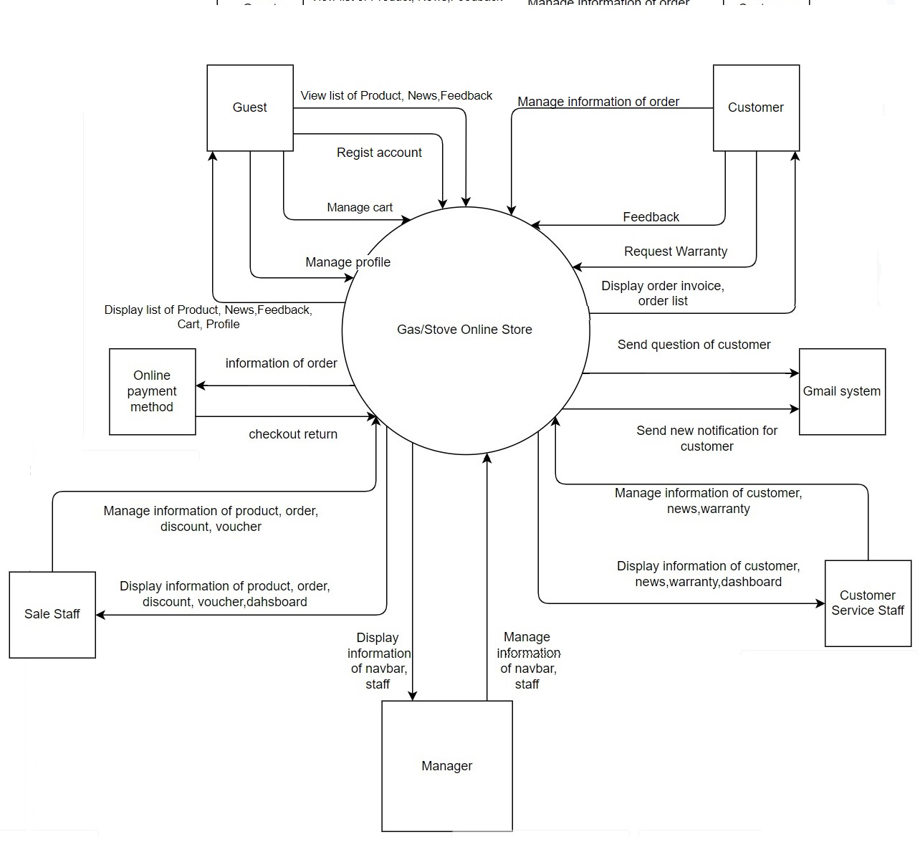

## 2. User Requirements

### 2.1 Actors

| **#** | **Actor** | **Description** |
| --- | --- | --- |
| 1 | Guest | Guest can use public feature of a shop like view home page, view product, view news, view faq, contact with shop, register |
| 2 | Customer | Guest who bought product from shop |
| 3 | Sale Staff | A staff of the organization. They are people who manage everything about order, product, discount and voucher. |
| 4 | Customer Service Staff | A staff of the organization. They are people who manage everything about news, customer, feedback and warranty. |
| 5 | Manager | A manager can manage the staff |

### 2.2 Use Cases

#### *a. Diagram(s)*

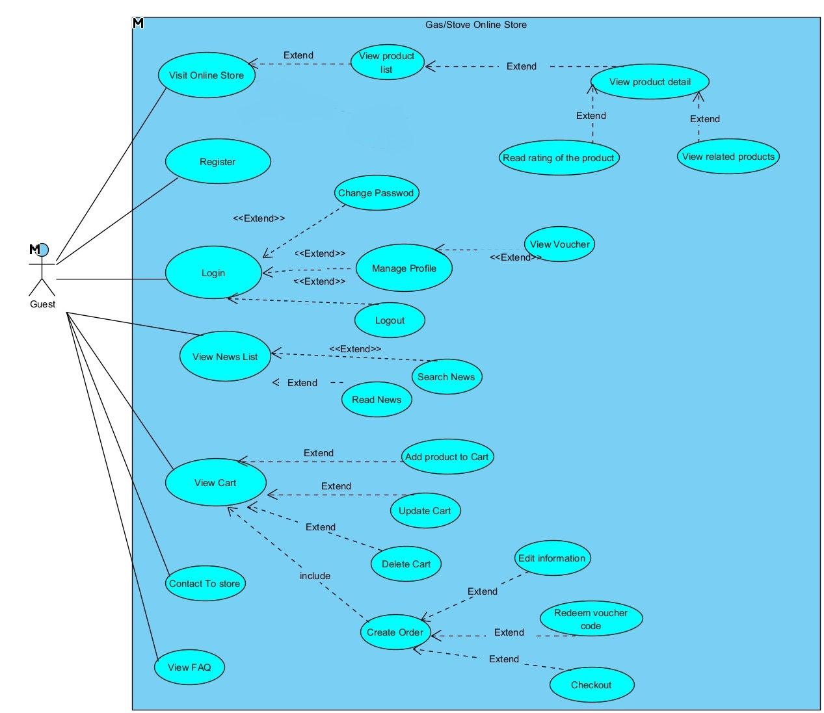

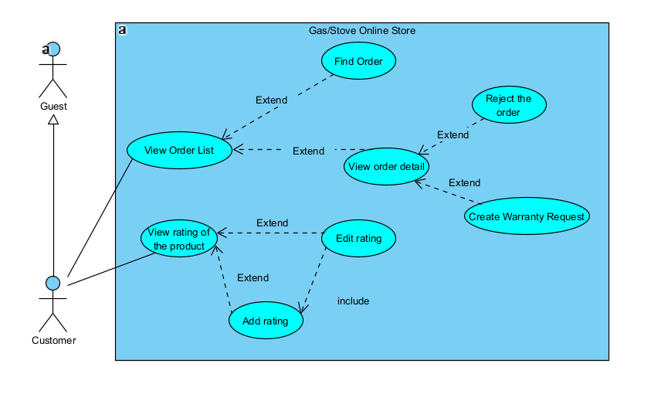

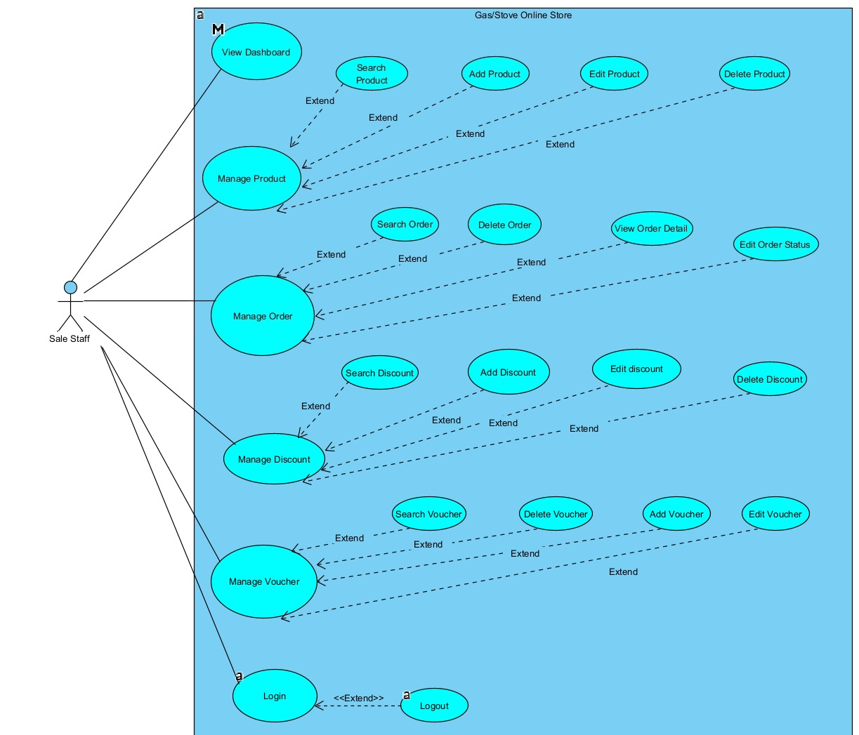

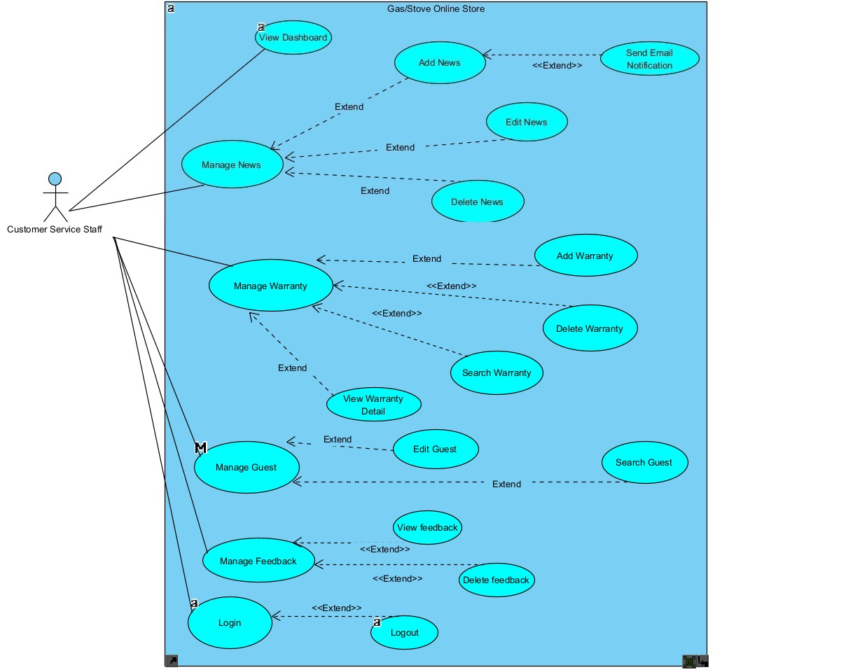

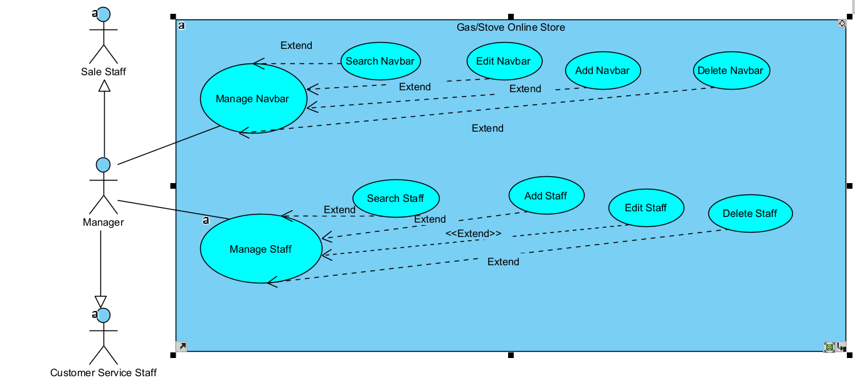

#### *b. Descriptions*

| **ID** | **Feature** | **Use Case** | **Use Case Description** |
| --- | --- | --- | --- |
| 1 | Public | Login | User can login to system with registered account |
| 2 | Public | Logout | User can log out of the account |
| 3 | Guest | Register | Guest can register to system |
| 4 | Guest | Change password | Guest can change password |
| 5 | Guest | Manage profile | Guest can view and edit personal information |
| 6 | Public | Visit Online Store | User can view home page with blogs and slider, best seller, new arrivals, hot sales |
| 7 | Public | View product list | User can view the list of product |
| 8 | Public | View Product Detail | User can read product information detail |
| 9 | Public | View Related Product | User can view related product |
| 10 | Public | Read rating of the product | User can view product feedback |
| 11 | Guest | View Voucher | User can view the voucher available now |
| 12 | Public | Contact To Shop | User can contact to the shop, the manager can see it via their email |
| 13 | Public | View FAQ | User can view the information of the store |
| 14 | Public | View News List | User can view the news list |
| 15 | Public | Search News | User can search news |
| 16 | Public | Read News | User can read news detail |
| 17 | Guest | View Cart | Guest can manage the shopping cart and see what products are in the cart |
| 18 | Guest | Add product to Cart | Guest can add product to cart |
| 19 | Guest | Create Order | Guest can create orders after created cart |
| 20 | Guest | Edit information | Guest can edit information about order |
| 21 | Guest | Redeem Voucher Code | Guest can input the voucher code to reduce the total price |
| 22 | Guest | Checkout | Guest checkout after created order |
| 23 | Customer | View Order list | Customer view their order history, tracking past transactions |
| 24 | Customer | Find Order | Customer can find order by filter |
| 25 | Customer | View order detail | Customer can view the order detail |
| 26 | Customer | Reject the order | Customer can reject the order if they want |
| 27 | Customer | Create Warranty Request | Customer can create warranty request. |
| 28 | Customer | Add rating | Customer can add the product feedback to the shop, they can rate the score of the product. They can give feedback only one per one product. |
| 29 | Customer | Edit rating | Customer can edit the feedback after they added it |
| 30 | Sale Staff, Customer Service Staff | View Dashboard | Staff can view sales statistics, orders.... |
| 31 | Sale Staff | Manage Product | Sale Staff can view the list of product |
| 32 | Sale Staff | Search Product | Sale Staff can search the product by filter |
| 33 | Sale Staff | Add Product | Sale Staff can add new product |
| 34 | Sale Staff | Edit Product | Sale Staff can edit the information of product |
| 35 | Sale Staff | Delete Product | Sale Staff can delete the product |
| 36 | Sale Staff | Manage Order | Sale Staff can manage orders |
| 37 | Sale Staff | Search Order | Sale Staff can search order by filter |
| 38 | Sale Staff | Delete Order | Sale Staff can delete order |
| 39 | Sale Staff | View Order Detail | Sale Staff can view the detail of the order |
| 40 | Sale Staff | Edit Order Status | Sale Staff can edit the status of the order |
| 41 | Sale Staff | Manage Discount | Sale Staff can manage discount list |
| 42 | Sale Staff | Search Discount | Sale Staff can search discount by filter |
| 43 | Sale Staff | Add Discount | Sale Staff can add new discount |
| 44 | Sale Staff | Edit discount | Sale Staff can edit the selected discount |
| 45 | Sale Staff | Delete discount | Sale Staff can delete the selected discount |
| 46 | Sale Staff | Manage Voucher | Sale Staff can manage voucher list |
| 47 | Sale Staff | Search Voucher | Sale Staff can search the voucher by filter |
| 48 | Sale Staff | Add Voucher | Sale Staff can add new voucher |
| 49 | Sale Staff | Edit Voucher | Sale Staff can edit voucher |
| 50 | Sale Staff | Delete Voucher | Sale Staff can delete voucher |
| 51 | Customer Service Staff | News Management | Customer Service Staff can manage news list |
| 52 | Customer Service Staff | Search News | Customer Service Staff can search news by filter |
| 53 | Customer Service Staff | Add News | Customer Service Staff can add new news |
| 54 | Customer Service Staff | Edit News | Customer Service Staff can edit news |
| 55 | Customer Service Staff | Delete News | Customer Service Staff can delete news |
| 56 | Customer Service Staff | Manage Warranty | Customer Service Staff can manage warranty list |
| 57 | Customer Service Staff | Search Warranty | Customer Service Staff can search warranty by filter |
| 58 | Customer Service Staff | Add Warranty | Customer Service Staff can add new warranty through customer requirement |
| 59 | Customer Service Staff | Edit Warranty | Customer Service Staff can edit warranty |
| 60 | Customer Service Staff | Delete Warranty | Customer Service Staff can delete warranty |
| 61 | Customer Service Staff | Manage Guest | Customer Service Staff can manage detailed guest information |
| 62 | Customer Service Staff | Search Guest | Customer Service Staff can search the guest by filter |
| 63 | Customer Service Staff | Edit Guest | Customer Service Staff can edit the guest information |
| 65 | Customer Service Staff | Send email notification | Customer Service Staff can send email to guest who registered to take news |
| 66 | Customer Service Staff | Manage feedback | Customer Service Staff can manage detailed customer feedback |
| 67 | Customer Service Staff | Search Feedback | Customer Service Staff can search the feedback by filter |
| 68 | Customer Service Staff | Delete feedback | Customer Service Staff can delete feedback |
| 69 | Manager | Navbar Management | Manager can manage navbar list |
| 70 | Manager | Search navbar | Manager can search customer navlink by filter |
| 71 | Manager | Edit Navbar | Manager can edit customer navlink |
| 72 | Manager | Add Navbar | Manager can add new customer navlịnk |
| 73 | Manager | Delete Navbar | Manager can delete customer navlink |
| 74 | Manager | Manage Staff | Manager can manage staff list |
| 75 | Manager | Search Manager | Manager can search staff by filter |
| 76 | Manager | Add Manager | Manager can add new staff |
| 77 | Manager | Edit Manager | Manager can edit the staff information |
| 78 | Manager | Delete Manager | Manager can delete the staff |

## 3. Overall Functionalities

### 3.1 Screens Flow

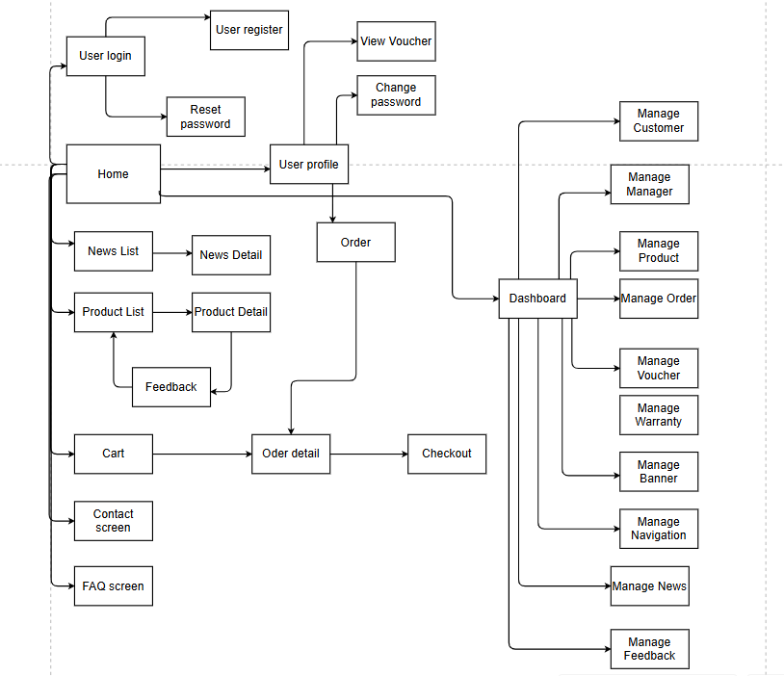

### 3.2 Screen Descriptions

| **#** | **Feature** | **Screen** | **Description** |
| --- | --- | --- | --- |
| 1 | Public | Home | * Show sliders, featured products, static contacts/links. * Shown slider information includes its image and title; the user is redirected to the slider's backlink on his/her clicking. * Shown post information includes its thumbnail, title, brief-info; the user is redirected to the post's details on his/her clicking. * Shown product information includes its thumbnail, title, brief information; the user is redirected to the product's details on his/her clicking. |
| 2 | Public | User Login | This is a screen which allows the user to enter email & password to login; on this page, there are also options for user to register new information or reset the password for the case s/he forget it |
| 3 | Public | User Register | This is screen which allows the user to register himself/herself to the system by inputting following information: full name, gender, email, mobile, and address; User then need to verify by clicking the link sent via email to him/her before being able to access the system |
| 4 | Public | Reset Password | The user input his/her email to receive the reset password link. This link is sent to the user's email for his/her password resetting.  - On clicking the link, the user is redirected to the password resetting page in which s/he input new password (twice) for the system access  - Note that the link is only available for a specific time duration as configured in the system config file. |
| 5 | Guest | Password Change | This is a screen which allows the user to change his/her password by inputting his current password as well as new password (twice) |
| 6 | Guest | User Profile | This is a screen which allows the guest to edit his/her profile information, including the registered ones & the avatar image. |
| 7 | Guest | View voucher | This is a screen which allows the guest to view and save voucher to use when checkout |
| 8 | Public | Contact Screen | This is a screen which allows the user see more information about store and send question to the mail of store |
| 9 | Public | FAQ Screen | This is a screen which allows the user see more populate question and the answer of this question about store |
| 10 | Public | Product List | Show the products paginated (sorted by updated date) + the sider with the product search box, product categories, the latest products, and static contacts/links;  - Shown product information includes its thumbnail, title, brief information, original price, and sale price;  - The user is redirected to the product's details on his/her clicking on the product  - The user can choose to add the product to the cart or to feedback on the product by clicking the product's Buy & Feedback buttons responsively |
| 11 | Public | Product Details | Show product details (including title, category, images, original price, sale price, and product details) + the sider with the product search box, product categories, the latest products, and static contacts/links |
| 12 | Public | News List | Show the news paginated (sorted by updated date) + the slider with the news search box, news categories, the latest news, and static contacts/links;  - Shown news information includes its thumbnail, title, brief information, date;  - The user is redirected to the news's details on his/her clicking on the product |
| 13 | Public | News Detail | Show news details + the slider with the news search box, news categories, the latest news, related news, hot news |
| 14 | Guest | Cart | Show the ordered items before checkout. |
| 15 | Guest | Checkout | Show the ordered items, pop-up screen checkout, payment. |
| 16 | Customer | Orders | Show the list of customer's orders paginated + the slider with the product search box, product categories, the latest products, and static contacts/links  - Each order include below information: id, ordered date, product (first product name & number of other products if any), total cost, status;  - On clicking the link under the order id, customer would be redirected to the Order Detail page |
| 17 | Customer | Order Details | Show the order details, including the following information:  - Basic order information: order id, customer full name, email, mobile, order date, total cost, sale name, status  - The receiver information: full name, gender, email, mobile, address  - This list of ordered products, each product include following information: thumbnail, name, category, unit price, quantity, total cost    Manager can change the order status & the sale notes |
| 18 | Staff | Dashboard | Show statistics of new orders (success, canceled, submitted), revenues (total, by product categories), customers (newly registered, newly bought), feedbacks (average star: total, by product categories) & the trend of order counts (success, all) by day for the last 7 days (the start date & end date can be adjustable). |
| 19 | Customer Service Staff | Manage Customer | Show the paginated list of registered customer (include users' id, full name, gender, email, mobile, role, status):  - The staff can filter the users by gender, role, status  - Allow the staff to search users by full name, email, mobile  - The list is sortable by id, fullname, gender, email, mobile, role, status  - From each user, the staff can choose to view or edit it  - The page also have the button/link that allows the staff to add new customer |
| 20 | Manager | Manage Staff | Show the paginated list of staff  - The manager can filter the staff  - Allow the manager to search users by full name, email, mobile  - From each staff, the manager can choose to view or edit it  - The page also have the button/link that allows the manager to add new staff |
| 21 | Sale Staff | Manage Product | Show the paginated list of product  - The staff can filter the product by its attribute  - Allow the staff to search product by its attribute  - From each product, the staff can choose to view or edit it  - The page also have the button/link that allows the staff to add new product |
| 22 | Sale Staff | Manage Order | Show the paginated list of product  - The staff can filter the order by its attribute  - Allow the staff to search order by its attribute  - From each order, the staff can choose to view or edit it  - The page also have the button/link that allows the staff to add new order |
| 23 | Sale Staff | Manage Voucher | Show the paginated list of voucher  - The staff can filter the voucher by its attribute  - Allow the staff to search voucher by its attribute  - From each voucher, the staff can choose to view or edit it  - The page also have the button/link that allows the staff to add new voucher |
| 24 | Customer Service Staff | Manage Warranty | Show the paginated list of warranty  - The staff can filter the warranty by its attribute  - Allow the staff to search warranty by its attribute  - From each warranty, the staff can choose to view or edit it  - The page also have the button/link that allows the staff to add new warranty |
| 25 | Customer Service Staff | Manage News | Show the paginated list of news  - The staff can filter the news by its attribute  - Allow the staff to search news by its attribute  - From each news, the staff can choose to view or edit it  - The page also have the button/link that allows the staff to add new news |
| 26 | Customer Service Staff | Manage Feedback | Show the paginated list of user feedbacks  - The staff can filter the feedbacks by its attribute  - Allow the staff to search feedbacks by its attribute  - From each feedback, the staff can choose to view it  - The page also have the button/link that allows the staff to delete feedbacks |
| 27 | Manager | Manage Banner | Show the paginated list of banner  - The manager can filter the banner by its attribute  - Allow the manager to search banner by its attribute  - From each banner, the manager can choose to view or edit it  - The page also allow manager to add new banner |
| 28 | Manager | Manage Navigation | Show the paginated list of navigation  - The manager can filter the navigation by its attribute  - Allow the manager to search navigation by its attribute  - From each navigation, the manager can choose to view or edit it  - The page also have the button/link that allows the manager to add new navigation |

### 3.3 Screen Authorization

| **Screen** | **Guest** | **Customer** | **Sale Staff** | **Customer Service Staff** | **Manager** |
| --- | --- | --- | --- | --- | --- |
| Home Page | x | x | x | x | x |
| User Login | x | x | x | x | x |
| User Register | x |  |  |  |  |
| Reset Password | x | x |  |  |  |
| Password Change | x | x | x | x | x |
| User Profile | x | x | x | x | x |
| View voucher | x | x |  |  |  |
| Orders |  | x |  |  |  |
| Order Details |  | x |  |  |  |
| Cart | x | x |  |  |  |
| Product List | x | x | x | x | x |
| Product Details | x | x | x | x | x |
| News List | x | x | x | x | x |
| News Detail | x | x | x | x | x |
| Checkout | x | x |  |  |  |
| Dashboard |  |  | x | x | x |
| Manage Staff |  |  |  |  | x |
| Manage Customer |  |  |  | x | x |
| Manage product |  |  | x |  | x |
| Manage Order |  |  | x |  | x |
| Manage voucher |  |  | x |  | x |
| Manage warranty |  |  |  | x | x |
| Manage news |  |  |  | x | x |
| Manage banner |  |  |  |  | x |
| Manage navigation |  |  |  |  | x |

### 3.4 Non-UI Functions

| **#** | **Feature** | **System Function** | **Description** |
| --- | --- | --- | --- |
| 1 | Data Processing | Non-UI Data Processing | Perform complex calculations on data without displaying results directly to the user. |
| 2 | Communication | Communication with External Services | This functionality allows applications to connect and communicate with external services or systems via API |
| 3 | Database Communication | Database Communication | Executes database queries to retrieve and update information without requiring direct interaction from the user. |
| 4 | System Event Handling | System Event Handling | Monitors and handles system events such as errors (404,...), notifications, or automatic events without direct intervention from the user. |
| 5 | Authorization | User Identity Verification and Access Control | This function verifies the identity of users and determines whether they have permission to access certain resources or perform specific actions within the application |
| 6 | Security | Hash password | Passwords must be encrypted before adding to database to secure user information |

## 4. System High Level Design

### 4.1 Database Design

#### *a. Database Schema*

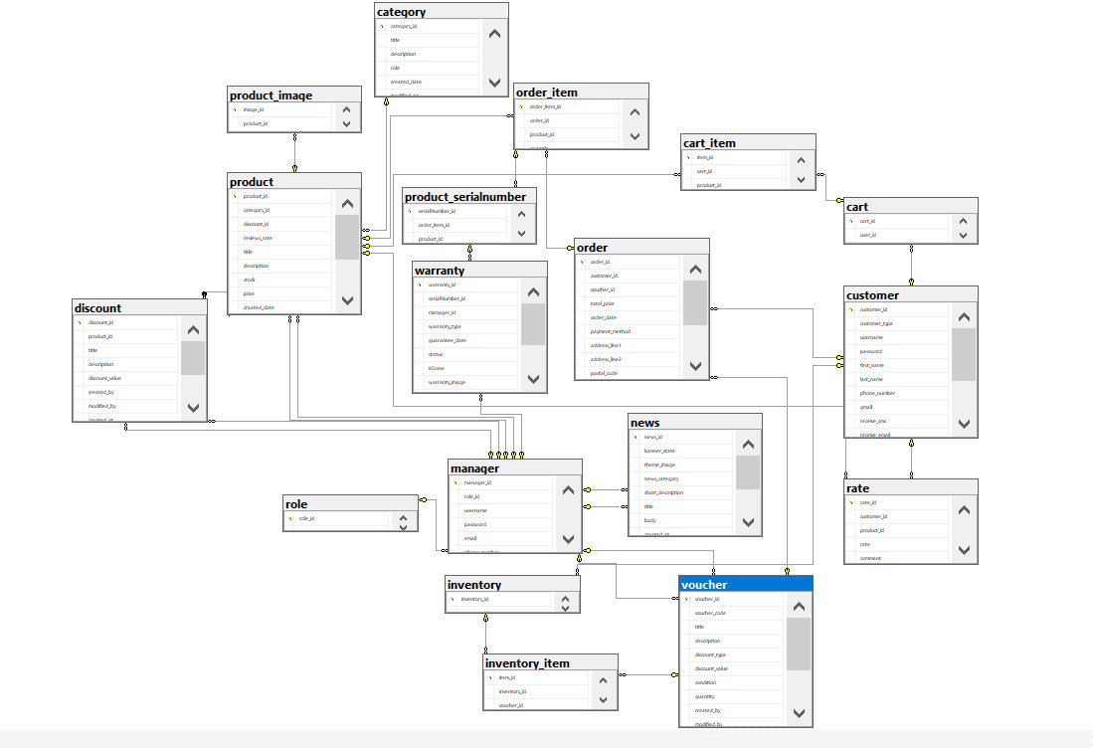

#### *b. Table Descriptions*

| **No** | **Table** | **Description** |
| --- | --- | --- |
| **01** | customer | customer_id INT PRIMARY KEY IDENTITY,  customer_type INT,  customer_img NVARCHAR(max),  username NVARCHAR(255),  [password] NVARCHAR(255),  first_name NVARCHAR(255),  last_name NVARCHAR(255),  phone_number NVARCHAR(255),  gmail NVARCHAR(255),  receiveNotif BIT,  address_line1 NVARCHAR(255),  address_line2 NVARCHAR(255),  postal_code NVARCHAR(255),  city NVARCHAR(255) |
| **02** | inventory | inventory_id INT PRIMARY KEY IDENTITY,  customer_id INT |
| **03** | inventory_item | item_id INT PRIMARY KEY IDENTITY,  inventory_id INT,  voucher_id INT,  amount INT |
| **04** | manager | manager_id INT PRIMARY KEY IDENTITY,  role_id INT,  username NVARCHAR(255),  password NVARCHAR(255),  email NVARCHAR(255),  phone_number NVARCHAR(255),  first_name NVARCHAR(255),  last_name NVARCHAR(255) |
| **05** | role | role_id INT PRIMARY KEY IDENTITY,  title NVARCHAR(255) |
| **06** | product | product_id INT PRIMARY KEY IDENTITY,  category_id INT,  discount_id INT,  reviews_rate INT,  title NVARCHAR(255),  description NVARCHAR(MAX),  stock INT,  price FLOAT,  created_date DATE,  modified_on DATE,  created_by INT,  modified_by INT,  warranty_months INT |
| **07** | rate | rate_id INT PRIMARY KEY IDENTITY,  customer_id INT,  product_id INT,  rate INT,  comment NVARCHAR(MAX),  created_on DATETIME,  modified_on DATETIME |
| **08** | category | category_id INT PRIMARY KEY IDENTITY,  title NVARCHAR(255),  description NVARCHAR(max),  role INT,  created_date DATE,  modified_on DATE,  created_by INT,  modified_by INT |
| **09** | order | order_id INT PRIMARY KEY IDENTITY,  customer_id INT,  voucher_id INT,  total_price FLOAT,  order_date DATE,  payment_method INT,  address_line1 NVARCHAR(255),  address_line2 NVARCHAR(255),  postal_code NVARCHAR(255),  city NVARCHAR(255),  phone_number NVARCHAR(255),  created_at DATE,  status tinyint |
| **10** | order_item | order_item_id INT PRIMARY KEY IDENTITY,  order_id INT,  product_id INT,  quantity INT,  price FLOAT |
| **11** | discount | discount_id INT PRIMARY KEY IDENTITY,  product_id INT,  title NVARCHAR(255),  description NVARCHAR(MAX),  discount_value FLOAT,  created_by INT,  modified_by INT,  created_at DATE,  modified_at DATE,  expiry datetime,  status bit |
| **12** | voucher | voucher_id INT PRIMARY KEY IDENTITY,  voucher_code NVARCHAR(MAX),  title NVARCHAR(MAX),  description NVARCHAR(MAX),  discount_type INT,  discount_value FLOAT,  condition float,  quantity INT,  created_by INT,  modified_by INT,  created_at DATE,  modified_on DATE,  expiry DATE,  statusBIT |
| **13** | product_image | image_id INT PRIMARY KEY IDENTITY,  product_id INT,  url NVARCHAR(255) |
| **14** | news | news_id INT PRIMARY KEY IDENTITY,  banner_state INT,  theme_image NVARCHAR(MAX),  news_category NVARCHAR(255),  short_description NVARCHAR(MAX),  title NVARCHAR(255),  body NVARCHAR(MAX),  created_at DATE,  modified_on DATE,  created_by INT,  modified_by INT |
| **15** | cart | cart_id INT PRIMARY KEY IDENTITY,  user_id INT,  total FLOAT |
| **16** | cart_item | item_id INT PRIMARY KEY IDENTITY,  cart_id INT,  product_id INT,  quantity INT |
| **17** | product_serialnumber | serialNumber_id INT PRIMARY KEY IDENTITY,  order_item_id INT,  product_id int,  service_tag NVARCHAR(MAX), |
| **18** | warranty | warranty_id INT PRIMARY KEY IDENTITY,  serialNumber_id int,  manager_id int,  warranty_type int,  guarantee_date DATE,  status NVARCHAR(255),  isDone BIT,  warranty_image NVARCHAR(MAX),  created_by INT,  modified_by INT,  created_at DATE,  modified_at DATE, |

### 4.2 Code Packages

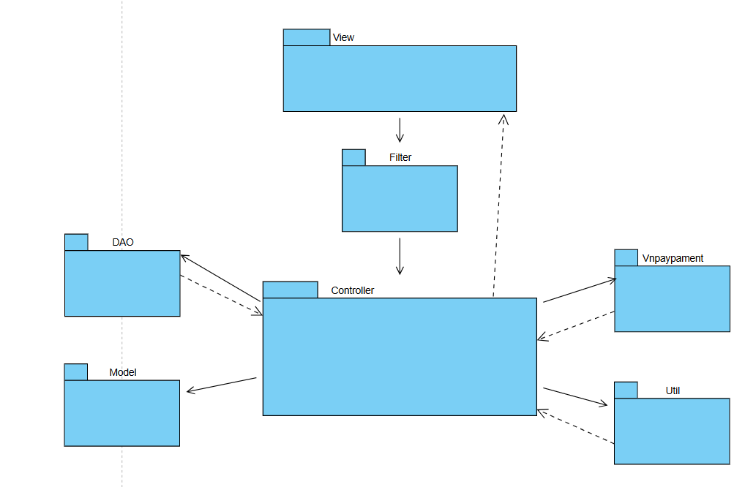

***Package descriptions***

| **No** | **Package** | **Description** |
| --- | --- | --- |
| 1 | Util | The "Util" package contains utility classes and helper methods used to perform common tasks and facilitate reusability within the application. Classes in this package typically include functions such as string manipulation, date formatting, encoding and decoding, and other utility functions. |
| 2 | DAO | The "DAO" package contains classes used to access and interact with the database. Classes in this package typically include methods to perform operations such as adding, updating, deleting, and querying data from the database. The "dal" package often serves as an intermediary layer between the application and the database, helping to separate application logic from data access logic. |
| 3 | Model | The "Model" package contains classes representing data entities within the application. Classes in this package are designed to represent objects in the application but do not contain any business logic. Instead, they simply model the data and are often used to transfer data between different layers and components of the application. |
| 4 | Vnpaypayment | The "Vnpaypaymentl" package contains vnpay payment api |
| 5 | Controller | The "Controller" package contains classes and method to control, process data and connect each other package |
| 6 | Filter | The "Filter" package contains classes to verifies the identity of users and determines whether they have permission to access certain resources or perform specific actions within the application |
| 7 | View | The "Model" package contains jsp file to display user interface |

# II. Requirement Specifications

## 1. Public Feature

### 1.1 UC-1:View home page

#### *a. Functionalities*

| UC ID and Name: | **UC-1:View Home Page** | | |
| --- | --- | --- | --- |
| Created By: | AnLT | Date Created: | 21/05/2024 |
| Primary Actor: | All actor | Secondary Actors: | None |
| Trigger: | User clicks Logo from the page header or User accesses the website. | | |
| Description: | This use case allows users to access and view the website's home page. The home page displays products, news, promotions, and provides links to different sections of the site. Users can easily navigate to different parts of the website from the home page. | | |
| Preconditions: | 1. **Data Availability**: The data required to populate the home page must be accessible and up-to-date. This includes content such as articles, products, news, or any dynamic elements on the page. 2. **User Interface Ready**: The user interface for the home page must be developed and ready for display to the user. | | |
| Postconditions: | 1. **Home Page Displayed**: The home page has been successfully displayed to the user with all the necessary content and user interface elements. 2. **User Can View Content**: The user can view the content on the home page, such as articles, products, general information, etc. 3. **Data Updated (if needed)**: If the home page displays dynamic data, such as the latest information, featured products, news, the data has been updated to reflect the latest information. 4. **Errors and Notifications (if errors occurred)**: If there were errors during the process of viewing the home page (e.g., data errors, UI issues), the user has been notified of the error and provided with guidance or contact information for issue resolution. 5. **Load Time and Performance (if relevant)**: Information regarding page load times and performance may be recorded for monitoring and optimization purposes. | | |
| Normal Flow: | 1. Users access the home page by entering a website address or clicking a link from another page. 2. The home page loads quickly and displays full content, including product listings, promotions, latest information, and links to other pages on the site. 3. Users can scroll the page to see the entire content or use the slider to view different sections on the home page. | | |
| Alternative Flows: | 1. **Page loading error:** Home page does not load or loads slowly due to technical problems or internet connection problems. The user may need to refresh the page or recheck their internet connection to reload the page. 2. **Link errors:** Links from the home page may lead to non-existent or error pages. | | |
| Exceptions: | ***Error when surfing home page:***   1. **System Instability**: System issues or maintenance are affecting access. 2. **Data Not Found or Data Error**: Errors when retrieving or accessing data. 3. **Slow Page Load:** Home page loads slowly due to weak network or heavy data. 4. **UI Errors:** Display issues, browser incompatibility, or UI errors. 5. **Security Breach:** Security vulnerabilities or attacks. 6. **Overload**: Home page experiences overload due to sudden traffic or heavy data. | | |
| Priority: | Must Have | | |
| Frequency of Use: | High | | |
| Business Rules: | FR1.1 | | |
| Other Information: | **Homepage Content**: Provide details about what types of content are typically found on the home page. This may include featured products, announcements, news, promotional banners, navigation menus, search bars, and more. | | |
| Assumptions: | **Existing User Interface**: It is assumed that there is an existing user interface or homepage that has been developed and is ready for display to users. | | |

#### *b. Business Rules*

| **ID** | **Business Rule** | **Business Rule Description** |
| --- | --- | --- |
| FR1.1 | Dynamic Content Display | The home page may contain dynamic content such as the latest articles, best-selling products, recent news, etc. Business rules need to ensure that this content is updated and displayed correctly. |

### 

### 

### 

### 

### 1.2 UC-2:View News List

#### *a. Functionalities*

| UC ID and Name: | **UC-2:View News List** | | |
| --- | --- | --- | --- |
| Created By: | TienTM | Date Created: | 21/05/2024 |
| Primary Actor: | All actor | Secondary Actors: | None |
| Trigger: | 1. **User Clicks on "News" tab**: The user selects a specific tab or menu option dedicated to news or articles, indicating their intention to view a list of news articles. 2. **User Navigates to a News Section**: If the application or website has dedicated sections for news (e.g., sports news, tech news), the user may navigate to one of these sections, triggering the display of news articles in that category. | | |
| Description: | The "View News List" use case involves users accessing a list of news articles or updates on a website or application. Users can browse through a collection of news items to stay informed about recent developments, articles, or announcements. This use case is common on news websites, blogs, and content-driven platforms. | | |
| Preconditions: | There needs to be post data and related information in the database to display on the blogroll. | | |
| Postconditions: | 1. Correct Display of Content 2. Filter and Search Functions Operation 3. Read More Function Operation | | |
| Normal Flow: | 1. The user initiates the use case trigger. 2. The system responds by retrieving a list of news articles based on the user's action or request. 3. The system displays the list of news articles, typically in a user-friendly format, such as a grid or list, on the user's device. 4. The user can browse, read, and interact with the displayed news articles, which may include clicking on individual articles for more details. | | |
| Alternative Flows: | 1. If there are no news articles available, the system may display a message indicating that there are no articles to show. 2. In the case of a search-triggered flow, the system may filter and display only relevant articles based on the user's search criteria. | | |
| Exceptions: | 1. System unavailability or technical errors. 2. Lack of available news articles. 3. Search criteria returning no results. 4. Errors in loading or displaying news articles. | | |
| Priority: | Must Have | | |
| Frequency of Use: | High | | |
| Business Rules: | FR1.2 | | |
| Other Information: | * **Website Visitor/Registered User:** Interested in accessing news articles and updates to stay informed about recent events or topics of interest. * **System:** Responsible for retrieving and displaying news articles in a user-friendly format, providing navigation options, and ensuring a seamless reading experience. | | |
| Assumptions: | 1. **Existence of Blog Data**: It is assumed that there is a dataset of news articles or entries available within the system to be displayed in the news list. 2. **Valid Blog Data**: The assumption is that the news data stored in the system is valid, accurate, and has been verified for correctness and relevance. 3. **Regular Data Updates**: It is assumed that the news data is regularly updated to ensure the freshness and relevance of the information. 4. **Ready User Interface**: The assumption is that the user interface to display the news list has been developed and is ready for use. | | |

#### *b. Business Rules*

| **ID** | **Business Rule** | **Business Rule Description** |
| --- | --- | --- |
| FR1.2 | Sorting | The news list can be sorted by criteria such as date, popularity, category, or user preference. This rule defines the default sorting order and user options for reordering. |

### 

### 

### 

### 

### 

### 

### 

### 1.3 UC-3:View News Detail

#### *a. Functionalities*

| UC ID and Name: | **UC-3:View News Detail** | | |
| --- | --- | --- | --- |
| Created By: | TienTM | Date Created: | 21/05/2024 |
| Primary Actor: | Actor | Secondary Actors: | None |
| Trigger: | The trigger for this use case occurs when the user selects or clicks on a specific news article from the list of news articles. | | |
| Description: | Allow users to view the details of a specific news post. This includes the entire content of the news including title, publication date, view count, description, images. | | |
| Preconditions: | * The system must be operational and accessible. * The specific news article that the user wishes to view must exist and be accessible. | | |
| Postconditions: | * The user has successfully viewed the detailed content of the selected news article. * Users can choose to interact further with the category or return to the news list. | | |
| Normal Flow: | If the selected news article does not exist or is inaccessible, the system may display an error message and get back to the Blog list page. | | |
| Alternative Flows: | None | | |
| Exceptions: | * System unavailability or technical errors, such as database conflicts or information errors from the database. * The selected news article does not exist or is inaccessible. * Errors in loading or displaying the detailed news article content. | | |
| Priority: | Must Have | | |
| Frequency of Use: | Medium | | |
| Business Rules: | FR1.3_1, FR1.3_2 | | |
| Other Information: | None | | |
| Assumptions: | 1. Data Accuracy: The news data, including the title, publication date, description, and images, is considered to be accurate and up-to-date. 2. System Availability: The system is considered to be operational and accessible when users attempt to view news article details. | | |

#### *b. Business Rules*

| **ID** | **Business Rule** | **Business Rule Description** |
| --- | --- | --- |
| FR1.3_1 | Content Availability: | Detailed news articles must exist and be accessible in the system before they can be viewed. |
| FR1.3_2 | Content Consistency: | The content displayed in the detailed news article view should match the content as it was originally published. Any updates or changes should be clearly indicated |

### 

### 

### 

### 

### 

### 1.4 UC-4:View Product List

#### *a. Functionalities*

| UC ID and Name: | **UC-4: View Product List** | | |
| --- | --- | --- | --- |
| Created By: | AnLT | Date Created: | 21/05/2024 |
| Primary Actor: | All actor | Secondary Actors: | None |
| Trigger: | The trigger for this use case occurs when the customer/user expresses the intent to view a list of available products. This could be through actions like clicking on a "Product" tab, selecting a product category, or performing a search. | | |
| Description: | Permits users to browse through a list of gas/stove products. Users can see product thumbnails, names, prices, and short descriptions. Clicking on a product takes them to the Product Details page. | | |
| Preconditions: | * The customer/user must have access to the system or website. * The system must be operational and accessible. | | |
| Postconditions: | * The customer/user has successfully viewed the list of available products. * The customer/user may choose to interact further with individual products, such as clicking on them for more information or adding them to a shopping cart. | | |
| Normal Flow: | * The customer/user initiates the use case by selecting a category, performing a search, or taking an action that leads to viewing the product list. * The system retrieves and displays a list of available products based on the customer's/user's request. * The product list is presented in a user-friendly format, typically as a grid or list, containing product names, images, prices, and rate, price sale * The customer/user can browse, filter, sort, and interact with the product list. They can click on individual products to view more details. | | |
| Alternative Flows: | * If the customer/user's access permissions are insufficient, the system may deny access and display an error message. * If there are no products available in the selected category or matching the search criteria, the system may display a message indicating that there are no products to show. * If there are technical issues or errors during the retrieval or display of the product list, the system may generate error messages and prompt the customer/user to retry or contact support. | | |
| Exceptions: | Product display error | | |
| Priority: | Must Have | | |
| Frequency of Use: | High | | |
| Business Rules: | FR1.4_1, FR1.4_2 | | |
| Other Information: | None | | |
| Assumptions: | * Product Availability: It is assumed that there are products available for display in the system's database or inventory. In other words, products have been added and are in stock. * Data Accuracy: The product data, including names, descriptions, prices, and images, are assumed to be accurate and up to date. * System Availability: The system is assumed to be operational and accessible when users attempt to view the product list. * User Interface Readiness: The user interface (UI) components and layouts for presenting the product list have been designed and developed and are ready for use. | | |

#### *b. Business Rules*

Provide the business rules those are applied only to the use case

| **ID** | **Business Rule** | **Business Rule Description** |
| --- | --- | --- |
| FR1.4_1 | **Product Presentation**: | * Products should be presented in a clear and user-friendly format, including product names, images, prices, and brief descriptions. * The order in which products are displayed (e.g., by popularity, price, or relevance) may follow specific rules or user preferences. |
| FR1.4_2 | **Product Availability and Stock**: | Products listed in the view must be available in stock for purchase. Out-of-stock or discontinued products should not appear in the list. |

### 1.5 UC-5:View Product Detail

#### *a. Functionalities*

| UC ID and Name: | **UC-5: View Product Detail** | | |
| --- | --- | --- | --- |
| Created By: | AnLT | Date Created: | 21/05/2024 |
| Primary Actor: | All actor | Secondary Actors: | None |
| Trigger: | The trigger for this use case occurs when the user selects or clicks on a specific product article from the list of product articles. | | |
| Description: | Allow users to view the details of a specific product. This includes the entire content of the product including name, description, images, price…. | | |
| Preconditions: | * The user must have access to the system or website. * The system must be operational and accessible. | | |
| Postconditions: | * The user has successfully viewed the detailed content of the selected product article. * Users can choose to interact further with the product or return to the product list. | | |
| Normal Flow: | * User go to the website * User choose a product on homepage * The web navigate to the product details screen | | |
| Alternative Flows: | * User go to the website * User go to the product list screen * User choose a product to see * The web navigate to the product details screen | | |
| Exceptions: | Product display error | | |
| Priority: | Must Have | | |
| Frequency of Use: | High | | |
| Business Rules: | FR1.4_1, FR1.4_2 | | |
| Other Information: | None | | |
| Assumptions: | * Product Availability: It is assumed that there are products available for display in the system's database or inventory. In other words, products have been added and are in stock. * Data Accuracy: The product data, including names, descriptions, prices, and images, are assumed to be accurate and up to date. * System Availability: The system is assumed to be operational and accessible when users attempt to view the product list. * User Interface Readiness: The user interface (UI) components and layouts for presenting the product list have been designed and developed and are ready for use. | | |

#### *b. Business Rules*

Provide the business rules those are applied only to the use case

| **ID** | **Business Rule** | **Business Rule Description** |
| --- | --- | --- |
| FR1.4_1 | **Product Presentation**: | * Products should be presented in a clear and user-friendly format, including product names, images, prices, and brief descriptions. * The order in which products are displayed (e.g., by popularity, price, or relevance) may follow specific rules or user preferences. |
| FR1.4_2 | **Product Availability and Stock**: | Products listed in the view must be available in stock for purchase. Out-of-stock or discontinued products should not appear in the list. |

### 1.6 UC-6:Read rating of the product

#### *a. Functionalities*

| UC ID and Name: | **UC-6: Read rating of the product** | | |
| --- | --- | --- | --- |
| Created By: | AnLT | Date Created: | 21/05/2024 |
| Primary Actor: | All actor | Secondary Actors: | None |
| Trigger: | The trigger for this use case occurs when the user selects or clicks on a specific product article and scroll to the bottom to see rating | | |
| Description: | Allow users to view the details of a rating of product. | | |
| Preconditions: | * The user must have access to the system or website. * The system must be operational and accessible. | | |
| Postconditions: | * The user has successfully viewed the detailed content of the rating. * Customer can choose to interact further with the rating if they had bought this product | | |
| Normal Flow: | * User go to the website * User choose a product on homepage * The web navigate to the product details screen * User scroll to bottom | | |
| Alternative Flows: | * User go to the website * User go to the product list screen * User choose a product to see * The web navigate to the product details screen * User scroll to bottom | | |
| Exceptions: | Product rating display error | | |
| Priority: | Must Have | | |
| Frequency of Use: | High | | |
| Business Rules: | FR1.4_1, FR1.4_2 | | |
| Other Information: | None | | |
| Assumptions: | * Product Availability: It is assumed that there are products available for display in the system's database or inventory. In other words, products have been added and are in stock. * Data Accuracy: The product data, including names, descriptions, prices, and images, are assumed to be accurate and up to date. * System Availability: The system is assumed to be operational and accessible when users attempt to view the product list. * User Interface Readiness: The user interface (UI) components and layouts for presenting the product list have been designed and developed and are ready for use. | | |

#### *b. Business Rules*

Provide the business rules those are applied only to the use case

| **ID** | **Business Rule** | **Business Rule Description** |
| --- | --- | --- |
| FR1.4_1 | **Product Presentation**: | * Products should be presented in a clear and user-friendly format, including product names, images, prices, and brief descriptions. * The order in which products are displayed (e.g., by popularity, price, or relevance) may follow specific rules or user preferences. |
| FR1.4_2 | **Product Availability and Stock**: | Products listed in the view must be available in stock for purchase. Out-of-stock or discontinued products should not appear in the list. |
| FR1.6_1 | **Customer can rating 1 time** | Customer who had bought product can rating and feedback just 1 time |

### 1.7 UC-7_Login

#### *a. Functional Description*

| UC ID and Name: | **UC-1: Login** | | |
| --- | --- | --- | --- |
| Created By: | TienTM | Date Created: | 21/05/2024 |
| Primary Actor: | All actor | Secondary Actors: |  |
| Trigger: | User clicks Sign In button from the page header | | |
| Description: | As a user, I want to be able to log into the system so that I can use the system’s authenticated features and access my personalized account. | | |
| Preconditions: | User account has been created & authorized | | |
| Postconditions: | * User logs in the system successfully * The system tracked successful login into the Activity Log | | |
| Normal Flow | 1. User accesses the Login screen  2. User choose actor  3.User input information and click sign in  4. System validates the login details  5. System allows user to access  6. System accesses the Home Page (or the previous calling page if any) | | |
| Alternative Flows: | 1.User can login via google account   * User accesses the Login screen * User clicks Login with google * System validates the login google | | |
| Exceptions: | 1. The Error Message screen is shown to the user  2. User cancels the logging in *=> UC stops, change to UC-1_View Home Page*  3. User clicks “Forgot Password?” link *=> change to UC-9_Reset Password*  4. User clicks “Register” link *=> change to UC-8_Register User Account* | | |
| Priority: | Must Have | | |
| Frequency of Use: | High | | |
| Business Rules: | FR1.7_1, FR1.7_2, FR1.7_3 | | |
| Other Information: | User sessions should have a timeout to automatically log users out after a period of inactivity. | | |
| Assumptions: | Users have been properly registered and provided with login credentials.  The system has been set up to handle user authentication and authorization.  Security measures are in place to protect user credentials and data during login. | | |

#### *b. Business Rules*

| **ID** | **Business Rule** | **Business Rule Description** |
| --- | --- | --- |
| FR1.7_1 | Password Encoding | User’s password must be encoded with MD5 hashing |
| FR1.7_2 | Invalid Logging In | User can’t be authenticated to login the system if below cases   * His/her logging-in details are incorrect * His/her account has not been verified * His/her account has been locked or blocked |
| FR1.7_3 | Password Reset | Password reset mechanism should be applied for cases of forgotten passwords. |

### 1.8 UC-8:View voucher

#### *a. Functionalities*

| UC ID and Name: | **UC-2:View Voucher** | | |
| --- | --- | --- | --- |
| Created By: | TienTM | Date Created: | 21/05/2024 |
| Primary Actor: | All actor | Secondary Actors: | None |
| Trigger: | 1. **User Clicks on "Blog" tab**: The user selects a specific tab or menu option dedicated to news or articles, indicating their intention to view a list of news articles. 2. **User Navigates to a Blog Section**: If the application or website has dedicated sections for news (e.g., sports news, tech news), the user may navigate to one of these sections, triggering the display of news articles in that category. | | |
| Description: | The "View Blog List" use case involves users accessing a list of news articles or updates on a website or application. Users can browse through a collection of news items to stay informed about recent developments, articles, or announcements. This use case is common on news websites, blogs, and content-driven platforms. | | |
| Preconditions: | There needs to be post data and related information in the database to display. | | |
| Postconditions: | 1. Correct Display of Content 2. Filter and Search Functions Operation 3. Read More Function Operation | | |
| Normal Flow: | 1. The user initiates the use case trigger. 2. The system responds by retrieving a list of news articles based on the user's action or request. 3. The system displays the list of news articles, typically in a user-friendly format, such as a grid or list, on the user's device. 4. The user can browse, read, and interact with the displayed news articles, which may include clicking on individual articles for more details. | | |
| Alternative Flows: | 1. If there are no news articles available, the system may display a message indicating that there are no articles to show. 2. In the case of a search-triggered flow, the system may filter and display only relevant articles based on the user's search criteria. | | |
| Exceptions: | 1. System unavailability or technical errors. 2. Lack of available news articles. 3. Search criteria returning no results. 4. Errors in loading or displaying news articles. | | |
| Priority: | Must Have | | |
| Frequency of Use: | High | | |
| Business Rules: | FR1.2 | | |
| Other Information: | * **Website Visitor/Registered User:** Interested in accessing news articles and updates to stay informed about recent events or topics of interest. * **System:** Responsible for retrieving and displaying news articles in a user-friendly format, providing navigation options, and ensuring a seamless reading experience. | | |
| Assumptions: | 1. **Existence of Blog Data**: It is assumed that there is a dataset of news articles or entries available within the system to be displayed in the news list. 2. **Valid Blog Data**: The assumption is that the news data stored in the system is valid, accurate, and has been verified for correctness and relevance. 3. **Regular Data Updates**: It is assumed that the news data is regularly updated to ensure the freshness and relevance of the information. 4. **Ready User Interface**: The assumption is that the user interface to display the news list has been developed and is ready for use. | | |

## 2. Guest Functions

### 2.1 UC-8:Register

#### *a. Functionalities*

**Functional Description Template**

| UC ID and Name: | **UC-8: Register** | | |
| --- | --- | --- | --- |
| Created By: | TienTM | Date Created: | 21/05/2024 |
| Primary Actor: | Guest | Secondary Actors: | None |
| Trigger: | The guest clicks the "sing up" button from the Login page | | |
| Description: | Allow new users to create an account on the website. Users provide personal information such as email, phone number, and password. If the user registers with an email that already exists or enters the password incorrectly compared to the first password, the registration will not be successful. | | |
| Preconditions: | Users have access to the registration page.  The system is operational and online. | | |
| Postconditions: | A new user account is created in the system.  The user is logged into their newly created account. | | |
| Normal Flow: | Users navigate to the registration page.  Users enter their personal information, including name, email address, and password.  User submits the registration form.  System validates the provided information.  If validation is successful, the system creates a new user account and logs the user in.  Users are redirected to their dashboard or the home page. | | |
| Alternative Flows: | If validation fails, the system displays error messages and prompts the user to correct their input.  If the provided email address is already associated with an existing account, the system should inform the user and ask them to use a different email address. | | |
| Exceptions: | If the system is offline or experiencing technical issues, the registration process cannot proceed. | | |
| Priority: | Must have | | |
| Frequency of Use: | high | | |
| Business Rules: | FR2.1_1, FR2.1_2 | | |
| Other Information: | The registration form may include additional fields for optional information like phone numbers, etc. | | |
| Assumptions: | Users have access to a device with an internet connection to complete the registration process. | | |

#### *b. Business Rules*

Provide the business rules those are applied only to the use case

| **ID** | **Business Rule** | **Business Rule Description** |
| --- | --- | --- |
| FR2.1_1 | Unique Email | Usernames or email addresses must be unique within the system. |
| FR2.1_2 | Required Information | Users must provide a set of mandatory information to complete the registration process, including email address, phone number, and password. |

### 

### 2.2 UC-9:Reset Password

#### *a. Functionalities*

Provide the functional description for the use cases using the template/guides below

**Functional Description Template**

| UC ID and Name: | UC-9:Reset Password | | |
| --- | --- | --- | --- |
| Created By: | TienTM | Date Created: | 21/05/2024 |
| Primary Actor: | Guest | Secondary Actors: | None |
| Trigger: | The user clicks the "Reset password?" button from the Login page | | |
| Description: | This use case outlines the process of resetting a user's forgotten password in a system. It is triggered when a user initiates a password reset request, typically by clicking on a "Forgot Password" link on the login page. | | |
| Preconditions: | 1. **User Account Existence**: The user must have an existing account within the system. The email address provided for the password reset must match an account in the system. 2. **Password Reset Request**: The user must initiate the password reset process by providing their email address or username, indicating their intention to reset the password. | | |
| Postconditions: | The user's password is successfully reset.  The user is notified of the password reset. | | |
| Normal Flow: | User initiates the password reset process by providing their email.  The system verifies the email, sends a reset link to the user, and guides them through setting a new password.  The user's password is updated, and they are redirected to the login page with a confirmation message. | | |
| Alternative Flows: | If the user's email is not found in the system, the process ends. | | |
| Exceptions: | Technical issues with sending the reset email are handled with error messages.  Invalid or expired reset tokens are addressed with error messages and a request to start the process again. | | |
| Priority: | High | | |
| Frequency of Use: | High | | |
| Business Rules: | FR2.2 | | |
| Other Information: | Users are assumed to have access to their email accounts for the reset link. | | |
| Assumptions: | 1. **User Intent**: It is assumed that when a user requests a password reset, they have a legitimate reason, such as forgetting their password or needing to change it for security reasons. 2. **Email Communication**: The system assumes that email communication is a secure and reliable method for sending password reset links to users. 3. **User Authentication**: Users are assumed to be properly authenticated when they click the password reset link to access the password resetting page. 4. **Email Accuracy**: Users are assumed to provide a valid and accurate email address associated with their user account when requesting a password reset. | | |

#### *b. Business Rules*

Provide the business rules those are applied only to the use case

| **ID** | **Business Rule** | **Business Rule Description** |
| --- | --- | --- |
| FR2.2 | Password Encoding | User’s password must be encoded with hashing |

### 2.3 UC-10:Manage Profile

#### *a. Functional Description*

| UC ID and Name: | UC-10:Manage Profile | | |
| --- | --- | --- | --- |
| Created By: | TienTM | Date Created: | 21/05/2024 |
| Primary Actor: | Guest | Secondary Actors | None |
| Trigger: | The trigger for this use case occurs when the user selects or clicks on user profile at home screen | | |
| Description: | Allows users to view their information as signed and allows them to update new information about themselves | | |
| Preconditions: | User already has an account  The system is active and online. | | |
| Postconditions: | * User information is displayed * Users can use their new information to make purchases | | |
| Normal Flow | 1. The user accesses the user profile management page on the user interface. 2. The system displays the user's current profile information so they can view and edit. 3. Users make necessary changes, including updating personal information, The user confirms and saves the changes. 4. The system confirms that the profile information has been successfully updated and move to home screen 5. The user interface displays newly updated profile information for users to review. | | |
| Alternative Flows: | none | | |
| Exceptions: | Invalid information: If the user provides invalid or incomplete information, the system will display an error message and request the user to provide correct information again. | | |
| Priority: | Must Have | | |
| Frequency of Use: | High | | |
| Business Rules: | None | | |
| Other Information: | Security: The system needs to ensure that user information is kept safe and only accessible by authorized users. | | |
| Assumptions: | None | | |

#### *b. Business Rules*

Provide the business rules those are applied only to the use case

| **ID** | **Business Rule** | **Business Rule Description** |
| --- | --- | --- |
|  |  |  |

### 

### 

### 2.4 UC-11:View Cart

#### *a. Functional Description*

| UC ID and Name: | **UC-11:View Cart** | | |
| --- | --- | --- | --- |
| Created By: | TienTM | Date Created: | 21/05/2024 |
| Primary Actor: | Guest | Secondary Actors: | None |
| Trigger: | Guest clicks Cart icon from the page header or User accesses an authenticated feature (from a link or type the page URL directly into the address bar) | | |
| Description: | Allows users to view their shopping cart with selected products they want to buy. | | |
| Preconditions: | * The system must be operational and accessible. * The customer/user must have added one or more items to their shopping cart. | | |
| Postconditions: | * The customer/user has successfully viewed the contents of their shopping cart and may choose to take further actions, such as updating quantities, removing items, or proceeding to checkout. | | |
| Normal Flow | 1. The customer/user starts the use case by selecting the "View Cart" option from the user interface. 2. The system retrieves and displays the current content in the customer/user's shopping cart. 3. Cart contents are presented in a clear and organized format, listing items, quantities, prices, and subtotals. 4. Customers/users can review the items in their shopping cart, 5. User can update quantity if quantity is 0 will delete this item, bulk can be changed with item quantity in database 6. The user clicks on the Remove icon to delete the item 7. Select items using the checkbox or proceed to checkout. 8. User can click the button to check | | |
| Alternative Flows: | * If the customer/user's access permissions are insufficient, the system may deny access to view the cart contents and display an error message. * If the customer/user has not added any items to their cart, the system may display a message indicating that the cart is empty. * If there are technical issues or errors during the retrieval or display of cart contents, the system may generate error messages and prompt the customer/user to retry or contact support. | | |
| Exceptions: | * System unavailability or technical errors. * The customer/user's shopping cart is empty. * Errors in loading or displaying the cart contents. | | |
| Priority: | Must Have | | |
| Frequency of Use: | High | | |
| Business Rules: | FR2.4_1, FR2.4_2, FR2.4_3 | | |
| Other Information: | None | | |
| Assumptions: | 1. Cart Initialization: Users are assumed to have added one or more items to their shopping cart before attempting to view the cart contents. 2. Cart Item Accuracy: The items displayed in the cart should accurately reflect what the user has added, including item names, quantities, prices, and any applied discounts. 3. Currency and Pricing: Pricing information is displayed in the currency relevant to the user's location or preferences, and currency conversion rules are applied if necessary. | | |

#### *b. Business Rules*

| **ID** | **Business Rule** | **Business Rule Description** |
| --- | --- | --- |
| FR2.4_1 | **Cart Item Presentation**: | * Cart contents should be presented in a clear and organized format, listing item names, quantities, prices, and a subtotal. * Users may have options to view additional details about each cart item, such as product images or descriptions. |
| FR2.4_2 | **Cart Item Accuracy**: | * The items displayed in the cart should accurately reflect what the user has added, including item names, quantities, prices, and applied discounts. |
| FR2.4_3 | **Cart Item Interactivity**: | * Users should be able to interact with the cart contents, such as updating quantities, removing items, or clearing the entire cart. * The system should validate and update cart items based on user actions. |

### 

### 2.5 UC-12 Change Password

#### *a.Functional Description*

| UC ID and Name: | UC-12: Change Password | | |
| --- | --- | --- | --- |
| Created By: | TienTM | Date Created: | 21-05-2024 |
| Primary Actor: | Guest | Secondary Actors: | None |
| Trigger: | User clicks on the "User Profile" option in Home page. | | |
| Description: | This use case describes the process of a registered user changing their password within the system. | | |
| Preconditions: | The user must be logged into their account. | | |
| Postconditions: | The user's password is successfully updated in the system. | | |
| Normal Flow: | User clicks on the "User Profile" option in Home page.  User is prompted to enter their current password.  User enters their current password.  User is prompted to enter a new password.  User enters a new password.  User confirms the new password.  System validates the current password.  If validations are successful, the system updates the user's password. | | |
| Alternative Flows: | None | | |
| Exceptions: | If the current password entered by the user is incorrect, an error message is displayed, and the password change process is halted.  If there is a system error during the password change process, an error message is displayed, and the process is halted. | | |
| Priority: | Must Have | | |
| Frequency of Use: | High | | |
| Business Rules: | FR2.5_1  FR2.5_2 | | |
| Other Information: | None | | |
| Assumptions: | The user knows their current password.  The user has access to their registered email address for potential password reset requests. | | |

#### *b. Business Rules*

| **ID** | **Business Rule** | **Business Rule Description** |
| --- | --- | --- |
| FR2.5_1 | Must meet complexity requirements | Passwords must meet minimum complexity requirements (e.g. length). |
| FR2.5_2 | Required login | Users cannot change their password without logging into their account. |

Provide the business rules those are applied only to the use case

### 2.6 UC-13: Checkout

#### *a. Functionalities*

Provide the functional description for the use cases using the template/guides below

**Functional Description Template**

| UC ID and Name: | UC-13 Checkout | | |
| --- | --- | --- | --- |
| Created By: | TienTM | Date Created: | 21/05/2024 |
| Primary Actor: | Guest | Secondary Actors: |  |
| Trigger: | The user clicks on the "Checkout" button on the Cart page. | | |
| Description: | Allows users to complete purchases and payments.  This includes verifying user information, shipping address, phone number..., order confirmation and receiving order confirmation email. | | |
| Preconditions: | 1. The user has selected all the products they want to purchase from the website. 2. All information in the shopping cart, including product quantity and total value, has been checked and is accurate. 3. Products in the shopping cart are still in stock and available for purchase. 4. The user has logged in or provided sufficient information to proceed with the payment. 5. The user reviewed their shopping cart and made sure they did not want to add or remove any more products before completing their order. | | |
| Postconditions: | 1. The order has been created and stored in the system. 2. The inventory quantity of the products has been updated accordingly. 3. The total amount of the order has been accurately calculated and the details of the order have been stored in the system. 4. The shopping cart has been updated to prepare for the addition of new products.   . | | |
| Normal Flow: | 1. The user selects the "Checkout" on the cart page. 2. The user looks through all the products in the cart to make sure they are correct. 3. The order is saved in the system and sent to the user. 4. The system confirms and processes the order, then generates an order confirmation message. | | |
| Alternative Flows: | Invalid payment information: If the payment information provided is invalid or insufficient, the system will require the user to provide correct information before continuing.  The system experiences technical problems: In case the system experiences technical problems, the user may receive an error message or the system automatically retries the process or notifies them of the problem so they can try again later. | | |
| Exceptions: | If the customer is not logged in, they are prompted to log in or create an account before proceeding with the purchase. | | |
| Priority: | Must Have | | |
| Frequency of Use: | High | | |
| Business Rules: | FR2.6_1,FR2.6_2 | | |
| Other Information: | None | | |
| Assumptions: | Seamless Checkout Process: The checkout process is assumed to be smooth and without technical glitches, providing users with a hassle-free experience while finalizing their purchases. | | |

#### *b. Business Rules*

Provide the business rules those are applied only to the use case

| **ID** | **Business Rule** | **Business Rule Description** |
| --- | --- | --- |
| FR2.6_1 | Information security rules | Determine personal information security measures, including how to collect, store and process customers' personal information and ensure compliance with legal regulations on security data protection. |
| FR2.6_2 | Product management rules | Define new product posting processes, pricing rules, product descriptions, and inventory management processes, including inventory management and sold-out products. |
| FR2.6_2 | Voucher rules | Each guest can use 1 voucher when checkout |

### 

### 2.7 UC-14:View Voucher

#### *a. Functional Description*

| UC ID and Name: | UC-14:View Voucher | | |
| --- | --- | --- | --- |
| Created By: | TienTM | Date Created: | 21/05/2024 |
| Primary Actor: | Guest | Secondary Actors | None |
| Trigger: | The trigger for this use case occurs when the user selects or clicks on user profile at home screen and then choose voucher list | | |
| Description: | Allows users to view voucher available now and accept them save voucher | | |
| Preconditions: | User already has an account  The system is active and online.  The voucher is available | | |
| Postconditions: | * Voucher quantity decrease * Guest can use voucher when checkout | | |
| Normal Flow | 1. The user accesses the user profile management page on the user interface and clicks the voucher list. 2. The system displays available vouchers 3. Guest click save voucher | | |
| Alternative Flows: | none | | |
| Exceptions: | Invalid information: Display voucher expired or display voucher that have quantity < 1 | | |
| Priority: | Must Have | | |
| Frequency of Use: | High | | |
| Business Rules: | FR2.7 | | |
| Other Information: | Security: The system needs to ensure that user information is kept safe and only accessible by authorized users. | | |
| Assumptions: | None | | |

#### *b. Business Rules*

Provide the business rules those are applied only to the use case

| **ID** | **Business Rule** | **Business Rule Description** |
| --- | --- | --- |
| FR2.7 | Voucher management rules | Define voucher pricing rules, voucher descriptions, and inventory management processes, including inventory management and sold-out voucher. |

### 

## 3. Customer Feature

### 3.1 UC-15:View order list

#### *a. Functional Description*

| ID and Name: | UC-15: View order list | | |
| --- | --- | --- | --- |
| Created By: | Anlt | Date Created: | 21/05/2024 |
| Primary Actor: | Customer | Secondary Actors: | None |
| Description: | Allows customers to see their orders. They can view order details and order status | | |
| Trigger: | The trigger for this use case could be when a customer click order list | | |
| Preconditions: | There needs to be post data and related information in the database to display. | | |
| Postconditions: | After the execution of the use case, the user gains access to the list of customer orders. | | |
| Normal Flow: | The user logs into the system and navigates to the profile/order list section.  The system displays a list of customer orders.  Customer can find order by filter  The user selects a specific order to view its details. | | |
| Alternative Flows: | None | | |
| Exceptions: | Cannot display order list despite its exist | | |
| Priority: | High | | |
| Frequency of Use: | High | | |
| Business Rules: | FR3.1_1,FR3.1_2 | | |
| Other Information: | The system should provide a user-friendly interface for seamless order management and updates. | | |
| Assumptions: | None | | |

#### *b.Business Rules*

#### 

| **ID** | **Business Rule** | **Business Rule Description** |
| --- | --- | --- |
| FR3.1_1 | **Role Access** | Only authorized users can access and manage order information. |
| FR3.1_2 | **After Edit** | Any changes made to the order status should be logged and recorded for auditing purposes. |

### 

### 3.2 UC-16: Manage order detail

#### *a. Functional Description*

| ID and Name: | UC-16: Manage order detail | | |
| --- | --- | --- | --- |
| Created By: | AnLT | Date Created: | 21/05/2024 |
| Primary Actor: | Customer | Secondary Actors: | None |
| Description: | Allows customers to view detailed information about a specific order, including product details, shipping information, and payment details. They can update orders to confirm orders and ship goods. Cancel orders when the order or shipping reason cannot be met | | |
| Trigger: | The user selects a specific order from the list of orders for viewing detailed information and can edit them. | | |
| Preconditions: | There is an existing order in the system database for the user to view. | | |
| Postconditions: | The user can make necessary updates to the order details, which are reflected in the system database. | | |
| Normal Flow: | The customer logs into the system and navigates to the order list section.  The system displays a list of orders.  The customer selects a specific order from the list.  The system presents the detailed information of the selected order, including product details, shipping information, and payment details…  The customer can update the order status, confirm the order, or cancel the order based on the requirements. | | |
| Alternative Flows: | None | | |
| Exceptions: | Information of order cannot update | | |
| Priority: | High | | |
| Frequency of Use: | Daily | | |
| Business Rules: | FR3.2 | | |
| Other Information: | The system should provide a user-friendly interface with clear navigation for seamless order management.  The order details should include comprehensive information for effective decision-making by the seller. | | |
| Assumptions: | The system is operational and properly maintained to ensure smooth order management functionality. | | |

#### 

| **ID** | **Business Rule** | **Business Rule Description** |
| --- | --- | --- |
| FR3.2 | When change status | Customer cannot change information when order status is done |

### 3.3 UC-17: Request Warranty

#### *a. Functional Description*

| ID and Name: | UC-17: Request Warranty | | |
| --- | --- | --- | --- |
| Created By: | AnLT | Date Created: | 21/05/2024 |
| Primary Actor: | Customer | Secondary Actors: | None |
| Description: | Allows customers request warranty for product they bought | | |
| Trigger: | The user selects a specific order from the list of orders for viewing detailed information and then click ‘request warranty’ button | | |
| Preconditions: | There is an existing order in the system database for the user to view. | | |
| Postconditions: | The notification will appear to help customer know that request is successful | | |
| Normal Flow: | The customer logs into the system and navigates to the order list section.  The system displays a list of orders.  The customer selects a specific order have status ‘done’ from the list.  The system presents the detailed information of the selected order  The customer click ‘request warranty’ button | | |
| Alternative Flows: | Customer use contact form to send request email for store | | |
| Exceptions: | Customer requested but request cannot send to store | | |
| Priority: | Medium | | |
| Frequency of Use: | Medium | | |
| Business Rules: | FR3.3_1, FR3.3_2 | | |
| Assumptions: | The system is operational and properly maintained to ensure smooth order management functionality. | | |

#### *b.Business Rules*

| **ID** | **Business Rule** | **Business Rule Description** |
| --- | --- | --- |
| FR3.3_1 | When request | Customer just can request warranty for order have status is done |
| FR3.3_1 | About warranty | Warranty fee is free if warranty is in date |

## 4. Sale Staff Feature

### 4.1 UC-18:View Dashboard

#### *a. Functionalities*

#### 

| UC ID and Name: | UC-18:View Dashboard | | |
| --- | --- | --- | --- |
| Created By: | AnLT | Date Created: | 21-05-2024 |
| Primary Actor: | Sale Staff | Secondary Actors: | Customer Service Staff/Manager |
| Trigger: | Staff will access the dashboard directly. | | |
| Description: | Allow authorized accounts to access the dashboard page to view statistics on user traffic to news articles, sales figures, and top-selling products in order to devise appropriate strategies for product promotion. | | |
| Preconditions: | User is logged in and has a sale staff/ customer service staff/ manager role.  The system is operational and online. | | |
| Postconditions: | Dashboard is displayed. | | |
| Normal Flow: | 1. Users with the corresponding role will go directly to the "Dashboard".  2. The system displays a dashboard with related data and tools. | | |
| Alternative Flows: | Click Dashboard in Menu bar | | |
| Exceptions: | * Without the corresponding role, access to the Dashboard page is not allowed. * Data errors from the database or database conflicts. | | |
| Priority: | Must Have | | |
| Frequency of Use: | Medium | | |
| Business Rules: | FR4.1_1 | | |
| Assumptions: | * Sale staff is responsible for creating and managing marketing campaigns. | | |

#### 

#### *b. Business Rules*

| **ID** | **Business Rule** | **Business Rule Description** |
| --- | --- | --- |
| FR4.1_1 | Showing Important KPIs | Displays key KPIs (Key Performance Indicators) related to marketing such as sales, best-selling products, feedback, etc. |

### 

### 4.2 UC-19: Manage Product

#### *a. Functional Description*

#### 

| ID and Name: | **UC-19: Manage Product** | | |
| --- | --- | --- | --- |
| Created By: | AnLT | Date Created: | 21-05-2024 |
| Primary Actor: | Sale Staff | Secondary Actors: | Manager |
| Description: | The Product List feature gives users complete control over product list. It offers a wide range of features designed to optimize product management. Users can easily view, add, edit and delete products, while also having the ability to sort, filter and update necessary. This feature ensures that managing your product is easy and efficient, helping you browse through product listings conveniently. | | |
| Trigger: | 1.Signed in users with the sale staff/ manager role will access the marketing dashboard directly.  2.Sale staff select “Product Management” on the Menu bar. | | |
| Preconditions: | 1.System availability: The system must be active and ready for users to access the product listing page. This includes server and database stability and availability.  2.Data availability: The data required to display product listings for sale (including product, category, price, quantity, and status information) must be available and up to date. This ensures that users will see the most current and accurate information.  3.User Interface Ready: The user interface for the product listing page should be developed and ready to be displayed to the users. The interface must be optimized to ensure a smooth and non-disruptive user experience.  4.Sale staff Access: The user, in this case sale staff, must have access to the product listing page. This ensures that only authorized users can view product listings and perform product-related actions. | | |
| Postconditions: | 1. The product management page is displayed, all necessary data is displayed on the screen.  2. Sale staff can update product information and edit products.  3. Sale staff can add new product | | |
| Normal Flow: | 1.Login with corresponding role  2.If the system encounters an error while adding or displaying product listings, the system may generate an error message and prompt the user to try again.  3.Sale staff can choose product to edit information  4.Sale staff can add or delete product | | |
| Alternative Flows: | If the user doesn’t have a corresponding role, they will be redirected to the login page. | | |
| Exceptions: | If the system is unavailable, sale staff will receive an error message. | | |
| Priority: | High | | |
| Frequency of Use: | Medium | | |
| Business Rules: | FR4.4.1  FR4.4.2 | | |
| Other Information: | The marketer has the necessary permissions to access the Products List page.  The marketing administrator is familiar with the system and how to use it.The system is available and functioning properly. | | |
| Assumptions: | Assume that staff/manager know all necessary information and knowledge about management product | | |

#### 

#### *b. Business Rules*

#### 

| **ID** | **Business Rule** | **Business Rule Description** |
| --- | --- | --- |
| FR4.4.1 | **Product presentation** | Products must have a unique name and category.  Product price must be greater than 0. |
| FR4.4.2 | **Product availability and inventory** | Product inventory levels must be accurate. |

### 4.3 UC-20: Manage Product Detail

#### *a. Functional Description*

#### 

| ID and Name: | **UC-20 Manage Product Details** | | |
| --- | --- | --- | --- |
| Created By: | AnLT | Date Created: | 21-05-2024 |
| Primary Actor: | Sale Staff | Secondary Actors: | Manager |
| Description: | Allows user can view and edit product details, such as images, descriptions, rules, quantities, origins, prices, and availability | | |
| Trigger: | 1.Signed in users with the sale staff/ manager role will access the marketing dashboard directly.  2.Sale staff select “Product Management” on the Menu bar.  3.Sale staff select particular product | | |
| Preconditions: | 1.System availability: The system must be active and ready for users to access the product detail page.  2.Data availability: Data needed to display product details (including images, categories, product names, information such as number of players, playing time, attached images, description, quantity, price, discount price and status) must be available.  3. Must login with sale staff/ manager role | | |
| Postconditions: | 1.Product detail page is displayed successfully: The product detail page has been successfully displayed for Sale with full product information.  2.Users can view product information: Sales can view product details, including images, categories, product names, information such as number of players, playing time, attached images , description, quantity, price, sale price and status.  3.Sales can edit product information: If allowed, Marketer can edit product information, such as price, quantity and status of the product.  4.Update product data: If Sale Staff has edited product information, the product data has been updated in the database. | | |
| Normal Flow: | 1.Sale Staff login to the system.  2. Sale Staff choose product management  3.Sale Staff searches for specific products or selects products from the available list.  4.The system displays product details, including images, descriptions, rules, quantity, origin, price and availability.  4.Sale Staff has the ability to edit product information as required, including changing images, updating descriptions, rules, quantity, origin, price and availability.  5. After editing, Sale Staff can save the product information. | | |
| Alternative Flows: | 1.If Sale Staff has not logged in, the system will prompt Sale Staff to the login page | | |
| Exceptions: | 1.If the system cannot save the changes, the system will display an error message  2.If the system is unavailable or fails, Sales will not be able to view or edit product details. | | |
| Priority: | High | | |
| Frequency of Use: | Medium | | |
| Business Rules: | FR4.3_1  FR4.3_2 | | |
| Other Information: | None | | |
| Assumptions: | 1.User authentication: Assume that Sale Staff is logged in to the app or website before accessing the product detail page.  2.Assume that staff/manager know all necessary information and knowledge about management product | | |

#### *b. Business Rules*

#### 

| **ID** | **Business Rule** | **Business Rule Description** |
| --- | --- | --- |
| FR4.3_1 | Content accuracy | All product details, including names, descriptions, prices, specifications and images, must be accurate and up to date. |
| FR4.3_2 | Presentation of content | The product list must be displayed clearly, easily seen and understood by users |

### 

### 

### 4.4 UC-21:Manage Order

#### *a. Functional Description*

| ID and Name: | **UC-21: Manage Order** | | |
| --- | --- | --- | --- |
| Created By: | AnLT | Date Created: | 21/05/2024 |
| Primary Actor: | Sale Staff | Secondary Actors: | Manager |
| Description: | Allows sellers to manage the list of customer orders. They can view order details, customer information, and order status | | |
| Trigger: | The trigger for this use case could be when a Sale login to the system and click Order Management. | | |
| Preconditions: | 1. The user must be identified as a sale staff or manager. 2. The system must allow access to the sales order screen. 3. The order needs to be created or already exists in the system. | | |
| Postconditions: | 1. Change the status of the order successfully and updated in the system. 2. Sales can review order information, including newly updated status 3. Other actions or changes to the order (if any) are also performed and saved correctly. | | |
| Normal Flow: | The Sale Staff login to the system and navigate to the order management section.  The system displays a list of customer orders.  The Sale Staff selects a specific order to view its details.  The system presents the order details and customer information.  The user can update the order status if necessary. | | |
| Alternative Flows: | If the user does not have access rights, the system refuses and notifies about this refusal.  If the status change fails, the system provides an error message. | | |
| Exceptions: | Technical problems caused failure in the process of changing the order's status. | | |
| Priority: | Must have | | |
| Frequency of Use: | High | | |
| Business Rules: | FR4.4_1,FR4.4_2 | | |
| Other Information: | The system should provide a user-friendly interface for seamless order management and updates. | | |
| Assumptions: | Assume that staff/manager know all necessary information and knowledge about management order | | |

#### *b.Business Rules*

#### 

| **ID** | **Business Rule** | **Business Rule Description** |
| --- | --- | --- |
| FR4.4_1 | **Role Access** | Only authorized users can access and manage order information. |
| FR4.4_2 | **After Edit** | Any changes made to the order status should be logged and recorded for auditing purposes. |

### 4.5 UC-22: Manage Order Details

#### *a. Functional Description*

| ID and Name: | **UC-22:Manage Order Details** | | |
| --- | --- | --- | --- |
| Created By: | AnLT | Date Created: | 21/05/2024 |
| Primary Actor: | Sale Staff | Secondary Actors: | Manager |
| Description: | Allows sale staff to view detailed information about a specific order, including product details, shipping information, and payment details. They can update orders to confirm orders and ship goods. Cancel orders when the order or shipping reason cannot be met. | | |
| Trigger: | The sale staff selects a specific order from the list of orders for viewing detailed information. | | |
| Preconditions: | The sale staff is authenticated and authorized to access order details.  There is an existing order in the system database for the seller to view. | | |
| Postconditions: | The sale staff can make necessary updates to the order status or details, which are reflected in the system database. | | |
| Normal Flow: | The sale staff login to the system and navigate to the order management section.  The system displays a list of orders.  The sale staff selects a specific order from the list.  The system presents the detailed information of the selected order, including product details, shipping information, and payment details. | | |
| Alternative Flows: | None | | |
| Exceptions: | If the sale staff does not have the necessary permissions, the system denies access and displays an unauthorized access message. | | |
| Priority: | High | | |
| Frequency of Use: | High | | |
| Business Rules: | FR4.5_1 | | |
| Other Information: | The system should provide a user-friendly interface with clear navigation for seamless order management.  The order details should include comprehensive information for effective decision-making by the seller. | | |
| Assumptions: | The system is operational and properly maintained to ensure smooth order management functionality.  The seller has access to all the necessary information required to make informed decisions regarding the order.  Assume that staff/manager know all necessary information and knowledge about management order | | |

#### *b. Business Rules*

#### 

| **ID** | **Business Rule** | **Business Rule Description** |
| --- | --- | --- |
| FR4.5_1 | When change status | Changes to the Order Status Notification Requirement Rule |

#### 

### 

### 4.6 UC-23: Manage Discount

#### *a. Functional Description*

#### 

| ID and Name: | **UC-23 Manage Product** | | |
| --- | --- | --- | --- |
| Created By: | AnLT | Date Created: | 21-05-2024 |
| Primary Actor: | Sale Staff | Secondary Actors: | Manager |
| Description: | Allows sellers to manage the list of discount. They can view discount details, discount information, and discount status | | |
| Trigger: | 1.Signed in users with the sale staff/ manager role will access the marketing dashboard directly.  2.Sale staff select “Discount Management” on the Menu bar. | | |
| Preconditions: | 1.System availability: The system must be active and ready for users to access the discount listing page. This includes server and database stability and availability.  2.Data availability: The data required to display discount listings must be available and up to date. This ensures that users will see the most current and accurate information.  3.User Interface Ready: The user interface for the discount listing page should be developed and ready to be displayed to the users. The interface must be optimized to ensure a smooth and non-disruptive user experience.  4.Sale staff Access: The user, in this case sale staff, must have access to the discount listing page. This ensures that only authorized users can view product listings and perform product-related actions. | | |
| Postconditions: | 1. The discount management page is displayed, all necessary data is displayed on the screen.  2. Sale staff can update discount information and edit products.  3. Sale staff can add new discount | | |
| Normal Flow: | 1.Login with corresponding role  2.If the system encounters an error while adding or displaying discount listings, the system may generate an error message and prompt the user to try again.  3.Sale staff can choose discount to edit information  4.Sale staff can add or delete discount | | |
| Alternative Flows: | If the user doesn’t have a corresponding role, they will be redirected to the login page. | | |
| Exceptions: | If the system is unavailable, sale staff will receive an error message. | | |
| Priority: | High | | |
| Frequency of Use: | Medium | | |
| Business Rules: | FR4.6.1 | | |
| Other Information: | The marketer has the necessary permissions to access the Products List page.  The marketing administrator is familiar with the system and how to use it.The system is available and functioning properly. | | |
| Assumptions: | Assume that staff/manager know all necessary information and knowledge about management discount | | |

#### 

#### *b. Business Rules*

#### 

| **ID** | **Business Rule** | **Business Rule Description** |
| --- | --- | --- |
| FR4.6.1 | **Discount presentation** | Discount price must be greater than 0 |

### 4.7 UC-24: Manage Discount Detail

#### *a. Functional Description*

#### 

| ID and Name: | **UC-24 Manage Discount Details** | | |
| --- | --- | --- | --- |
| Created By: | AnLT | Date Created: | 21-05-2024 |
| Primary Actor: | Sale Staff | Secondary Actors: | Manager |
| Description: | Allows sale staff can view and edit discount details | | |
| Trigger: | 1.Signed in users with the sale staff/ manager role will access the marketing dashboard directly.  2.Sale staff select “Discount Management” on the Menu bar.  3.Sale staff select particular discount | | |
| Preconditions: | 1.System availability: The system must be active and ready for users to access the discount detail page.  2.Data availability: Data needed to display discount details must be available.  3. Must login with sale staff/ manager role | | |
| Postconditions: | 1.Discount detail page is displayed successfully: The discount detail page has been successfully displayed for Sale with full discount information.  2.Users can view discount information: Sales can view discount details, including images, categories, discount names, information such as number of players, playing time, attached images , description, quantity, price, sale price and status.  3.Sales can edit discount information: If allowed, Marketer can edit discount information, such as price, quantity and status of the discount.  4.Update discount data: If Sale Staff has edited discount information, the discount data has been updated in the database. | | |
| Normal Flow: | 1.Sale Staff login to the system.  2. Sale Staff choose discount management  3.Sale Staff searches for specific discount or selects discount from the available list.  4.The system displays discount details, including images, descriptions, rules, quantity, origin, price and availability.  4.Sale Staff has the ability to edit discount information as required, including changing images, updating descriptions, rules, quantity, origin, price and availability.  5. After editing, Sale Staff can save the discount information. | | |
| Alternative Flows: | 1.If Sale Staff has not logged in, the system will prompt Sale Staff to the login page | | |
| Exceptions: | 1.If the system cannot save the changes, the system will display an error message  2.If the system is unavailable or fails, Sales will not be able to view or edit discount details. | | |
| Priority: | High | | |
| Frequency of Use: | Medium | | |
| Business Rules: | FR4.7_1  FR4.7_2 | | |
| Other Information: | None | | |
| Assumptions: | 1.User authentication: Assume that Marketer is logged in to the app or website before accessing the discount detail page.  2.Assume that staff/manager know all necessary information and knowledge about management discount | | |

#### *b. Business Rules*

#### 

| **ID** | **Business Rule** | **Business Rule Description** |
| --- | --- | --- |
| FR4.7_1 | Content accuracy | All discount details must be accurate and up to date. |
| FR4.7_2 | Presentation of content | The discount list must be displayed clearly, easily seen and understood by users |

### 

### 4.8 UC-25: Manage Voucher

#### *a. Functional Description*

#### 

| ID and Name: | **UC-25 Manage Voucher** | | |
| --- | --- | --- | --- |
| Created By: | TienTM | Date Created: | 21-05-2024 |
| Primary Actor: | Sale Staff | Secondary Actors: | Manager |
| Description: | Allows sellers to manage the list of vouchers. They can view voucher details, voucher information, and voucher status | | |
| Trigger: | 1.Signed in users with the sale staff/ manager role will access the marketing dashboard directly.  2.Sale staff select “Voucher Management” on the Menu bar. | | |
| Preconditions: | 1.System availability: The system must be active and ready for users to access the voucher listing page. This includes server and database stability and availability.  2.Data availability: The data required to display voucher listings must be available and up to date. This ensures that users will see the most current and accurate information.  3.User Interface Ready: The user interface for the voucher listing page should be developed and ready to be displayed to the users. The interface must be optimized to ensure a smooth and non-disruptive user experience.  4.Sale staff Access: The user, in this case sale staff, must have access to the voucher listing page. This ensures that only authorized users can view product listings and perform product-related actions. | | |
| Postconditions: | 1. The voucher management page is displayed, all necessary data is displayed on the screen.  2. Sale staff can update voucher information and edit products.  3. Sale staff can add new voucher | | |
| Normal Flow: | 1.Login with corresponding role  2.If the system encounters an error while adding or displaying voucher listings, the system may generate an error message and prompt the user to try again.  3.Sale staff can choose voucher to edit information  4.Sale staff can add or delete voucher | | |
| Alternative Flows: | If the user doesn’t have a corresponding role, they will be redirected to the login page. | | |
| Exceptions: | If the system is unavailable, sale staff will receive an error message. | | |
| Priority: | High | | |
| Frequency of Use: | Medium | | |
| Business Rules: | FR4.8.1 | | |
| Assumptions: | Assume that staff/manager know all necessary information and knowledge about management voucher | | |

#### 

#### *b. Business Rules*

#### 

| **ID** | **Business Rule** | **Business Rule Description** |
| --- | --- | --- |
| FR4.8.1 | **Voucher presentation** | Voucher must have a unique code  voucher price must be greater than 0 |

### 4.9 UC-26: Manage Voucher Detail

#### *a. Functional Description*

#### 

| ID and Name: | **UC-26 Manage Voucher Details** | | |
| --- | --- | --- | --- |
| Created By: | TienTM | Date Created: | 21-05-2024 |
| Primary Actor: | Sale Staff | Secondary Actors: | Manager |
| Description: | Allows sale staff can view and edit voucher details | | |
| Trigger: | 1.Signed in users with the sale staff/ manager role will access the marketing dashboard directly.  2.Sale staff select “Voucher Management” on the Menu bar.  3.Sale staff select particular voucher | | |
| Preconditions: | 1.System availability: The system must be active and ready for users to access the voucher detail page.  2.Data availability: Data needed to display voucher details must be available.  3. Must login with sale staff/ manager role | | |
| Postconditions: | 1.Voucher detail page is displayed successfully: The voucher detail page has been successfully displayed for Sale with full voucher information.  2.Users can view voucher information: Sales can view voucher details, including images, categories, voucher names, information such as number of players, playing time, attached images , description, quantity, price, sale price and status.  3.Sales can edit voucher information: If allowed, Marketer can edit voucher information, such as price, quantity and status of the voucher.  4.Update voucher data: If Sale Staff has edited voucher information, the voucher data has been updated in the database. | | |
| Normal Flow: | 1.Sale Staff login to the system.  2. Sale Staff choose voucher management  3.Sale Staff searches for specific voucher or selects voucher from the available list.  4.The system displays voucher details, including images, descriptions, rules, quantity, origin, price and availability.  4.Sale Staff has the ability to edit voucher information as required, including changing images, updating descriptions, rules, quantity, origin, price and availability.  5. After editing, Sale Staff can save the voucher information. | | |
| Alternative Flows: | 1.If Sale Staff has not logged in, the system will prompt Sale Staff to the login page | | |
| Exceptions: | 1.If the system cannot save the changes, the system will display an error message  2.If the system is unavailable or fails, Sales will not be able to view or edit voucher details. | | |
| Priority: | High | | |
| Frequency of Use: | Medium | | |
| Business Rules: | FR4.9_1  FR4.9_2 | | |
| Other Information: | None | | |
| Assumptions: | 1.User authentication: Assume that Marketer is logged in to the app or website before accessing the voucher detail page.  2.Assume that staff/manager know all necessary information and knowledge about management voucher | | |

#### *b. Business Rules*

#### 

| **ID** | **Business Rule** | **Business Rule Description** |
| --- | --- | --- |
| FR4.9_1 | Content accuracy | All voucher details must be accurate and up to date. |
| FR4.9_2 | Presentation of content | The voucher list must be displayed clearly, easily seen and understood by users |

### 

## 5.Customer Service Feature

### 5.1 UC-27_Manage Guest

#### *a. Functional Description*

| ID and Name: | **UC-27: Manage Guest** | | |
| --- | --- | --- | --- |
| Created By: | TienTM | Date Created | 21/05/2024 |
| Primary Actor: | Customer Service Staff | Secondary Actors: | Manager |
| Description: | This use case allows Customer Service Staff to browse a list of guest. They can view guest profiles, roles, and contact information. | | |
| Trigger: | Customer Service Staff login to system and click ‘Guest Management’ | | |
| Preconditions: | 1. PRE-1: Customer Service Staff is logged into the system.  2. PRE-2: The Staff account has the role of Customer Service Staff/Manager. | | |
| Postconditions: | . 1. POST-1: The Customer Service Staff successfully views the list of guest.  2. POST-2: Any changes made by the Customer Service Staff (if applicable) are saved. | | |
| Normal Flow: | 1. 1. Customer Service Stafflogin to the system. 2. 2. Customer Service Staff selects "Guest Management" from the admin dashboard or menu. 3. 3. The system retrieves and displays a list of guest. 4. 4. Customer Service Staff can click on a guest's profile to view detailed information, including their roles and contact details. 5. 5. Customer Service Staff can navigate back to the guest list. 6. 6. Customer Service Staff logs out when done. | | |
| Frequency of Use: | This use case may be used periodically by Customer Service Staff to manage and review guest. | | |
| Alternative Flows: | None | | |
| Exceptions: | Can’t display guest list despite its exist | | |
| Priority: | High | | |
| Business Rules: | FR5.1_1  FR5.1_2 | | |
| Assumption | * Assume that staff/manager know all necessary information and knowledge about management guest | | |

#### *b. Business Rules*

#### 

| **ID** | **Business Rule** | **Business Rule Description** |
| --- | --- | --- |
| FR5.1_1 | Authentication and Permissions | Only authenticated admins with appropriate permissions can access the Users List. |
| FR5.1_2 | View Permissions | Customer Service Staff can view user profiles, roles, and contact information but cannot modify user data directly through this use case. |

### 

### 5.2 UC-28_Manage Guest Details

#### *a. Functional Description*

| ID and Name: | **UC-28:**Manage Guest Details | | |
| --- | --- | --- | --- |
| Created By: | TienTM | Date Created: | 21/05/2024 |
| Primary Actor: | Customer Service Staff | Secondary Actors: | Manager |
| Description: | Allows Customer Service Staff to browse a list of registered users. They can see user profiles, roles, and contact information. | | |
| Trigger: | Customer Service Staff wants to view or modify the details of a specific user's profile. | | |
| Preconditions: | . 1. PRE-1: Customer Service Staff is logged into the system.  2. PRE-2: The Customer Service Staff's account has the role of Customer Service Staff/Manager. | | |
| Postconditions: | 1. POST-1: The Customer Service Staff successfully views the list of guest.  2. POST-2: Any changes made by the Customer Service Staff (if applicable) are saved. | | |
| Normal Flow: | 1. Customer Service Staff logs in to the system.  2. Customer Service Staff selects "Guest Management" from the table user.  3 Customer Service Staff selects a specific guest from the list.  4. The system displays detailed guest information, including (avatar, full name, gender, email, mobile, role, address, status).  5. Customer Service Staff can modify account status if needed.  6. Customer Service Staff can modify account role if needed.  7. Customer Service Staff can navigate back to the list of guest. | | |
| Exceptions: | Cannot change the information of guest | | |
| Priority: | High | | |
| Business Rules: | FR5.2_1  FR5.2_2 | | |
| Frequency of Use: | Medium | | |
| Other Information: | - Customer Service Staff have been properly registered and have the necessary credentials. | | |
| Assumptions | * Assume that staff/manager know all necessary information and knowledge about management guest | | |

#### *b.Business Rules*

#### 

| **ID** | **Business Rule** | **Business Rule Description** |
| --- | --- | --- |
| FR5.3_1 | Authenticated Customer Service Staff | Only authenticated Customer Service Staff with appropriate permissions can access User Detail. |
| FR5.3_2 | Customer Service Staff Role | Customer Service Staff can view and modify guest information, including account status, account role. |

### 

### 5.3 UC-29: Manage News

#### *a. Functional Description*

| UC ID and Name: | UC-29: Manage News | | |
| --- | --- | --- | --- |
| Created By: | TienTM | Date Created: | 21/05/2024 |
| Primary Actor: | Customer Service Staff | Secondary Actors: | Manager |
| Trigger: | Customer Service Staff with permission to access the news list on the management page click on the ‘News Manager' button in the menu bar. | | |
| Description: | Allow Customer Service Staff with the appropriate permissions to access and manage a list of posts or articles. Customer Service Staff can view the post's title, publication date, category post. Clicking on a post will take them to the post's details page. They can also add, edit, and delete posts. | | |
| Preconditions: | Logged-in Customer Service Staff with permission access the news page.  The system is operational and online. | | |
| Postconditions: | News Manage list page is displayed. | | |
| Normal Flow: | 1. Customer Service Staff click on the "News Management" link in the site's navigation menu.  2.The system displays a list of news posts along with their titles  3.Customer Service Staff have the ability to add new news articles by click in button “Add News”  4. Click on the Edit to go to the 'Update News' page to edit the selected news article.  5.Click on the delete to remove a news article.  6.Customer Service Staff can filter the list of news articles by category, status or author. | | |
| Alternative Flows: | * In case of a database conflict or data error from the database, the list of news articles will not be displayed. * Without Customer Service Staff permissions, access to the News list page is not allowed. | | |
| Exceptions: | * News Not Found: If a Customer Service Staff searches for a news item in the list but doesn't find it. * Adding or Removing News Item: This exception may occur when a Customer Service Staff wants to add or remove a news item from the list. | | |
| Priority: | High, Must Have | | |
| Frequency of Use: | * Frequency: Moderate * Customer Service Staff browse posts when they are interested in news content. It occurs regularly but not necessarily daily. | | |
| Business Rules: | FR5.3 | | |
| Other Information: | * This feature allows Customer Service Staff to engage with news content, which can drive website traffic. * It may include filters and sorting options for better content discovery. | | |
| Assumptions: | * **Purpose of the News Manage**: To announce events, update website content, or manage content information. * **Basic Understanding of List Management**: The document may assume that readers have basic knowledge of news list management or are willing to learn about it. * Assume that staff/manager know all necessary information and knowledge about management news | | |

#### *b. Business Rules*

| **ID** | **Business Rule** | **Business Rule Description** |
| --- | --- | --- |
| FR5.3 | authorized users | Only Customer Service Staff with Customer Service Staff /Manager role permissions are allowed to access the News list page. |

### 

### 5.4 UC-30: Manage News Detail

#### *a. Functional Description*

| UC ID and Name: | UC-30 - Manage News Detail | | |
| --- | --- | --- | --- |
| Created By: | TienTM | Date Created: | 21/05/2024 |
| Primary Actor: | Customer Service Staff | Secondary Actors: | Manager |
| Trigger: | Customer Service Staff with the access rights can view the entire content of a news article and click on a specific news article from the list in the Manage News | | |
| Description: | Allow Customer Service Staff with the appropriate permissions to view detailed information about a specific post. This information includes the entire post content, including the title, publication date, post category, post details, and images. | | |
| Preconditions: | Logged-in Customer Service Staff with permission have access to the News Management page.  The system is operational and online. | | |
| Postconditions: | Full News content is displayed. | | |
| Normal Flow: | 1. Customer Service Staff clicks on a specific post to read it.  2.The system displays the entire content of the selected news article along with all relevant information, such as details like title, publication date, category, author, description, and images. | | |
| Alternative Flows: | If there is a database conflict or a data error from the database, the detailed information of that news article will not be displayed. | | |
| Exceptions: | * **News Details Do Not Exist:** If a Customer Service Staff attempts to manage news details that do not exist. * **Editing Conflict:** In cases where multiple people are simultaneously editing the same news details, conflicts can occur. | | |
| Priority: | High, Must Have | | |
| Frequency of Use: | * Frequency: Moderate * Customer Service Staff view post details when they want to read a specific news post. It happens whenever Customer Service Staff engage with news content. | | |
| Business Rules: | FR5.4 | | |
| Other Information: | * The Manage News details must provide all the information for Customer Service Staff to see and access all the details of that news article. | | |
| Assumptions: | * **Purpose and Target Audience:** The document assumes its goal is to provide guidance or information on managing news article details. The target audience may include editors, administrators, or anyone responsible for managing news content. * **News Article Detail Requirements:** The document may assume that specific changes or updates are needed for news article details, and the reader has detailed information about that news article. * Assume that staff/manager know all necessary information and knowledge about management news | | |

## 

#### *b. Business Rules*

| **ID** | **Business Rule** | **Business Rule Description** |
| --- | --- | --- |
| FR5.4 | authorized users | Only Customer Service Staff with Customer Service Staff/Manager role permissions are allowed to access the Post list page. |

### 

### 5.5 UC-31: Manage Warranty

#### *a. Functional Description*

| UC ID and Name: | UC-31: Manage Warranty | | |
| --- | --- | --- | --- |
| Created By: | TienTM | Date Created: | 21/05/2024 |
| Primary Actor: | Customer Service Staff | Secondary Actors: | Manager |
| Trigger: | Customer Service Staff with permission to access the warranty list on the management page click on the ‘warranty Manager' button in the menu bar. | | |
| Description: | Allow Customer Service Staff with the appropriate permissions to access and manage a list of warranty. Customer Service Staff can view the warranty information. They can also add, edit, and delete warranty. | | |
| Preconditions: | Logged-in Customer Service Staff with permission access the warranty page.  The system is operational and online. | | |
| Postconditions: | warranty Manage list page is displayed. | | |
| Normal Flow: | 1. Customer Service Staff click on the "warranty Management" link in the site's navigation menu.  2.The system displays a list of warranty along with their titles  3.Customer Service Staff have the ability to add new warranty by click in button “Add warranty”  4. Click on the Edit to go to the 'Update warranty' page to edit the selected warranty.  5.Click on the delete to remove a warranty.  6.Customer Service Staff can filter the list of warranty by category, status or author. | | |
| Alternative Flows: | * In case of a database conflict or data error from the database, the list of warranty will not be displayed. * Without Customer Service Staff permissions, access to the warranty list page is not allowed. | | |
| Exceptions: | * warranty Not Found: If a Customer Service Staff searches for a warranty item in the list but doesn't find it. * Adding or Removing warranty Item: This exception may occur when a Customer Service Staff wants to add or remove a warranty item from the list. | | |
| Priority: | High, Must Have | | |
| Frequency of Use: | Medium | | |
| Business Rules: | FR5.5 | | |
| Other Information: | * This feature allows Customer Service Staff to engage with warranty content, which can drive website traffic. * It may include filters and sorting options for better content discovery. | | |
| Assumptions: | The document may assume that readers have basic knowledge of warranty list management or are willing to learn about it.  Assume that staff/manager know all necessary information and knowledge about management warranty | | |

#### *b. Business Rules*

| **ID** | **Business Rule** | **Business Rule Description** |
| --- | --- | --- |
| FR5.5 | authorized users | Only Customer Service Staff with Customer Service Staff /Manager role permissions are allowed to access the warranty list page. |

### 

### 5.6 UC-32: Manage Warranty Detail

#### *a. Functional Description*

| UC ID and Name: | UC-32 - Manage Warranty Detail | | |
| --- | --- | --- | --- |
| Created By: | TienTM | Date Created: | 21/05/2024 |
| Primary Actor: | Customer Service Staff | Secondary Actors: | Manager |
| Trigger: | Customer Service Staff with the access rights can view the entire content of a warranty and click on a specific warranty from the list in the Manage Warranty | | |
| Description: | Allow Customer Service Staff with the appropriate permissions to access and manage a list of warranty details. Customer Service Staff can view and edit the warranty information. | | |
| Preconditions: | Logged-in Customer Service Staff with permission have access to the Warranty Management page.  The system is operational and online. | | |
| Postconditions: | Full Warranty content is displayed. | | |
| Normal Flow: | 1. Customer Service Staff clicks on a specific warranty to read it.  2.The system displays the entire content of the selected warranty along with all relevant information | | |
| Alternative Flows: | If there is a database conflict or a data error from the database, the detailed information of that warranty will not be displayed. | | |
| Exceptions: | * **Warranty Details Do Not Exist:** If a Customer Service Staff attempts to manage warranty details that do not exist. * **Editing Conflict:** In cases where multiple people are simultaneously editing the same warranty details, conflicts can occur. | | |
| Priority: | High, Must Have | | |
| Frequency of Use: | Medium | | |
| Business Rules: | FR5.6 | | |
| Other Information: | * The Manage Warranty details must provide all the information for Customer Service Staff to see and access all the details of that warranty. | | |
| Assumptions: | * **Purpose and Target Audience:** The document assumes its goal is to provide guidance or information on managing warranty details. The target audience may include editors, administrators, or anyone responsible for managing warranty content. * **Warranty Detail Requirements:** The document may assume that specific changes or updates are needed for warranty details, and the reader has detailed information about that warranty. * Assume that staff/manager know all necessary information and knowledge about management warranty | | |

## 

#### *b. Business Rules*

| **ID** | **Business Rule** | **Business Rule Description** |
| --- | --- | --- |
| FR5.6 | authorized users | Only Customer Service Staff with Customer Service Staff/Manager role permissions are allowed to access the Warranty Detail. |

### 5.7 UC-33: Manage Feedback

#### *a. Functional Description*

#### 

| UC ID and Name: | UC-33 - Manage Feedback | | |
| --- | --- | --- | --- |
| Created By: | AnLT | Date Created: | 21/05/2024 |
| Primary Actor: | Customer Service Staff | Secondary Actors: | Manager |
| Trigger: | Customer Service Staff with permission to access the feedback list on the management page click on the ‘warranty Feedback' button in the menu bar. | | |
| Description: | Allow Customer Service Staff with the appropriate permissions to access and manage a list of feedback details. Customer Service Staff can view and delete the feedback information. | | |
| Preconditions: | Logged-in Customer Service Staff with permission have access to the Feedback Management page.  The system is operational and online. | | |
| Postconditions: | Full Feedback content is displayed. | | |
| Normal Flow: | 1. Customer Service Staff clicks on a specific feedback to read it.  2.The system displays the entire content of the selected feedback along with all relevant information | | |
| Alternative Flows: | If there is a database conflict or a data error from the database, the detailed information of that feedback will not be displayed. | | |
| Exceptions: | * **Feedback Details Do Not Exist:** If a Customer Service Staff attempts to manage feedback details that do not exist. * **Editing Conflict:** In cases where multiple people are simultaneously editing the same feedback details, conflicts can occur. | | |
| Priority: | High, Must Have | | |
| Frequency of Use: | Medium | | |
| Business Rules: | FR5.7 | | |
| Other Information: | * The Feedback Warranty details must provide all the information for Customer Service Staff to see and access all the details of that warranty. | | |
| Assumptions: | * **Purpose and Target Audience:** The document assumes its goal is to provide guidance or information on managing feedback details. The target audience may include editors, administrators, or anyone responsible for managing feedback content. * **Warranty Detail Requirements:** The document may assume that specific changes or updates are needed for feedback details, and the reader has detailed information about that feedback. * Assume that staff/manager know all necessary information and knowledge about management feedback | | |

## 

#### *b. Business Rules*

| **ID** | **Business Rule** | **Business Rule Description** |
| --- | --- | --- |
| FR5.7 | authorized users | Only Customer Service Staff with Customer Service Staff /Manager role permissions are allowed to access the feedback list page. |

### 

## 6.Manager Feature

### 6.1 UC-34_Manage Navbar

#### *a. Functional Description*

| ID and Name: | **UC-34_Manage Navbar** | | |
| --- | --- | --- | --- |
| Created By: | TienTM | Date Created: | 21/05/2024 |
| Primary Actor: | Manager | Secondary Actors: | None |
| Description: | Allows manager to manage the navbar of home page | | |
| Trigger: | The manager initiates the "Manager Navbar" use case when they login to system end click ‘Navbar Management’ | | |
| Preconditions: | 1. **Manager Authentication**: The manager is authenticated and logged into the system with the necessary privileges to access. 2. **Availability of Settings Data**: Settings data is available and accessible within the system. The system should have a valid and accessible database or storage system where setting information is stored. | | |
| Postconditions: | The data related to navbar may be updated, modified in response to the actions taken by the Manager. | | |
| Normal Flow: | 1. Manager click on the "Navbar Management" link in the site's navigation menu.  2.The system displays a list of navbar along with their titles  3.Manager have the ability to add new navbar by click in button “Add Navbar”  4. Click on the Edit to go to the 'Update Navbar' page to edit the selected navbar.  5.Click on the delete to remove a navbar.  6.Manager can filter the list of navbar. | | |
| Exceptions: | 1. Navbar Not Found: If a Manager searches for a navbar item in the list but doesn't find it. 2. Adding or Removing Navbar: This exception may occur when a Manager wants to add or remove a navbar item from the list. | | |
| Priority: | Medium | | |
| Business Rules: | FR6.1_1 | | |
| Frequency of Use: | **Low** | | |
| Assumptions: | 1.Required access rights: It is assumed that Manager has the necessary permissions to access.  2.Assume that manager know all necessary information and knowledge about management navbar | | |

#### *b. Business Rules*

#### 

| **ID** | **Business Rule** | **Business Rule Description** |
| --- | --- | --- |
| FR6.1_1 | User Authentication | Users must be properly authenticated when initiating the password reset process to prevent unauthorized access. |

### 6.2 UC-35: Manage Staff

#### *a. Functional Description*

| UC ID and Name: | UC-35: Manage Staff | | |
| --- | --- | --- | --- |
| Created By: | TienTM | Date Created: | 21/05/2024 |
| Primary Actor: | Manager | Secondary Actors: | None |
| Trigger: | Manager with permission to access the staff list on the management page click on the ‘Staff Manager' button in the menu bar. | | |
| Description: | Allow Manager with the appropriate permissions to access and manage a list of staff. Manager can view the staff information. They can also add, edit, and delete staff. | | |
| Preconditions: | Logged-in Manager with permission access the staff management page.  The system is operational and online. | | |
| Postconditions: | Staff list is displayed. | | |
| Normal Flow: | 1. Customer Service Staff click on the "Staff Management" link in the site's navigation menu.  2.The system displays a list of staff along with their name  3.Manager have the ability to add new staff by click in button “Add Staff”  4. Click on the Edit to go to the 'Update staff' page to edit the selected staff.  5.Click on the delete to remove a staff.  6.Customer Service Staff can filter the list of staff | | |
| Alternative Flows: | * In case of a database conflict or data error from the database, the list of staff will not be displayed. * Without Manager permissions, access to the staff list page is not allowed and then return to login. | | |
| Exceptions: | * Staff Not Found: If a Manager searches for a staff in the list but doesn't find it. * Adding or Removing staff : This exception may occur when a Manager wants to add or remove a staff from the list. | | |
| Priority: | High | | |
| Frequency of Use: | Low | | |
| Business Rules: | FR6.2 | | |
| Assumptions: | The document may assume that Manager has basic knowledge of staff list management or is willing to learn about it. | | |

#### *b. Business Rules*

| **ID** | **Business Rule** | **Business Rule Description** |
| --- | --- | --- |
| FR6.2 | authorized users | Only Manager with Manager role permissions are allowed to access the staff list page. |

### 

### 6.3 UC-36: Manage Staff Detail

#### *a. Functional Description*

| UC ID and Name: | UC-36: Manage Staff Detail | | |
| --- | --- | --- | --- |
| Created By: | TienTM | Date Created: | 21/05/2024 |
| Primary Actor: | Manager | Secondary Actors: | None |
| Trigger: | Manager with the access rights can view the entire content of a staff and click on a specific staff from the list in the Staff Management | | |
| Description: | Allow Manager with the appropriate permissions to access and manage a list of staff details. Manager can view and edit the staff information. | | |
| Preconditions: | Logged-in Manager with permission have access to the Staff Management page.  The system is operational and online. | | |
| Postconditions: | Full Staff information is displayed. | | |
| Normal Flow: | 1. Manager clicks on a specific staff member to read it.  2.The system displays the entire content of the selected staff along with all relevant information | | |
| Alternative Flows: | * If there is a database conflict or a data error from the database, the detailed information of that staff will not be displayed. * Without Manager permissions, access to the staff list page is not allowed and then return to login. | | |
| Exceptions: | * **Staff Details Do Not Exist:** If a Manager attempts to manage staff details that do not exist. * **Editing Conflict:** In cases where multiple people are simultaneously editing the same staff details, conflicts can occur. | | |
| Priority: | High | | |
| Frequency of Use: | Medium | | |
| Business Rules: | FR6.3 | | |
| Other Information: | * The Manage Staff details must provide all the information for Manager to see and access all the details of that staff. | | |
| Assumptions: | Assume that manager know all necessary information and knowledge about management staff | | |

## 

#### *b. Business Rules*

| **ID** | **Business Rule** | **Business Rule Description** |
| --- | --- | --- |
| FR6.3 | authorized users | Only Manager with Manager role permissions are allowed to access the staff list page. |

### 

## 

# III. Design Specifications

## **1.Public Feature**

### 1.1 Home Page

##### **UI Design**

### 

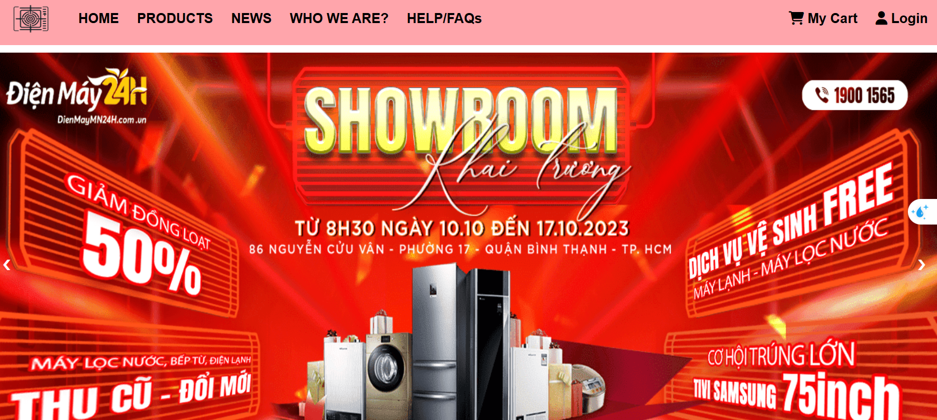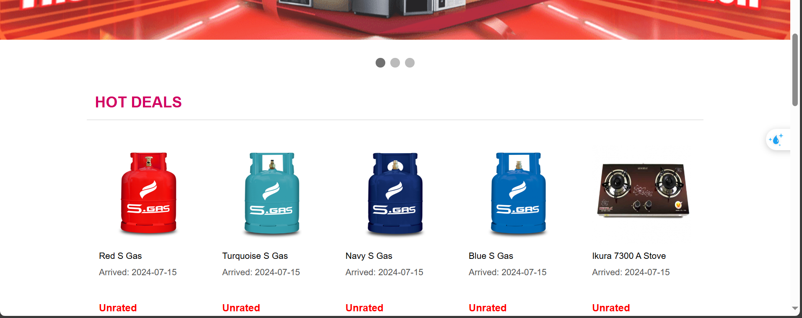

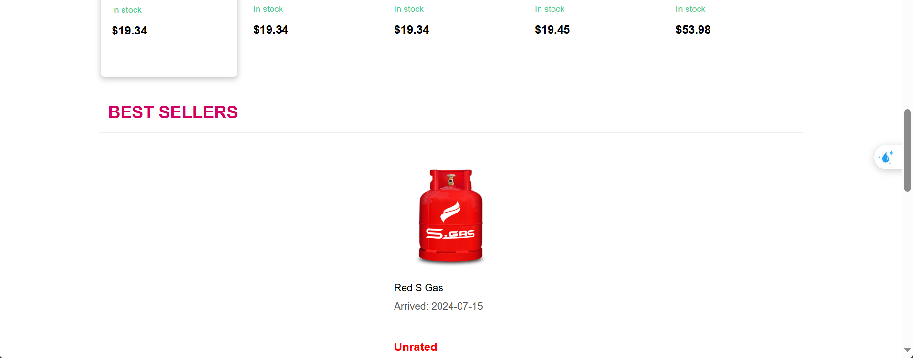

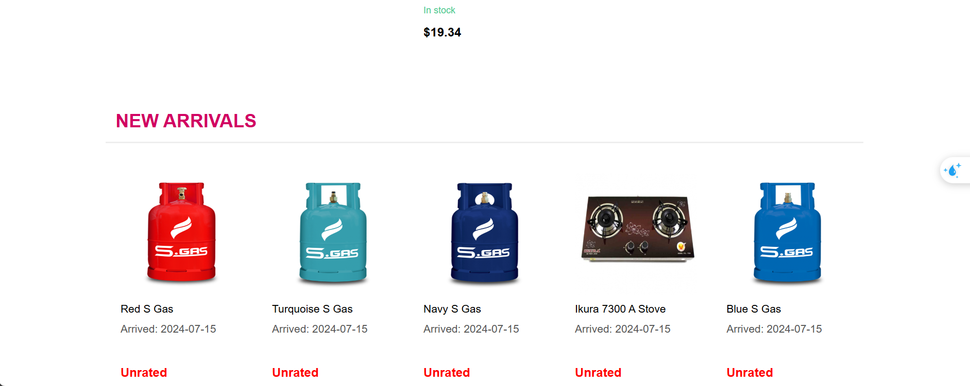

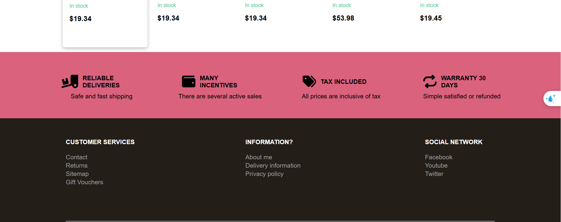

| **Field Name** | **Field Type** | **Description** |
| --- | --- | --- |
| Banner | Image | Show the banner |
| Hot deals | Text+Image | Display list hot product |
| Best seller | Text+Image | Display list best seller product |
| New arrival | Text+Image | Display list new arrival product |
| Products | Dropdown | Allow user choose product category to see |
| News | Hyperlink | System redirect user to news list |
| Who are we | Hyperlink | System redirect user page introduction about Blazo shop |
| Faq/help | Hyperlink | System redirect user to page answer common question about using page |
| My cart | Hyperlink | System redirect user to cart if they login |
| Login | Hyperlink | System redirect user to login screen |
| Footer | Hyperlink | System redirect user to corresponding page |

##### 

##### **Database Access**

| **Table** | **CRUD** | **Description** |
| --- | --- | --- |
| Product | R | Show list of Product Hot deals, Best Sellers, New Arrivals |
| Category | R | Show list of navigation |
| News | R | Show top 3 blog latest, Show list of Banner |

##### **SQL Commands:**

* List Hot Deals: SELECT TOP 5 p.product_id, p.title, p.price, COALESCE((p.price - (p.price * d.discount_value)), p.price) AS discounted_price FROM product p LEFT JOIN discount d ON p.discount_id = d.discount_id ORDER BY discounted_price ASC
* List Best Seller: SELECT TOP 5 p.product_id, p.category_id, p.discount_id, p.reviews_rate, p.title, p.price, p.stock, p.created_date, COUNT(oi.product_id) AS total_sold FROM product p JOIN order_item oi ON p.product_id = oi.product_id GROUP BY p.product_id, p.category_id, p.discount_id, p.title, p.reviews_rate, p.price, p.stock, p.created_date ORDER BY total_sold DESC
* List New Arrivals: SELECT TOP 5 * FROM Products ORDER BY created_at DESC
* List Banner: SELECT * FROM Banner WHERE status = 1 ORDER BY created_at DESC

### 1.2 News List

##### **UI Design**

### 

### 

### 

| **Field Name** | **Field Type** | **Description** |
| --- | --- | --- |
| Title,Picture | Link | By clicking in title,or picture user can see News detail |
| Category | Option | User can choose News by category News |
| News per page | Text | User can choose news per page |
| Search news | Text | User can find news by name |

##### **Database Access**

| **Table** | **CRUD** | **Description** |
| --- | --- | --- |
| News | R | List News include title, image, List News by hot News |

##### **SQL Commands**

List News: SELECT * FROM News ORDER BY updated_date DESC

Search by Blog Categories: SELECT * FROM News where bc_id = ?

Search by Title Blog: SELECT * FROM News where title like ?

### 1.3 News Details

##### **UI Design**

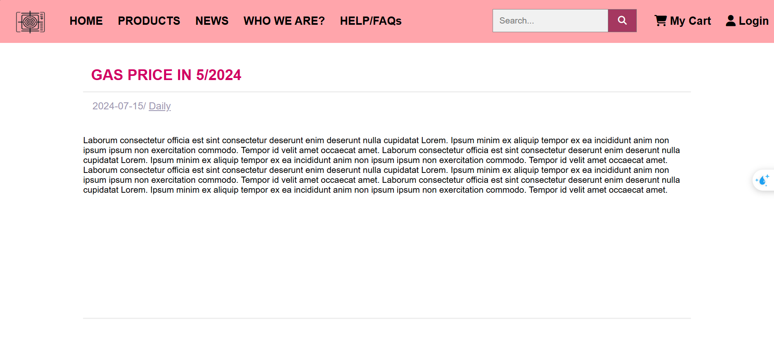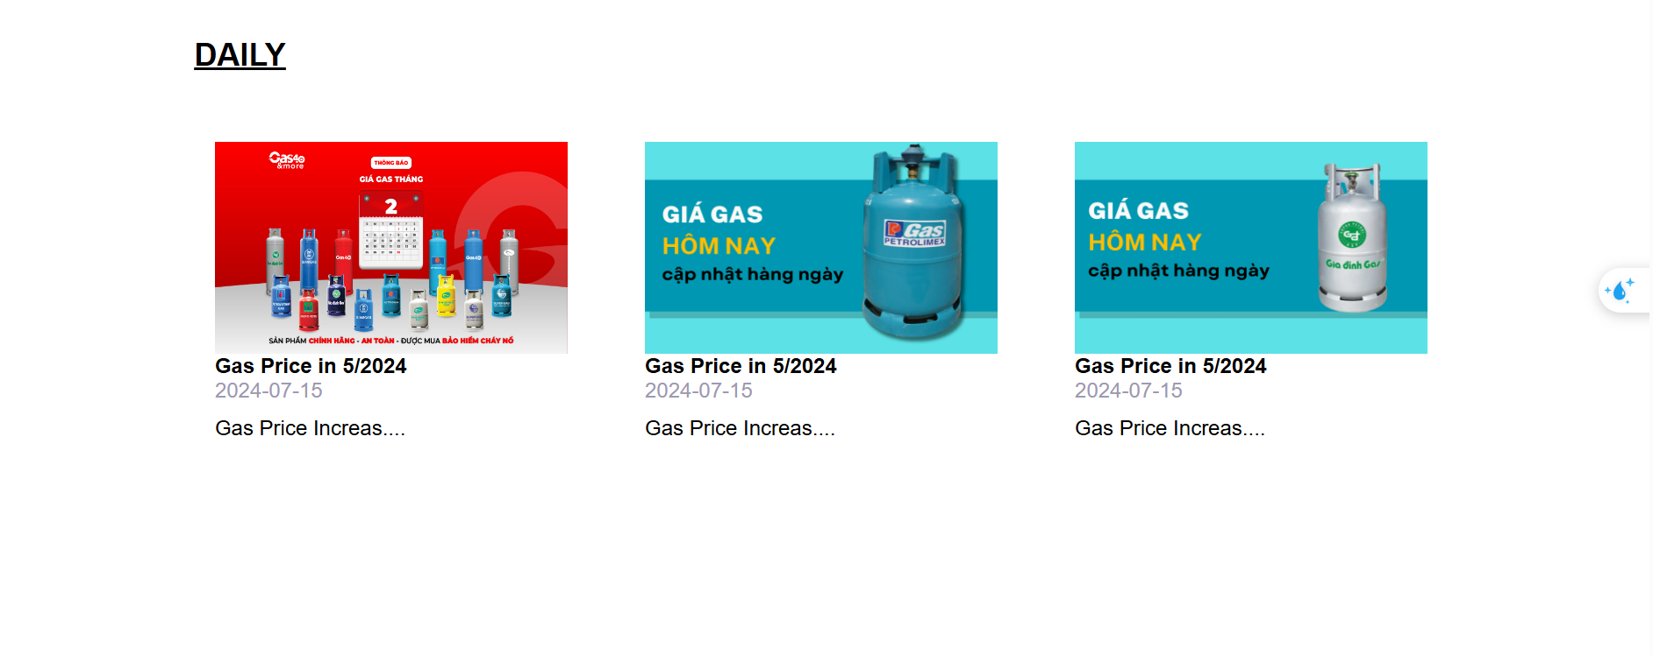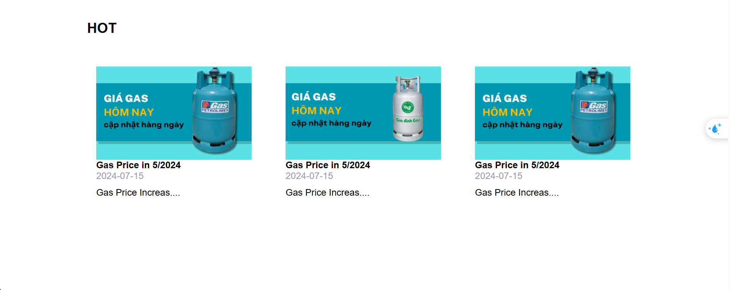

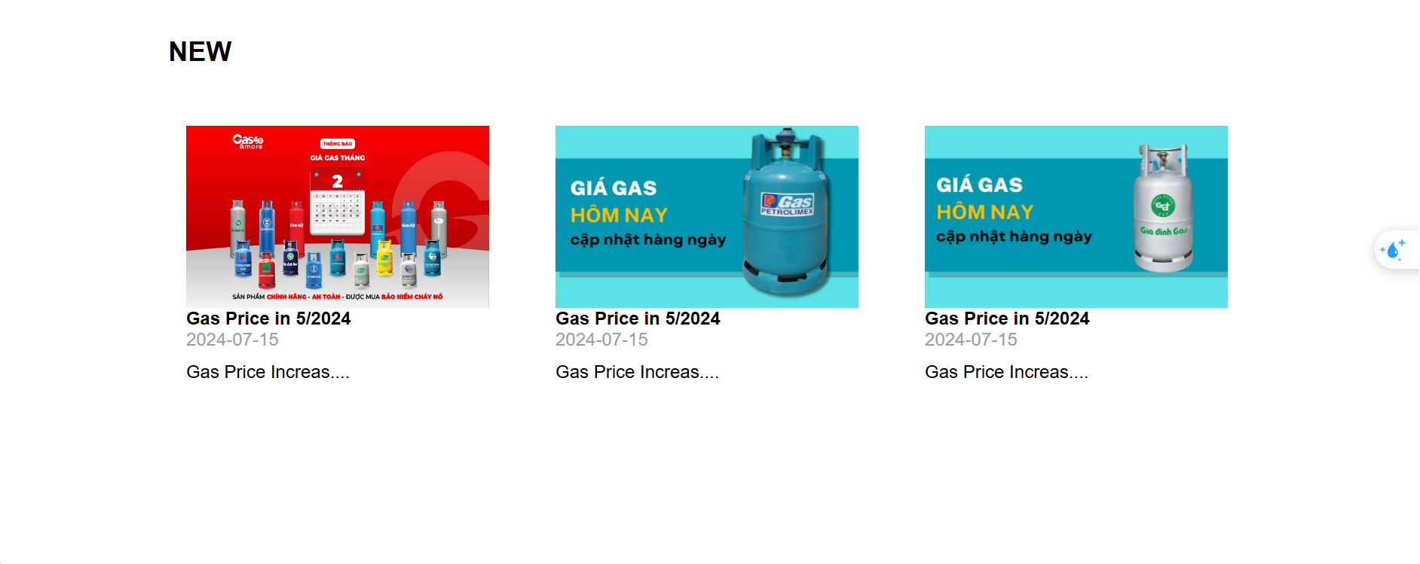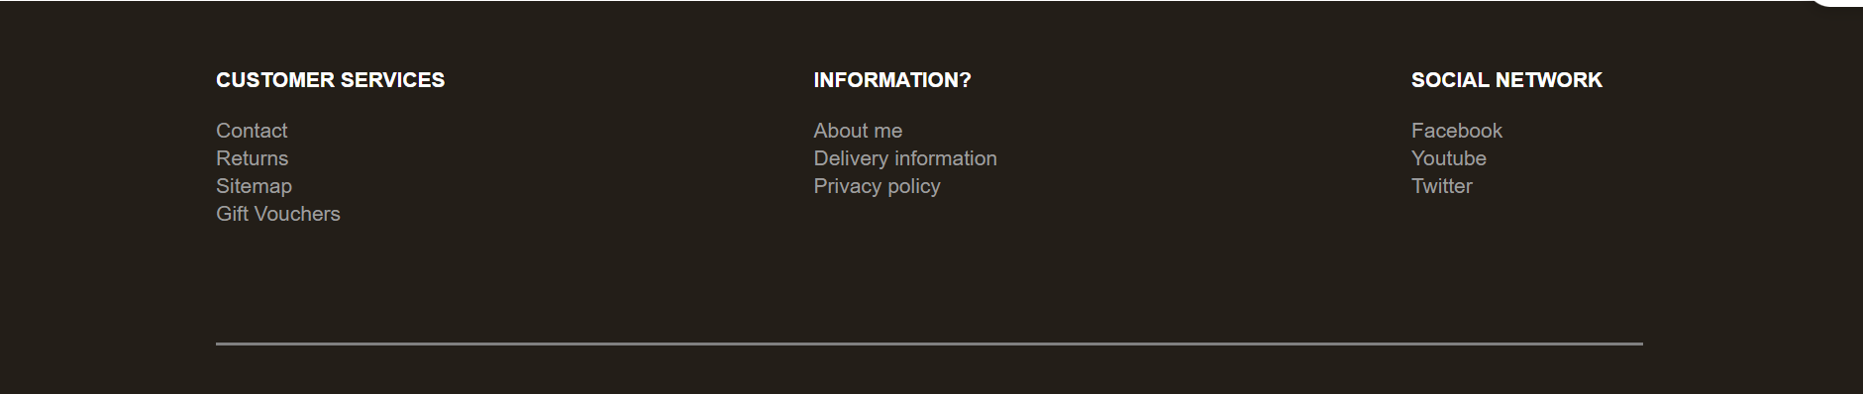

| **Field Name** | **Field Type** | **Description** |
| --- | --- | --- |
| Title | text | This show title of the news |
| Categories | hyperkink | click on categories can go to news list by that category |
| createat | text | this show publication date of the news |
| Content | hypertext | this show content of the news |
| Related news | link | Show list related news |
| Hot news | link | Show list hot news |
| New news | link | Show list new news |

##### **Database Access**

| **Table** | **CRUD** | **Description** |
| --- | --- | --- |
| News | R | Query list all the categories news. |

##### **SQL Commands**

News Details: SELECT * FROM News where post_id = ?

Search by Blog Categories: SELECT * FROM News where bc_id = ?

### 1.4 Product List

##### **UI Design**

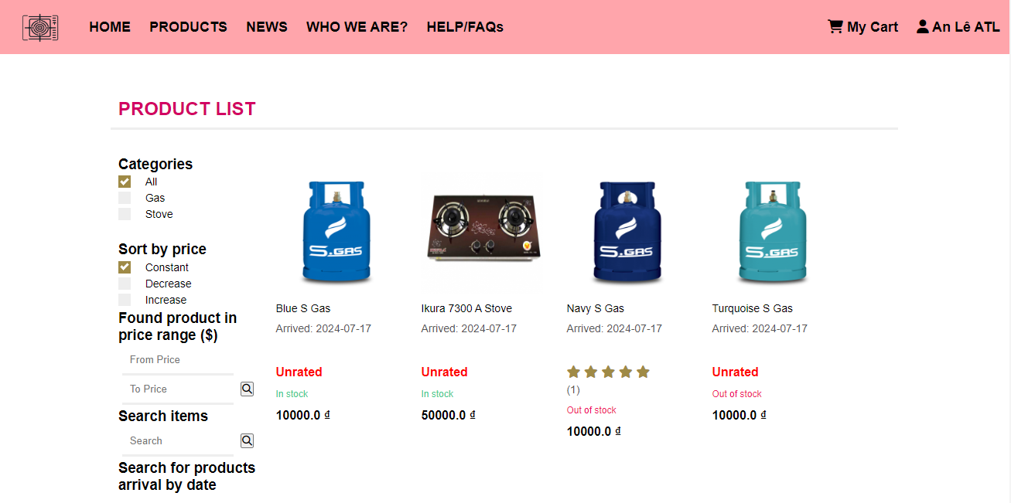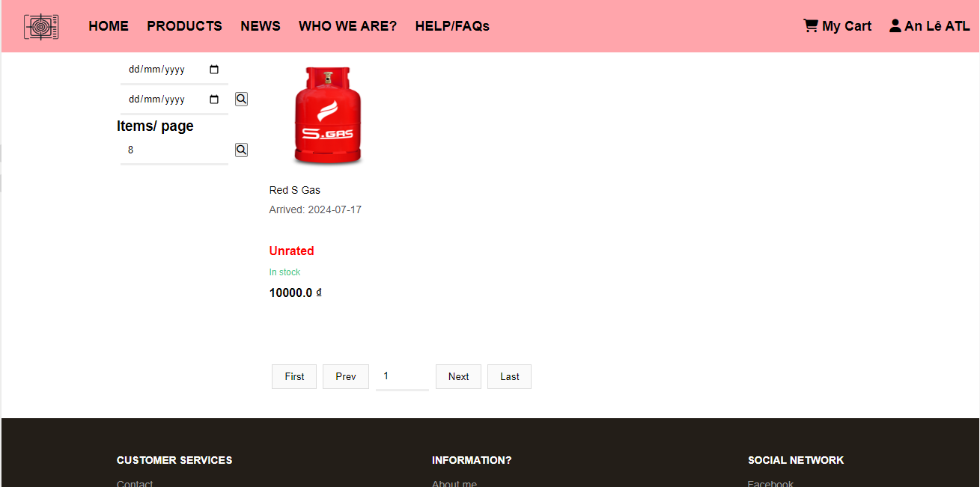

| **Field Name** | **Field Type** | **Description** |
| --- | --- | --- |
| Filter by categories | DROPDOWN | Allows the user to filter products by selecting a specific category. This field provides a list of available product categories for filtering. |
| Filter by brand | DROPDOWN | Allows the user to filter products by selecting a specific brand. This field provides a list of available product brand for filtering. |
| Filter by price | DROPDOWN | Allows user can filter product by price |
| Sort by Price | DROPDOWN | Allows the user to sort products by Price |
| Product List | List/Grid | Displays a paginated list of products, sorted by the updated date |
| Product Details Page | Page | When a user clicks on a product, they are redirected to the product details page, where they can view more information about the selected product. |
| Product Search Box | Text (String) and Button | Allows users to search for products by entering keywords in the search box and clicking the "Search" button. |

##### **Database Access**

| **Table** | **CRUD** | **Description** |
| --- | --- | --- |
| Products | R | Retrieve a list of products paginated and sorted by the updated date. Display product thumbnails, titles, original prices, and sale prices. |

**SQL Commands**

List categories: SELECT * FROM category WHERE role = 0

List all products : SELECT * FROM product

List by created by: SELECT *

FROM [dbo].[product]

WHERE [category_id] = ?

AND [created_by] IN (SELECT [manager_id] FROM [manager] WHERE [full_name] LIKE ?)

List by title: SELECT * FROM [dbo].[product] WHERE [title] LIKE ?

List by price :SELECT * FROM [dbo].[product] WHERE [price] >= ? AND [price] <= ?

List by arrived date: SELECT * FROM [dbo].[product] WHERE [created_date] >= ? AND [created_date] <= ?

### 1.5 Product Details

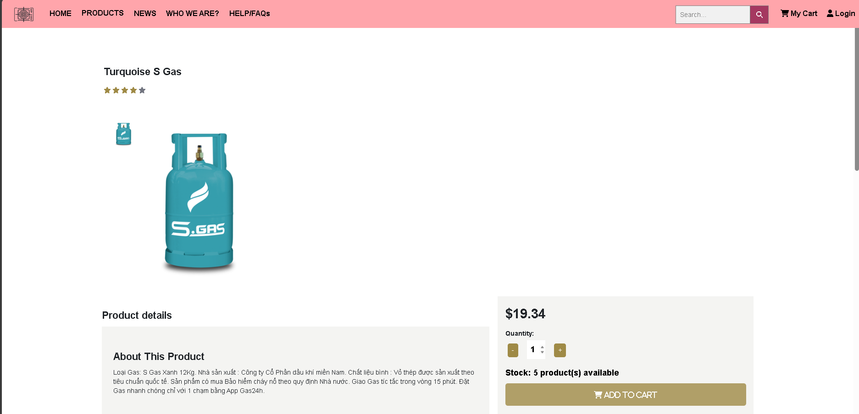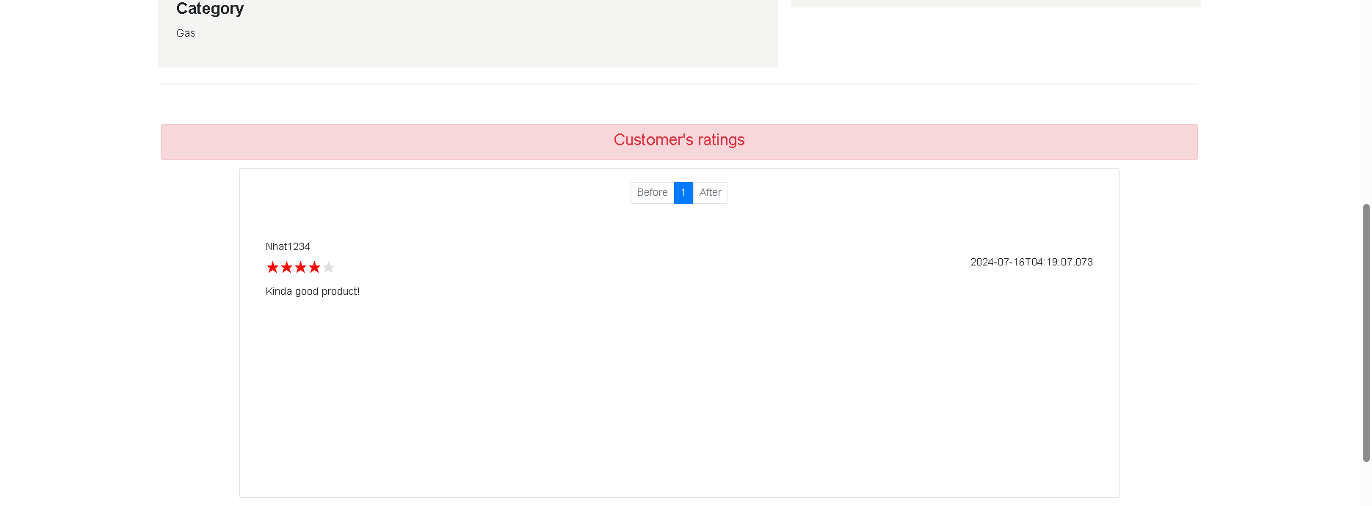

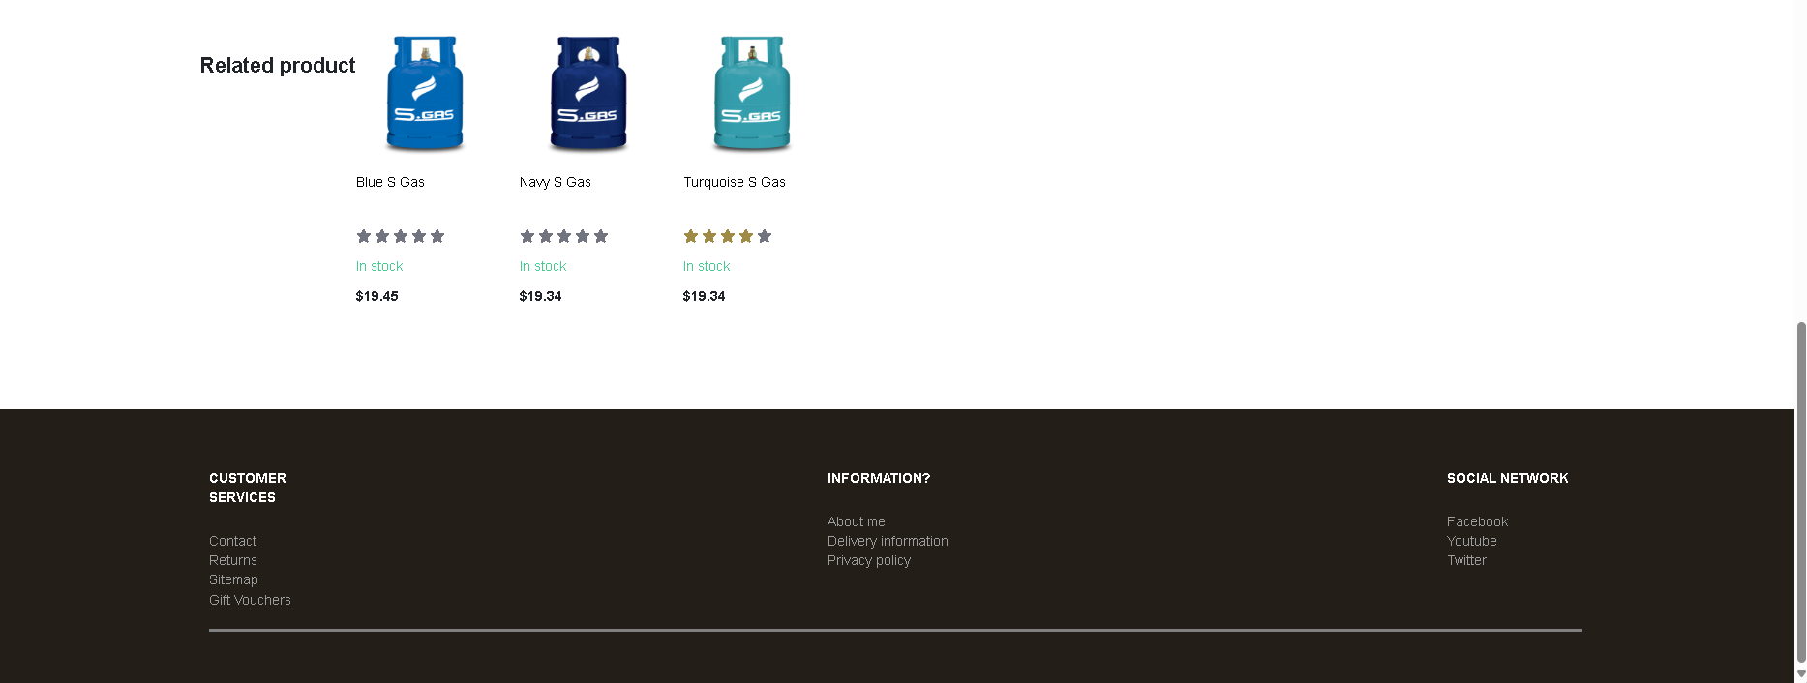

##### **UI Design**

| **Field Name** | **Field Type** | **Description** |
| --- | --- | --- |
| Product ID | Text | Show name of product |
| Price | Text | Show price of product |
| Description | Text | Show description of product |
| Category | Select box | Show all category and user can choose category for product |
| Search | text | search product |
| Image | Choose file | Allow user upload image ,allow user edit |

##### **Database Access**

##### 

| **Table** | **CRUD** | **Description** |
| --- | --- | --- |
| Products | R | Query list the Product from the database |
| ProductDetail | R | Show ProductDetail |
| Categories | R | Show Category of product |

##### **SQL Commands**

String sql = "SELECT *\n"

+ "FROM Products p\n"

+ "JOIN ProductDetail pd ON p.pid = pd.pid\n"

+ "WHERE p.pid = ?";

String sql = " SELECT TOP 4 *\n"

+ "FROM Products\n"

+ "WHERE brandid = (SELECT brandid FROM Products WHERE pid = ?)\n"

+ "ORDER BY price DESC;";

select * from Categories

### 1.6 Contact Page

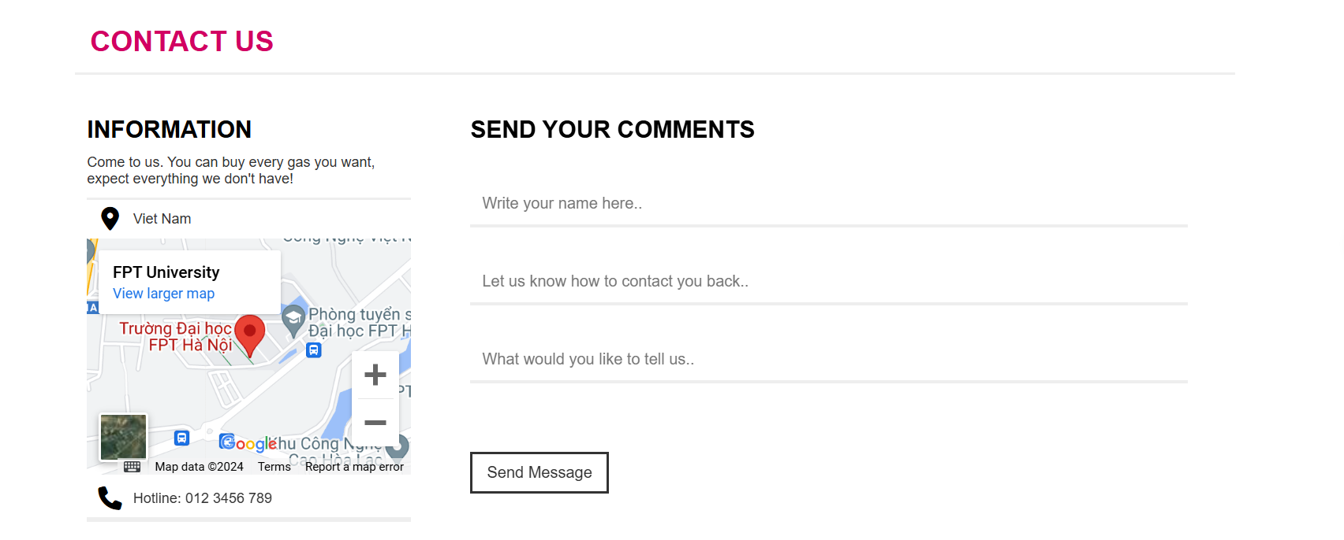

##### **UI Design**

| **Field Name** | **Field Type** | **Description** |
| --- | --- | --- |
| Information | Text + Img + Link | Show basic information of store |
| Send your comments | Form | User can sent comment via gmail |

##### **Database Access**

None

##### **SQL Commands**

None

### 1.7 FAQ Page

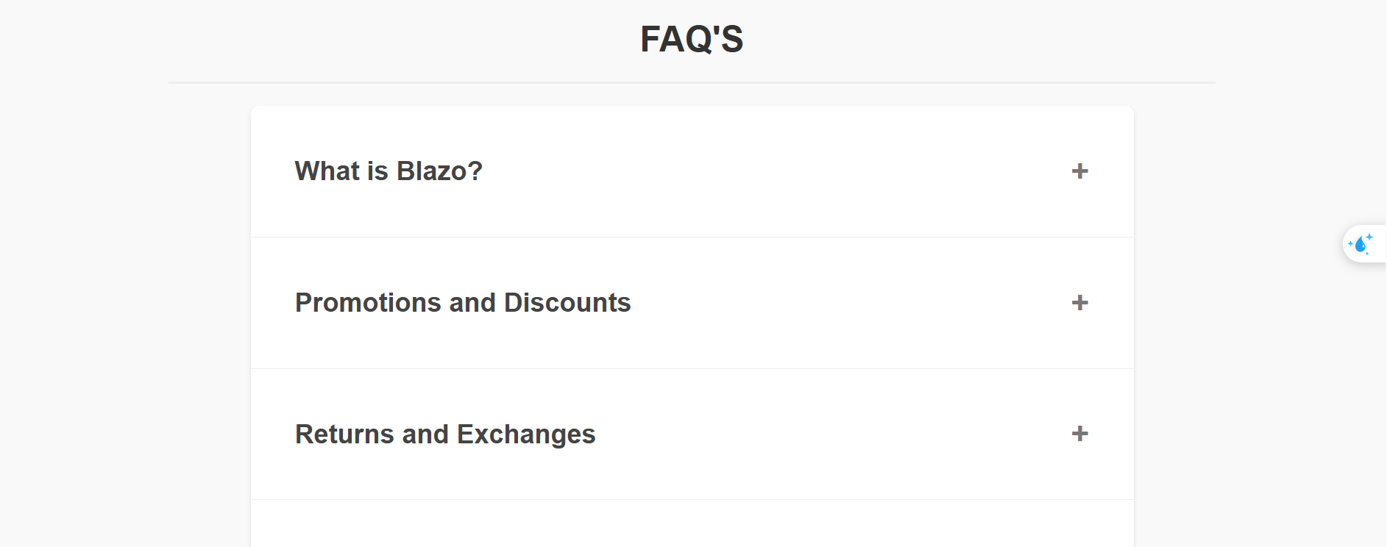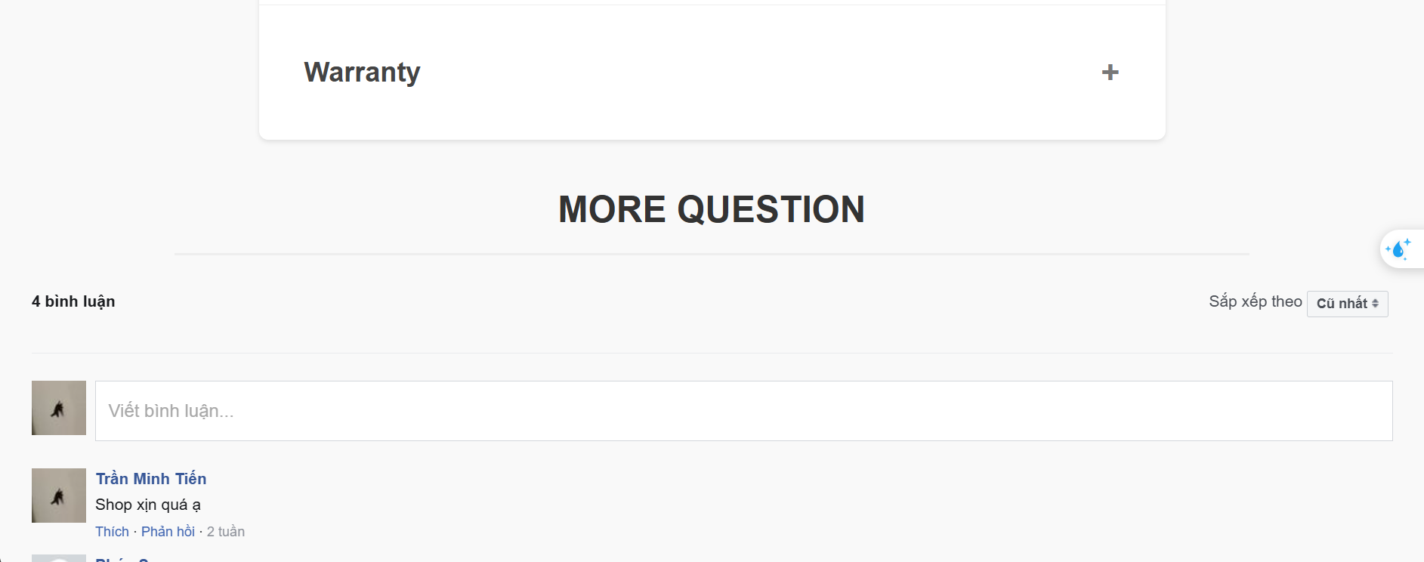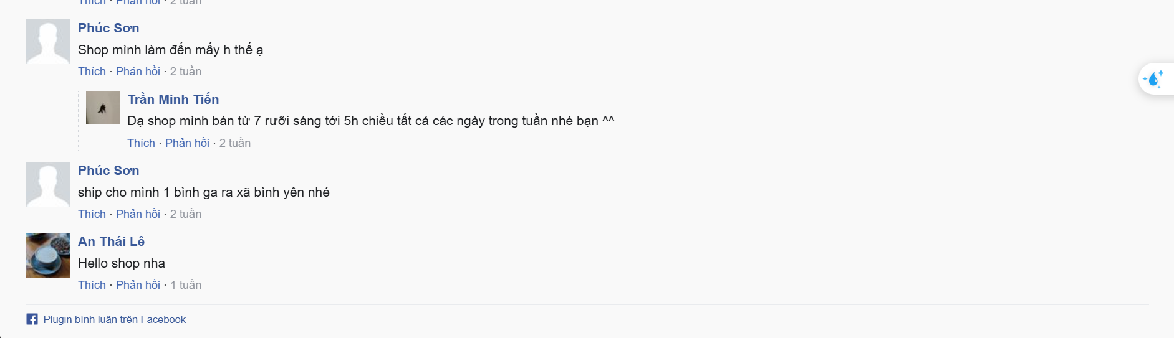

##### **UI Design**

| **Field Name** | **Field Type** | **Description** |
| --- | --- | --- |
| FAQ | Text | Show basic question of store |
| More question | Integrate API | Guest comment directly |

##### **Database Access**

None

##### **SQL Commands**

None

### 1.8. Login

##### **UI Design**

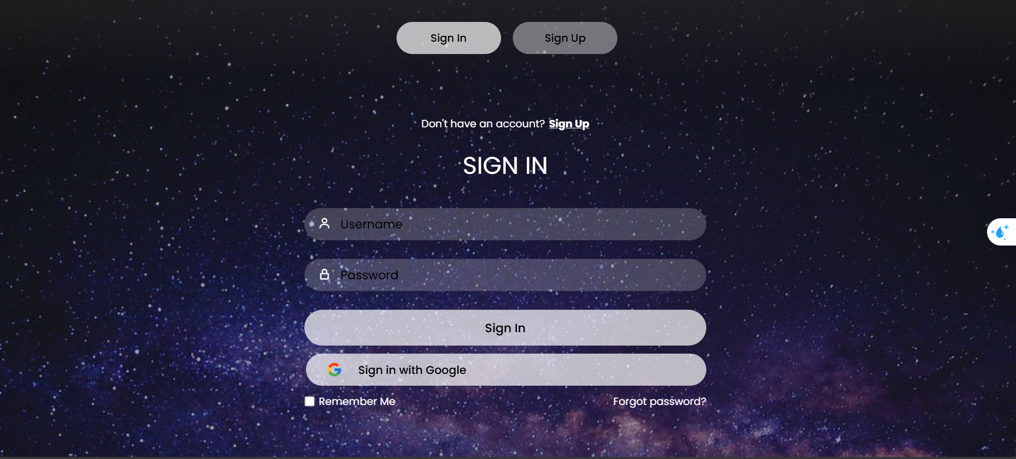

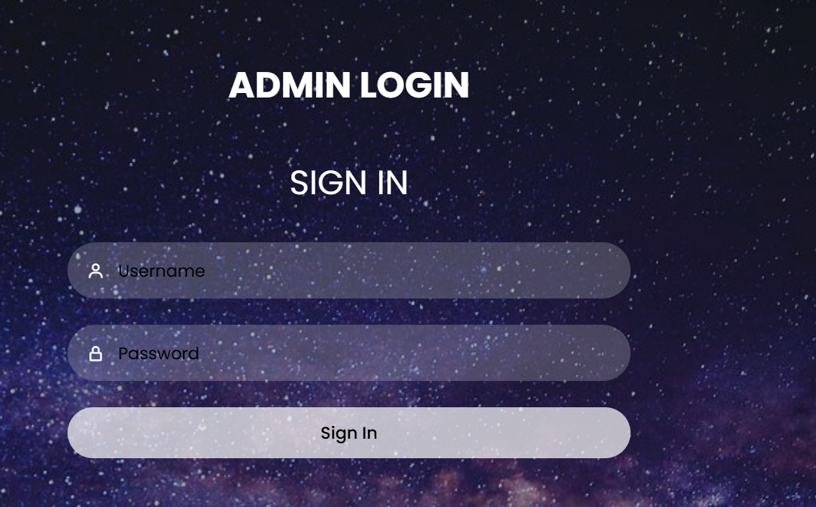

| **Field Name** | **Field Type** | **Description** |
| --- | --- | --- |
| Username | Text Box | This is for user to input valid username for logging in |
| Password | Password Box | This is for user to input password for logging in |
| Login | Button | User clicks to authenticate him/herself into the system with provided email & password |
| Sign in with google | HyperLink | Accept user sign in with google account |
| Create an account | Hyperlink | User clicks to redirect to the User Register page for registering new user account to access the system |
| Reset Password | Hyperlink | User clicks to redirect to the Password Reset page for resetting his/her forgot password |
| Remember me | Button | Save user information when logging in |

##### **Database Access**

| **Table** | **CRUD** | **Description** |
| --- | --- | --- |
| Customer | R | Show information of Account |

##### **SQL Commands**

Get Account : select * from Customer where email=? and password=?

## **2. Guest Feature**

### 2.1 User Register

##### **UI Design**

##### 

#### 

| **Field Name** | **Field Type** | **Description** |
| --- | --- | --- |
| Username | Text box | This is for user to input valid username for register |
| Gmail | Text box | This is for user to input valid gmail for register |
| Password | Password box | This is for user to input valid password for register |
| Repeat your password | Password box | This is for user to input re-password to validate password for register |
| First name & Last name | Text box | This is for user to input name |
| Register | button | User clicks to authenticate him/herself into the system with provided email, phone number, password, re-password to register a new account. |

##### **Database Access**

| **Table** | **CRUD** | **Description** |
| --- | --- | --- |
| Customer | CR | - Verify Email and Password information  - Query Insert a new account into the database if every information is valid. |

##### **SQL Commands**

select * from Customer where email=?

select * from Customer where username=?

INSERT INTO Customer (email, password, username,role_id,created_at, status_id,phone_number, gender, address) VALUES (?, ?, ?, ?, ?, ?, ?, ?, ?)

### 2.2 Reset password

#### *UI Design*

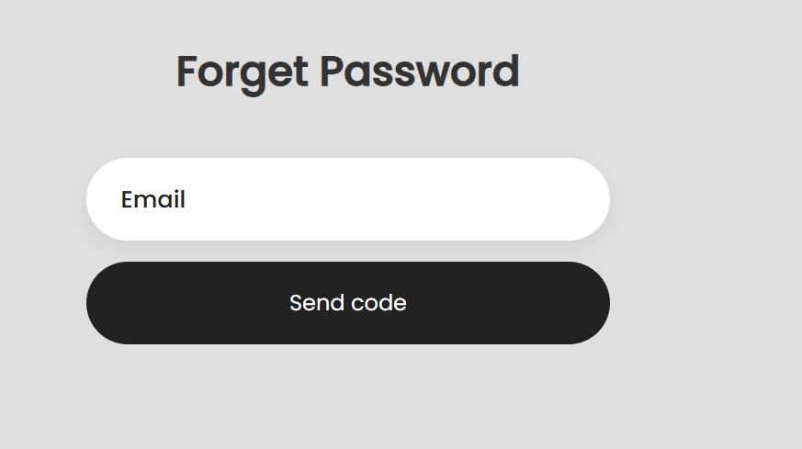

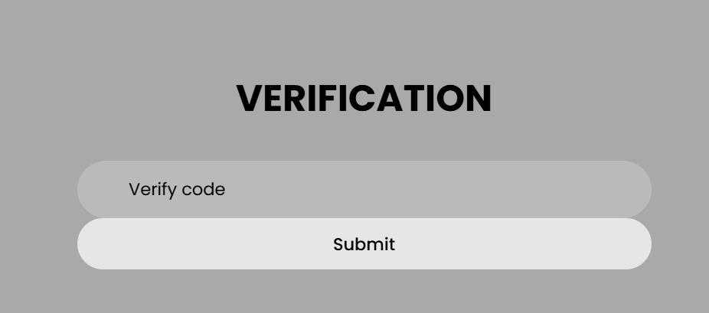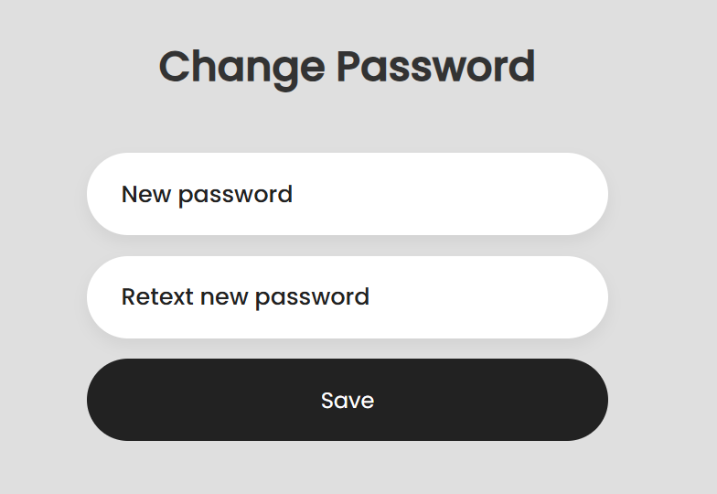

| **Field Name** | **Field Type** | **Description** |
| --- | --- | --- |
| your Email | Email box | Enter your Email. |
| Verify code | Text box | Enter verify code |
| new password | Password box | Enter a new password for your account. |
| repeat your new password | Password box | Re-enter the new password to confirm. |

#### *Database Access*

| **Table** | **CRUD** | **Description** |
| --- | --- | --- |
| Account | CR | - Check and verify the provided email .  - Query: Insert a new password into the database if the information is valid. |

#### *SQL Commands*

select * from Accounts where email=?

UPDATE Accounts SET password = ? WHERE email = ?

### 2.3 Profile

##### **UI Design**

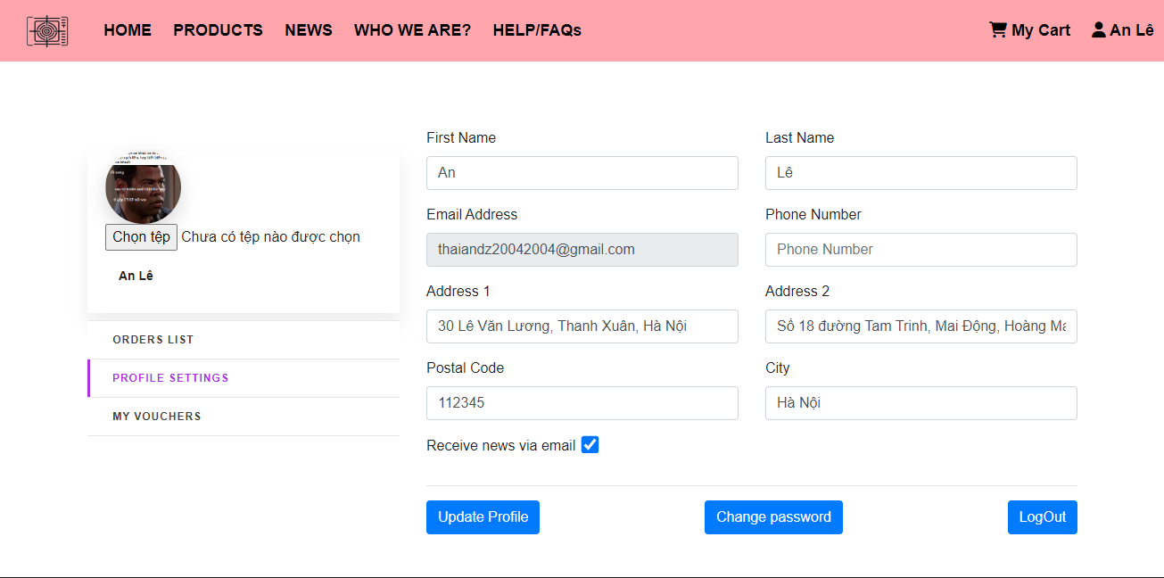

| **Field Name** | **Field Type** | **Description** |
| --- | --- | --- |
| First Name & Last Name | Text box | Show name |
| Phone | Text box | Show phone number |
| Email | read only | Show the email of user |
| Address 1 & Address 2 | Text box | Show address |
| City | Text box | Show city |
| Postal code | Text box | Show postal code |
| Save | button | System save the value user input |

##### **Database Access**

| **Table** | **CRUD** | **Description** |
| --- | --- | --- |
| Customer | R | Show information of Customer |

##### **SQL Commands**

String sql = "select * from Customer where email=?";

String sql = " update Customer\n"

+ " set username= ?,\n"

+ " phone_number = ?,\n"

+ " [address] = ?\n"

+ " \n"

+ " where email=?";

### 

### 2.4 Change Password

#### *UI Design*

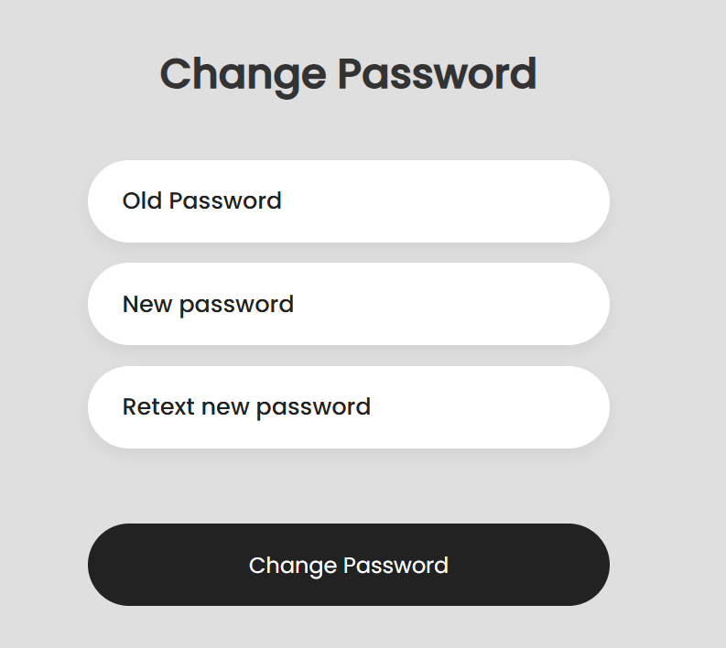

| **Field Name** | **Field Type** | **Description** |
| --- | --- | --- |
| Old Password | password box | Enter your old pass |
| new password | Password box | Enter new password |
| repeat new password | Password box | Re-enter the new password to confirm. |
| Change password | submit | save change |

#### *Database Access*

| **Table** | **CRUD** | **Description** |
| --- | --- | --- |
| Customer | CR | - Check and verify the provided email and password.  - Query: Insert a new password into the database if the information is valid. |

#### *SQL Commands*

UPDATE Customer SET password = ? WHERE email = ?;

#### 

### 2.5 Cart Detail

##### **UI Design**

##### 

| **Field Name** | **Field Type** | **Description** |
| --- | --- | --- |
| Product | List/Grid | Show Product user choose |
| Quantity | Text | The user change quantity of product |
| Name | Text | Show product name |
| Total | Text | Show Total Price |
| Remove | Button | When user click button will remove product to cart |
| Save changes | Button | System save cart for customer |
| Checkout | Hyperlink | System redirect user to provide cart details |

##### **Database Access**

#### 

| **Table** | **CRUD** | **Description** |
| --- | --- | --- |
| product | R | Get product |
| cart | RU | Get the user ‘s cart |
| cart_item | RU | Get the user's shopping cart details |

#### 

#### 

##### **SQL Commands**

SELECT TOP 1 * FROM cart WHERE user_id = ?

INSERT INTO cart (user_id) VALUES (?)

SELECT * FROM cart

UPDATE cart SET user_id = ?, total = ? WHERE cart_id = ?

DELETE FROM cart WHERE cart_id = ?

DELETE FROM cart WHERE user_id = ?

SELECT quantity FROM cart_item WHERE cart_id = ? AND product_id = ?;

UPDATE cart_item SET quantity = ? WHERE cart_id = ? AND product_id = ?;

INSERT INTO cart_item (cart_id, product_id, quantity) VALUES (?, ?, ?);

SELECT * FROM cart_item WHERE item_id = ?;

DELETE FROM cart_item WHERE cart_id = ?;

SELECT * FROM cart_item;

UPDATE cart_item SET cart_id = ?, product_id = ?, quantity = ? WHERE item_id = ?;

UPDATE cart_item SET quantity = ? WHERE item_id = ?;

DELETE FROM cart_item WHERE item_id = ?;

DELETE FROM cart_item WHERE product_id = ?;

SELECT * FROM cart_item WHERE cart_id = ?;

#### 

### 2.6 Checkout

##### **UI Design**

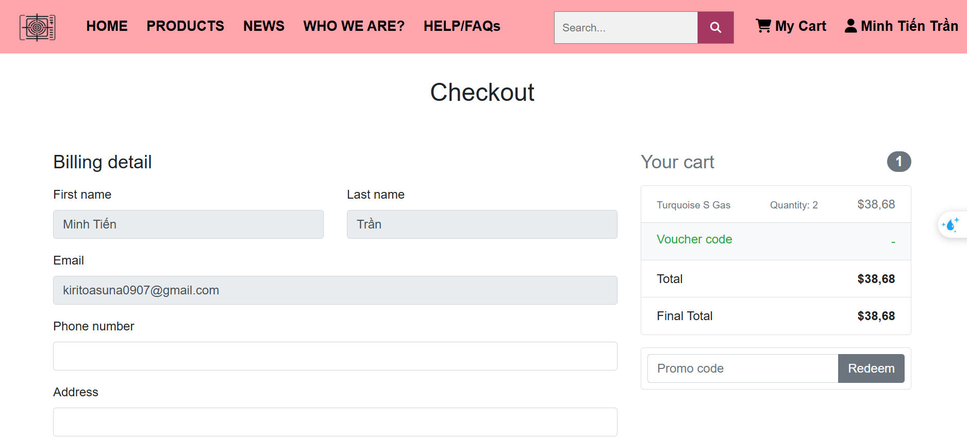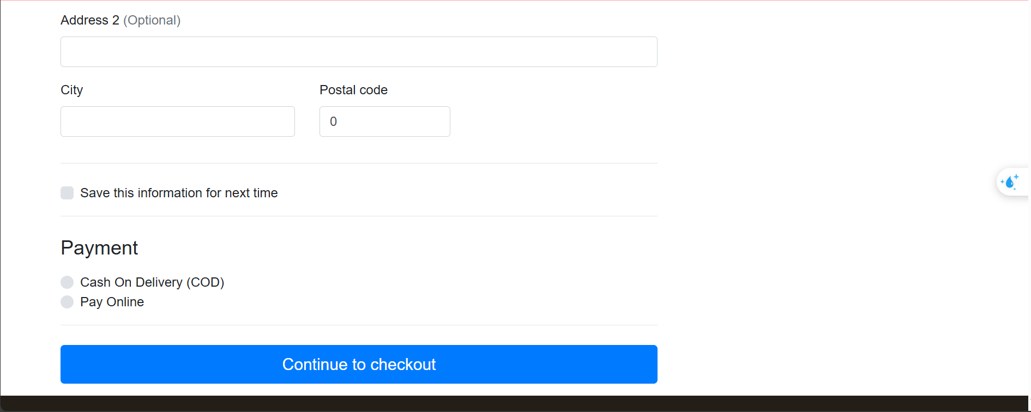

| **Field Name** | **Field Type** | **Description** |
| --- | --- | --- |
| Billing detail | Form+ Text | Show the customer information |
| Save this information for the next time | Checkbox | Check if customer want to save information |
| Your cart | Form | Display total money, select voucher |
| Payment | Option | Customer select payment option |
| Continue to checkout | Button | Customer continue to checkout |

##### **Database Access**

| **Table** | **CRUD** | **Description** |
| --- | --- | --- |
| customer | R | Get information of Customer |
| cart | R | Get the user ‘s cart |
| cart_item | R | Get the user's shopping cart details |

##### **SQL Commands**

select * from Accounts where email=?

select cart_id from Cart where acid=?

select cd.quantity,cd.total_cost,p.* from CartDetails cd join Products p on cd.pid=p.pid \n"

+ "where cd.cart_id=?

select total_order_price from Cart where acid=?

### 2.7 Voucher

##### **UI Design**

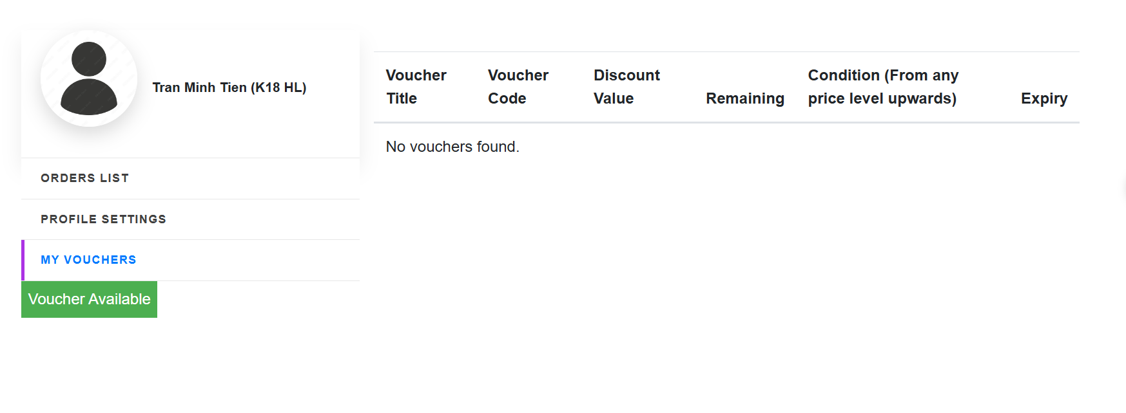

| **Field Name** | **Field Type** | **Description** |
| --- | --- | --- |
| Voucher List | Form | Show the customer’s voucher information |
| Voucher available | Form | Voucher available to save |

##### **Database Access**

| **Table** | **CRUD** | **Description** |
| --- | --- | --- |
| customer | R | Get information of Customer |
| voucher | R | Get the voucher list |
| inventory | R,U | Get the user's voucher |

##### **SQL Commands**

select * from Customer where email=?

select cart_id from Cart where acid=?

select * from Voucher where status=1

## 

## **3.Customer Feature**

### 3.1 My Order

##### **UI Design**

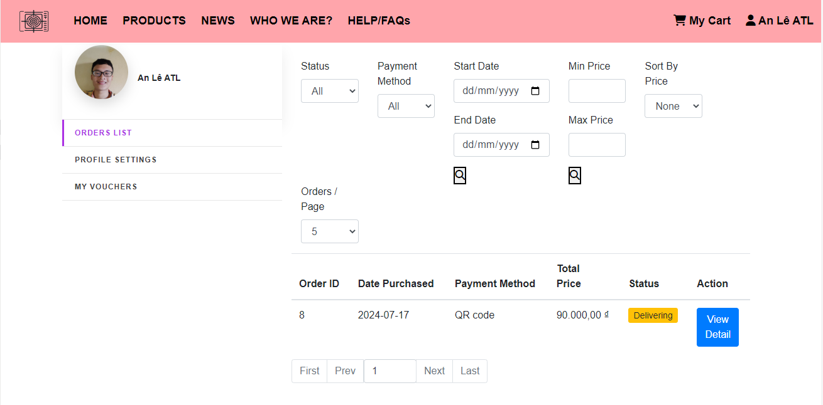

##### **Database Access**

##### 

| **Table** | **CRUD** | **Description** |
| --- | --- | --- |
| orders | R | get data |
| order_iem | R | get data |
| product | R | get data |
| customer | R | Get data |

##### **SQL Commands**

SELECT [order_id],

[customer_id],

[voucher_id],

[total_price],

[order_date],

[payment_method],

[address_line1],

[address_line2],

[postal_code],

[city],

[phone_number],

[created_at],

[status]

FROM [dbo].[order]

WHERE 1 = 1

AND [customer_id] = ?

AND ([payment_method] = ? OR ? = 0) -- This handles the case when paymentMethod is 1 or 2

AND ([status] = ? OR ? = 0) -- This handles the case when status is not 0

AND ([order_date] >= ? OR ? IS NULL)

AND ([order_date] <= ? OR ? IS NULL)

AND ([order_date] BETWEEN ? AND ? OR (? IS NULL OR ? IS NULL))

AND ([total_price] >= ? OR ? IS NULL)

AND ([total_price] <= ? OR ? IS NULL)

AND ([total_price] BETWEEN ? AND ? OR (? IS NULL OR ? IS NULL))

ORDER BY CASE WHEN ? = 1 THEN [total_price] END DESC,

CASE WHEN ? = 2 THEN [total_price] END ASC;

### 3.2 Order Information

##### **UI Design**

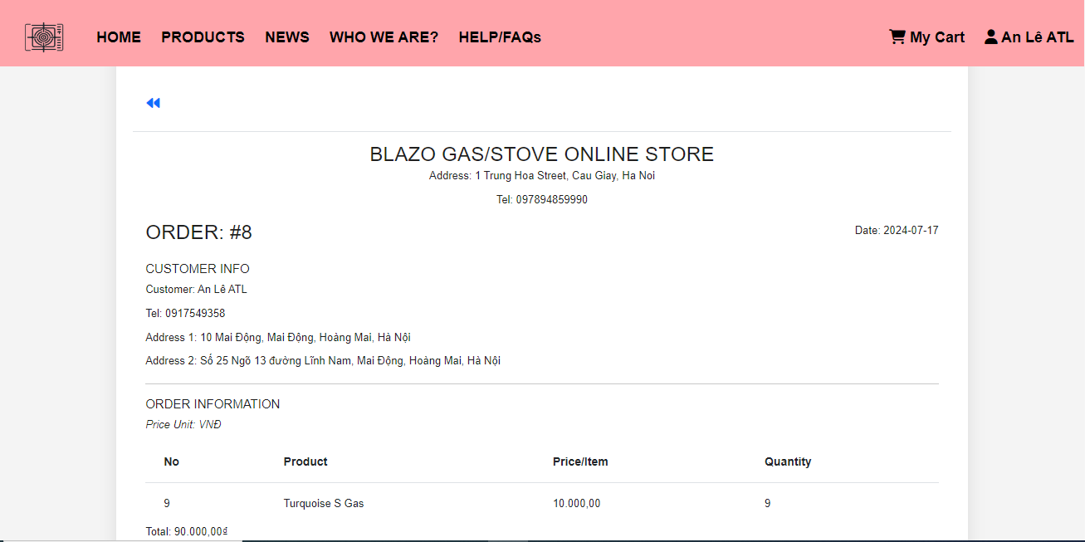

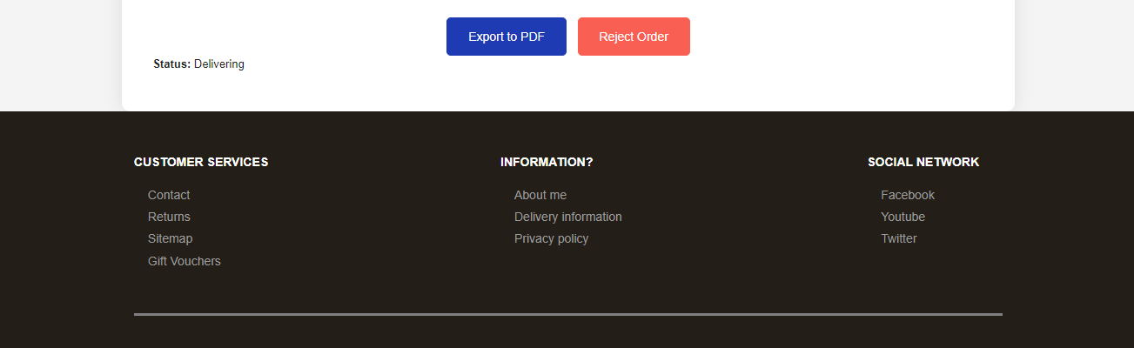

| **Field Name** | **Field Type** | **Description** |
| --- | --- | --- |
| Order date, customer,phone, address, status,quantity, price ,total price,email | Text | Show details |
| Export to PDF Order | Submit | System export order detail of customer to pdf file |
| Reject Order | button | System reject order of customer |

##### **Database Access**

##### 

| **Table** | **CRUD** | **Description** |
| --- | --- | --- |
| order | RU | Get data |
| order_item | R | get data |
| product | R | get data |

##### **SQL Commands**

SELECT * FROM [order] WHERE order_id=?

SELECT order_item_id FROM order_item WHERE order_id = ?

UPDATE [dbo].[order]

SET [status] = ?

WHERE order_id = ?

SELECT [status] FROM [order] WHERE order_id = ?

### 3.3 Request Warranty

##### **UI Design**

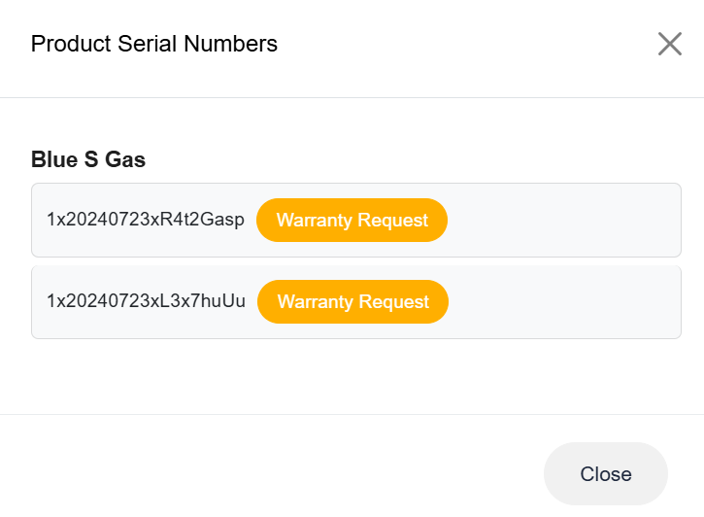

| **Field Name** | **Field Type** | **Description** |
| --- | --- | --- |
| Product name | Text | Show product name |
| List product serial number | Text | Show product serial number |
| Warranty Request | button | System request warranty with corresponding product serial number |

##### **Database Access**

##### 

| **Table** | **CRUD** | **Description** |
| --- | --- | --- |
| order | RU | Get data |
| order_item | R | get data |
| product | R | get data |
| Product serial number | R | Get data |

##### **SQL Commands**

SELECT * FROM [order] WHERE order_id=?

SELECT order_item_id FROM order_item WHERE order_id = ?

SELECT * FROM [productSerialNumber] WHERE productSerialNumber_id=?

## **4. Sale Staff Feature**

### 4.1 Dashboard

##### **UI Design**

### 

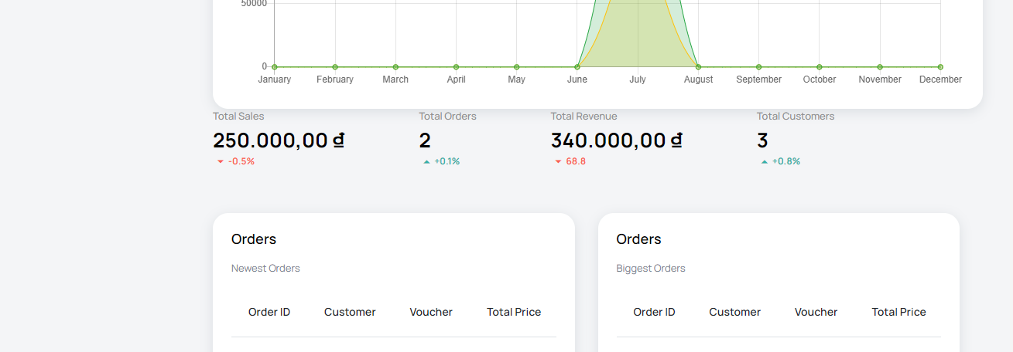

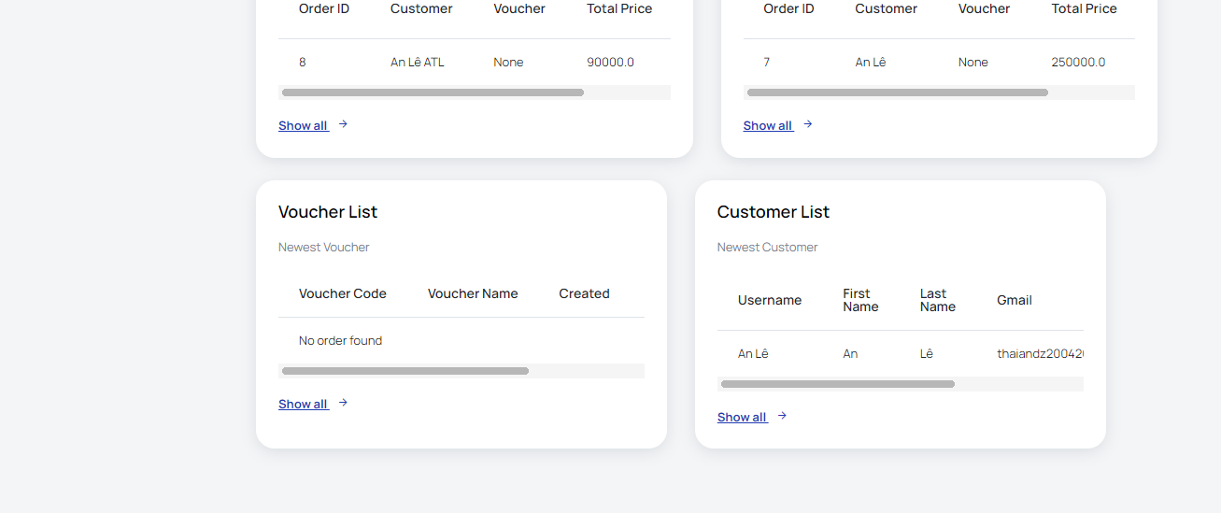

| **Field Name** | **Field Type** | **Description** |
| --- | --- | --- |
| ***Data Fields*** | | |
| Customer | text | This show total view count of all customer |
| Post | text | This show total product sold count of post |
| revenue | text | This show revenue |
| feedback | text | This show total feedback |
| ***Chart Fields*** | | |
| revenue Chart | chart | This chart show revenue count in each year |
| ***Data Table*** | | |
| top 4 best selling | table | This shows information of 4 most sold products providing product id, product name, number of sold and price sold |
| ***Data Action*** | | |
| show data by day for the last 7 days | Button | Change show data for the last 7 days |

##### **Database Access**

| **Table** | **CRUD** | **Description** |
| --- | --- | --- |
| BlogPost | R | Query get total blog |
| .Products | R | Query get total product sold of all products  Query list top 4 most sold products |
| Feedback | R | Query get total feedback |
| Order | R | Query get total money earned of all orders  Query get count money earned per year from all orders to put it in the chart. |
| Accounts | R | Query list some nearest customer accounts created |

##### **SQL Commands**

SELECT * FROM [order] WHERE order_id=?;

SELECT order_item_id FROM order_item WHERE order_id = ?;

UPDATE [dbo].[order] SET [status] = ? WHERE order_id = ?;

SELECT [status] FROM [order] WHERE order_id = ?;

SELECT TOP 1 [order_id], [customer_id], [voucher_id], [total_price], [order_date],

[payment_method], [address_line1], [address_line2], [postal_code], [city], [phone_number],

[created_at], [status] FROM [dbo].[order] ORDER BY order_id DESC;

SELECT TOP 1 [customer_id], [customer_type], [customer_img], [username], [password],

[first_name], [last_name], [phone_number], [gmail], [receive_sms], [receive_email],

[address_line1], [address_line2], [postal_code], [city] FROM [dbo].[customer]

ORDER BY customer_id DESC;

SELECT TOP 1 [voucher_id], [voucher_code], [title], [description], [discount_type],

[discount_value], [condition], [quantity], [created_by], [modified_by], [created_at],

[modified_on], [expiry], [status] FROM [dbo].[voucher] ORDER BY voucher_id DESC;

SELECT [order_id], [customer_id], [voucher_id], [total_price], [order_date],

[payment_method], [address_line1], [address_line2], [postal_code], [city], [phone_number],

[created_at], [status] FROM [dbo].[order] WHERE [total_price] =

(SELECT MAX(total_price) FROM [dbo].[order]) AND [status] = 3;

SELECT COUNT(customer_id) FROM customer;

SELECT COUNT(order_id) FROM [order];

SELECT SUM(total_price) AS total FROM dbo.[order];

SELECT SUM(total_price) AS total FROM dbo.[order] WHERE [status] = 3;

SELECT SUM(total_price) AS total FROM dbo.[order]

WHERE DATEPART(month, [order_date]) = ? AND DATEPART(year, [order_date]) = ?

AND [status] = 2;

SELECT SUM(total_price) AS total FROM dbo.[order]

WHERE DATEPART(month, [order_date]) = ? AND DATEPART(year, [order_date]) = ?

AND [status] = 3;

SELECT SUM(oi.quantity * p.price) AS total_revenue

FROM product p

JOIN category c ON p.category_id = c.category_id

JOIN order_item oi ON p.product_id = oi.product_id

JOIN [order] o ON oi.order_id = o.order_id

WHERE p.category_id = ?

AND o.status IN (2, 3);

SELECT * FROM category WHERE role = 0

### 4.2 Manager Product

##### **UI Design**

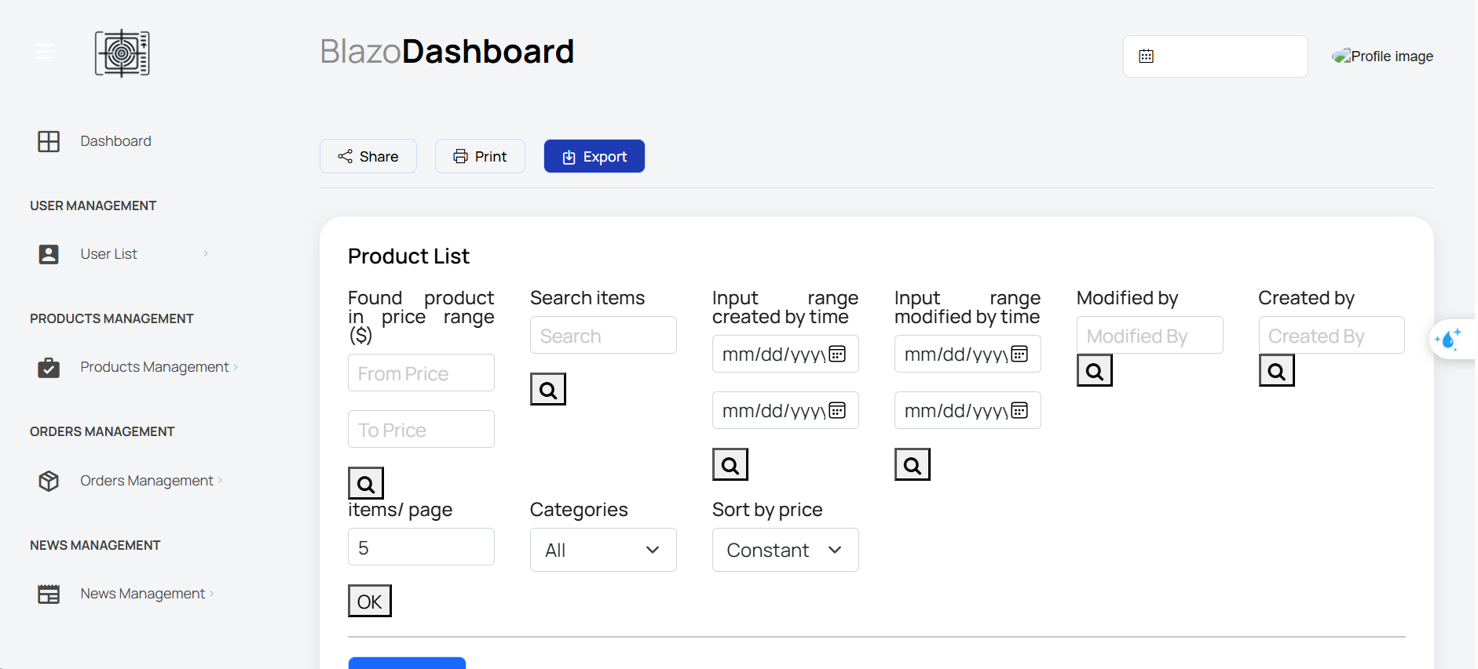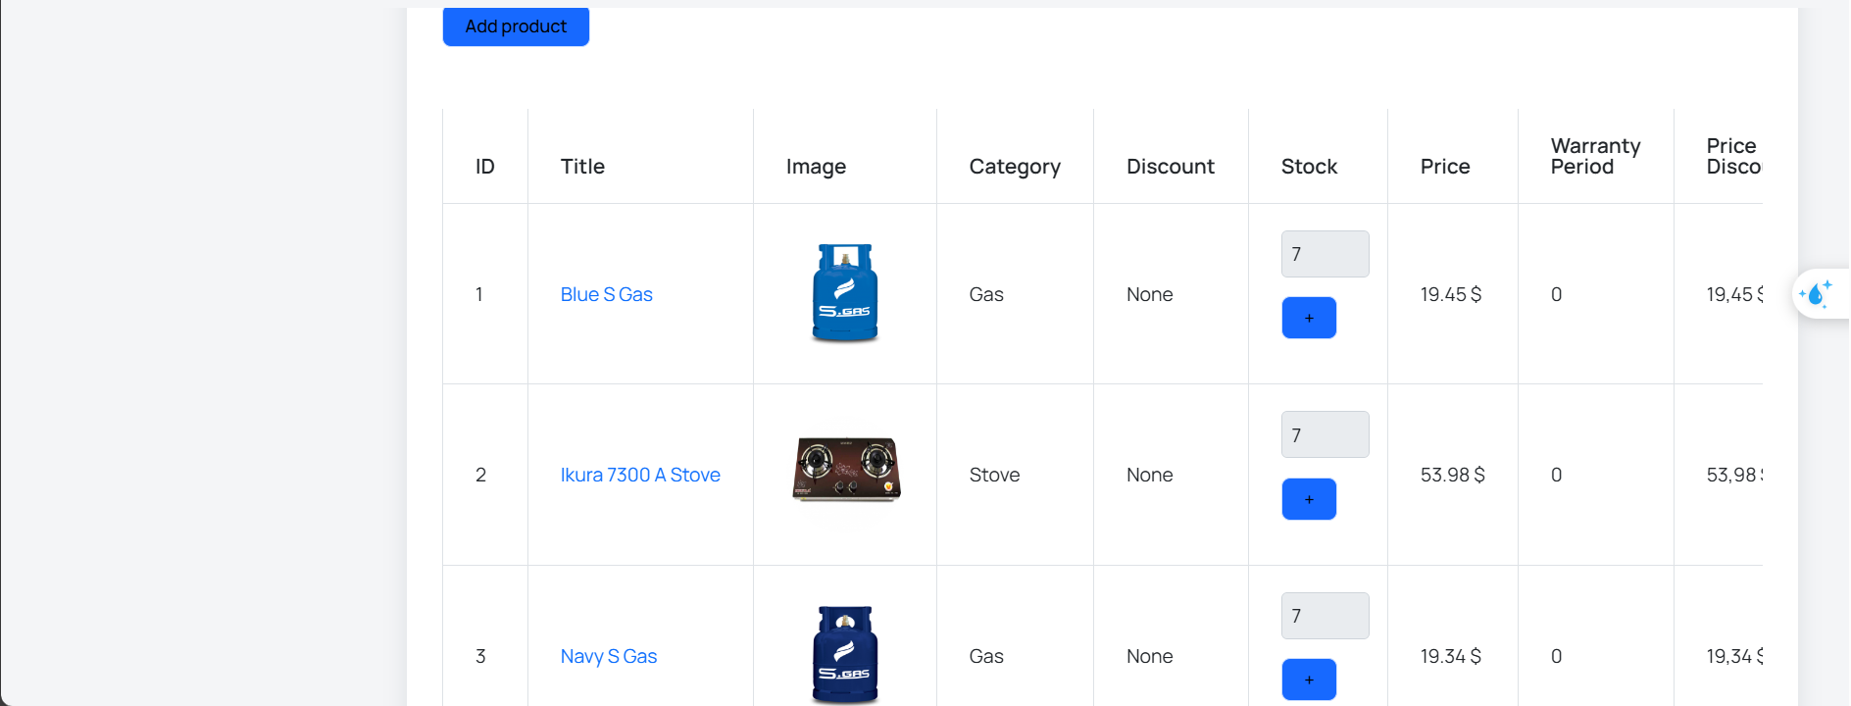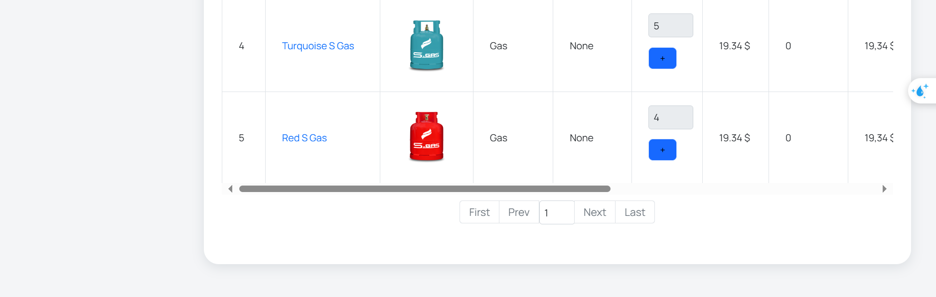

| **Field Name** | **Field Type** | **Description** |
| --- | --- | --- |
| Product List | Form | Display all information and filter of product |
| Add product | Link | Redirect to add product page |
| Edit product | Form | Form allow admin update product information |
| Delete product | Button | Button allow admin delete product |

##### **Database Access**

##### 

| **Table** | **CRUD** | **Description** |
| --- | --- | --- |
| Product | CRUD | Query list the product, Add new product ,Update and Delete Product from the database |
| ProductDetail | CRUD | Query list the product, Add new product ,Update and Delete Product from the database |

##### **SQL Commands**

select count(*) from Products

select pid

,cid

,pname

,rate

,img

,img2

,price

,brandid

,priceSale

,quantity

,isDiscount

,isSoldout

,created_at,

s.status_name

from Products p

Inner join Status s on p.status_id = s.status_id

ORDER BY pid Asc

select * from categories

select * from Status

### 4.3 Manager Product Details

##### **UI Design**

##### 

| Product Detail | Form | Show all information of product detail |
| --- | --- | --- |
| Save | Button | Save all change |

##### **Database Access**

##### 

| **Table** | **CRUD** | **Description** |
| --- | --- | --- |
| Products | CRUD | Query list the Product from the database, Update products |
| ProductDetail | CRUD | Show ProductDetail,Update product detail |
| Product Category | RU | Show Category of product |
| Status | R | Show Status of product |

##### **SQL Commands**

select * from categories

select * from Status

select * from Brand

INSERT INTO Products\n"

+ "VALUES(?,?,?,?,?,?,?,?,?,?,?,?,?);

insert into ProductDetail\n"

+ "values(?,?,?,?,?);

SELECT p.pid

,[cid]

,[pname]

,[rate]

,[img]

,[img2]

,[price]

,[brandid]

,[priceSale]

,[quantity]

,[isDiscount]

,[isSoldout]

,[created_at]

,[status_id]

,[size]

,[color]

,[gender]

,[description]

FROM Products p

JOIN ProductDetail pd ON p.pid = pd.pid

WHERE p.pid = ?

Update Products

set

[cid]=?

,[pname]=?

,[rate]=?

,[img]=?

,[img2]=?

,[price]=?

,[brandid]=?

,[priceSale]=?

,[quantity]=?

,[isDiscount]=?

,[isSoldout]=?

,[created_at]=?

,[status_id]=?

where pid = ?

Update ProductDetail

set size = ?,

color = ?,

gender = ?,

[description] = ?

where pid = ?

select [img] from Products

where pid = ?

delete from ProductDetail where pid = ?

delete from Products

where pid = ?

### 4.4 Manage Order

##### **UI Design**

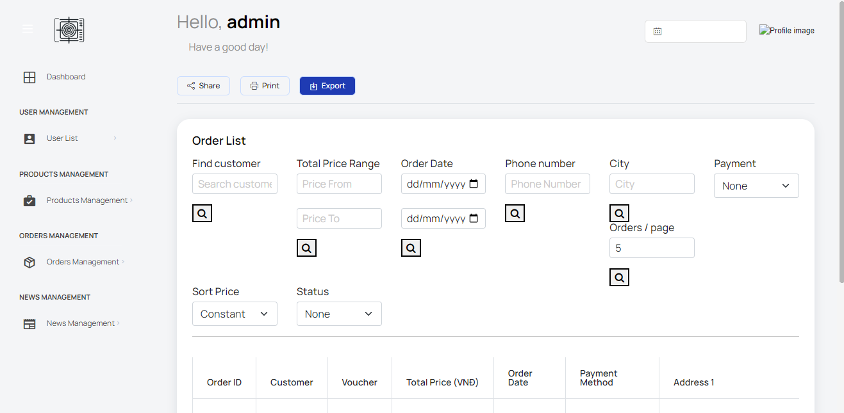

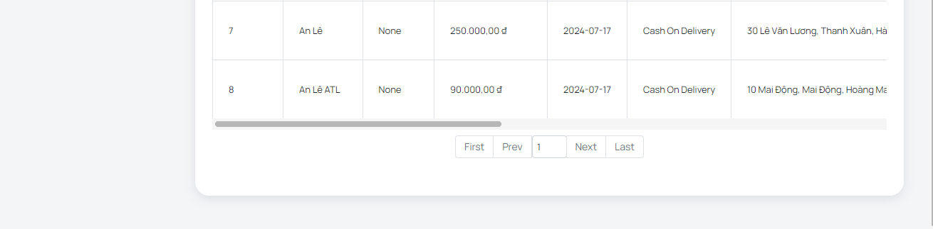

| **Field Name** | **Field Type** | **Description** |
| --- | --- | --- |
| Order List | Form | Display all information and filter of order |
| Add order | Link | Redirect to add order page |
| Edit order | Form | Form allow admin update order information |
| Delete order | Button | Button allow admin delete order |

##### 

##### **Database Access**

##### 

| **Table** | **CRUD** | **Description** |
| --- | --- | --- |
| statusOrder | R | Query list the status order |
| orders | RU | get information from orders |
| orderDetails | R | get information from orderDetail |
| Order | RU | get information and update from order |

##### **SQL Commands**

get order status: select * from statusOrder

get list order:WITH OrderedOrders AS (

SELECT o.oid, ordered_at, TotalAmount, status, pname,o.receiver, img,o.saleId,

ROW_NUMBER() OVER (PARTITION BY o.oid ORDER BY o.ordered_at) AS row_num

FROM orders o

JOIN orderDetails od ON o.oid = od.oid

JOIN Products p ON od.pid = p.pid

where o.saleId= ?

)

SELECT oid, ordered_at, TotalAmount, status, pname, receiver,img,saleId

FROM OrderedOrders

WHERE row_num = 1

ORDER BY ordered_at DESC, status ASC;

change status order:update orders set status=? where oid=?

update quantity product:update Products set quantity +=? where pid=?

### 4.5 Manage Order Details

##### **UI Design**

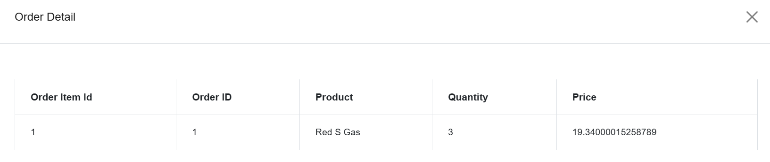

| Order Detail | Form | Show all information of order detail |
| --- | --- | --- |
| Save | Button | Save all change |

##### 

##### **Database Access**

##### 

| **Table** | **CRUD** | **Description** |
| --- | --- | --- |
| orders | R | get information from orders |
| orderDetails | R | get information from orderDetail |
| Order | R | get information and update from order |

##### **SQL Commands**

get Order Detail:select od.oid,od.pid,p.pname,p.img,od.price,od.quantity from orderDetails od

join Products p on od.pid=p.pid where oid=?

get order infomation:select o.*,so.status from orders o join statusOrder so on o.status=so.id where oid=?

### 4.6 Manage Discount

##### **UI Design**

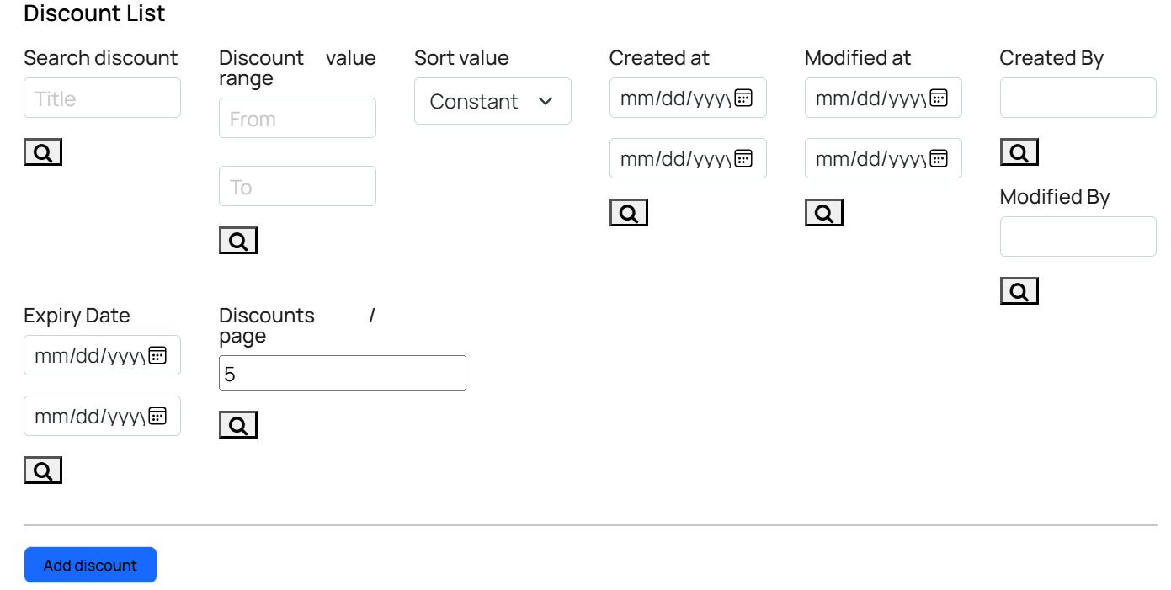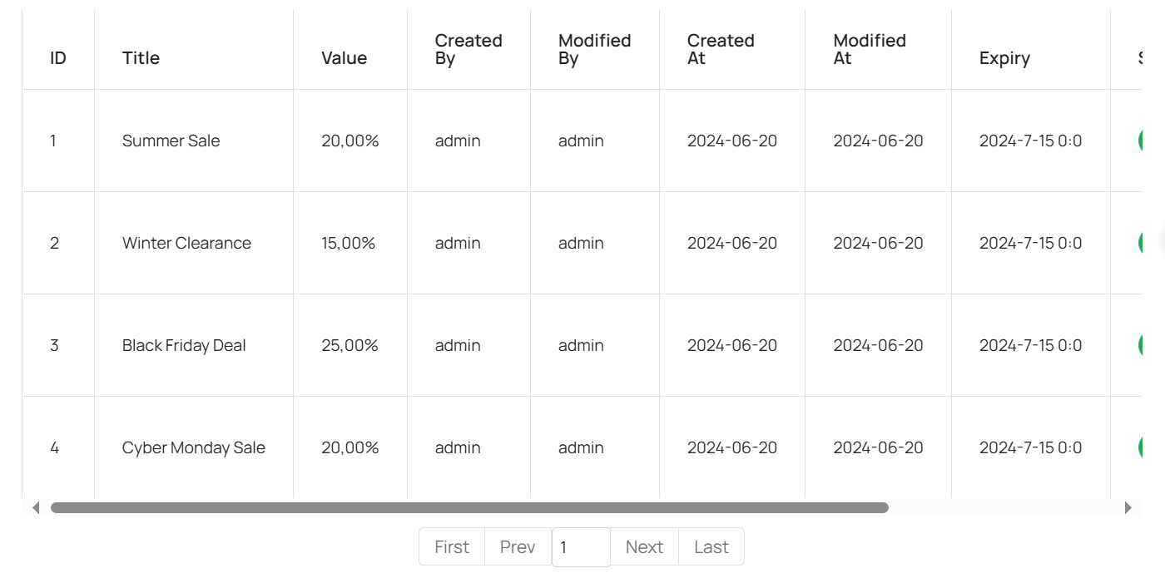

| **Field Name** | **Field Type** | **Description** |
| --- | --- | --- |
| Discount List | Form | Display all information and filter of discount |
| Add discount | Link | Redirect to add discount page |
| Edit discount | Form | Form allow admin update discount information |
| Delete discount | Button | Button allow admin delete discount |

##### 

##### **Database Access**

##### 

| **Table** | **CRUD** | **Description** |
| --- | --- | --- |
| Discount | RU | get information and update from discount |

##### **SQL Commands**

get discount status: select * from discount

get list discount:WITH discount AS (

SELECT o.oid, ordered_at, TotalAmount, status, pname,o.receiver, img,o.saleId,

ROW_NUMBER() OVER (PARTITION BY o.oid ORDER BY o.ordered_at) AS row_num

FROM discount o

JOIN orderDetails od ON o.oid = od.oid

JOIN Products p ON od.pid = p.pid

where o.saleId= ?

)

SELECT oid, ordered_at, TotalAmount, status, pname, receiver,img,saleId

FROM discount

WHERE row_num = 1

ORDER BY ordered_at DESC, status ASC;

change status discount:update discount set status=? where id=?

### 4.7 Manage Discount Details

##### **UI Design**

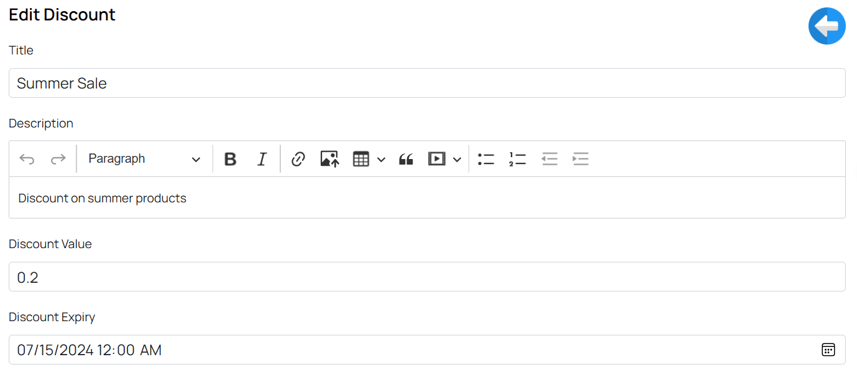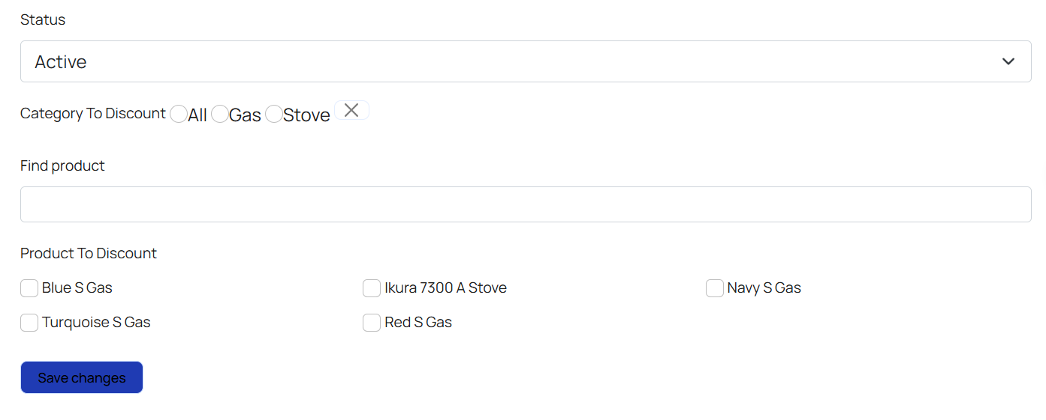

| Discount Detail | Form | Show all information of discount detail |
| --- | --- | --- |
| Save change | Button | Save all change |

##### 

##### **Database Access**

##### 

| **Table** | **CRUD** | **Description** |
| --- | --- | --- |
| Discount | R | get information and update from discount |

##### **SQL Commands**

get discount:select od.oid,od.pid,p.pname,p.img,od.price, od.quantity from discount

get discount information:select * from discount

### 4.8 Manage Voucher

##### **UI Design**

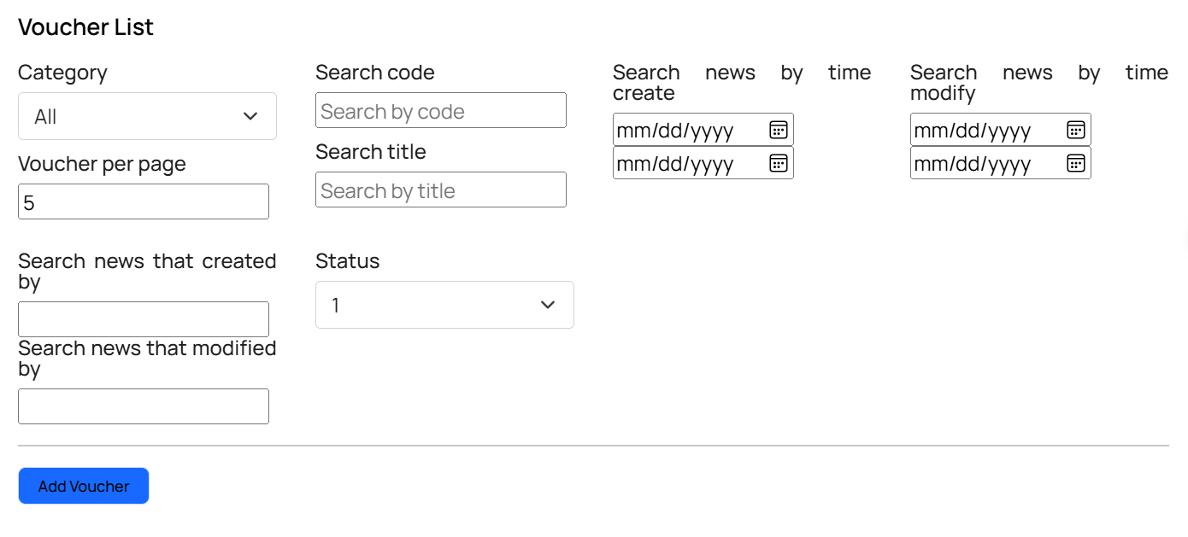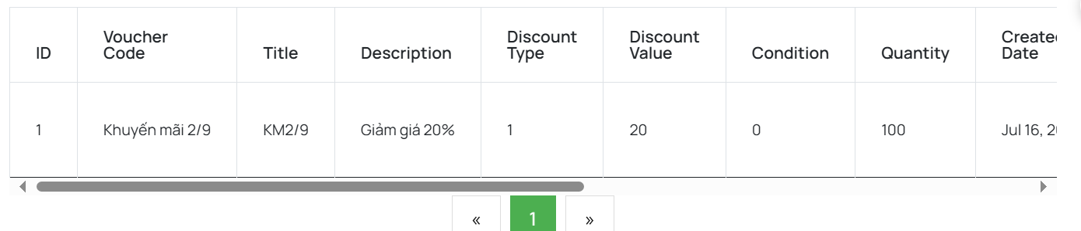

| **Field Name** | **Field Type** | **Description** |
| --- | --- | --- |
| Voucher List | Form | Display all information and filter of voucher |
| Add voucher | Link | Redirect to add voucher page |
| Edit voucher | Form | Form allow admin update voucher information |
| Delete voucher | Button | Button allow admin delete voucher |

##### 

##### **Database Access**

##### 

| **Table** | **CRUD** | **Description** |
| --- | --- | --- |
| Voucher | RU | get information and update from voucher |

##### **SQL Commands**

get voucher: select * from voucher

change status voucher : update voucher set status=? where id=?

update quantity voucher: update voucher set quantity +=? where id=?

### 4.9 Manage Voucher Details

##### **UI Design**

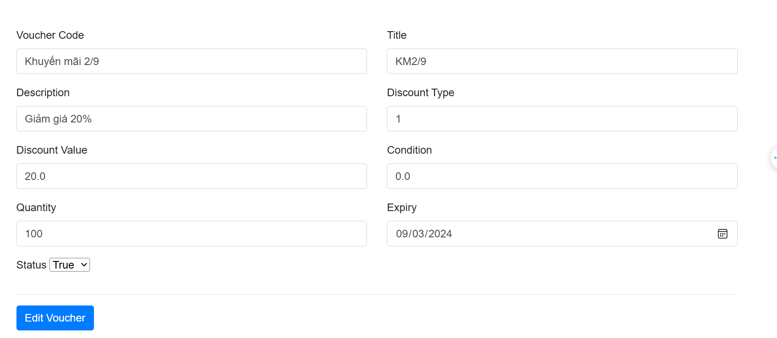

| Voucher Detail | Form | Show all information of voucher detail |
| --- | --- | --- |
| Edit voucher | Button | Save all change |

##### 

##### **Database Access**

##### 

| **Table** | **CRUD** | **Description** |
| --- | --- | --- |
| Voucher | R | get information and update from voucher |

##### **SQL Commands**

get voucher Detail:select * from voucher

get order information: select o.*,so.status from orders o join statusOrder so on o.status=so.id where oid=?

## 

## **5. Customer Service Feature**

### 5.1 Manager News

##### **UI Design**

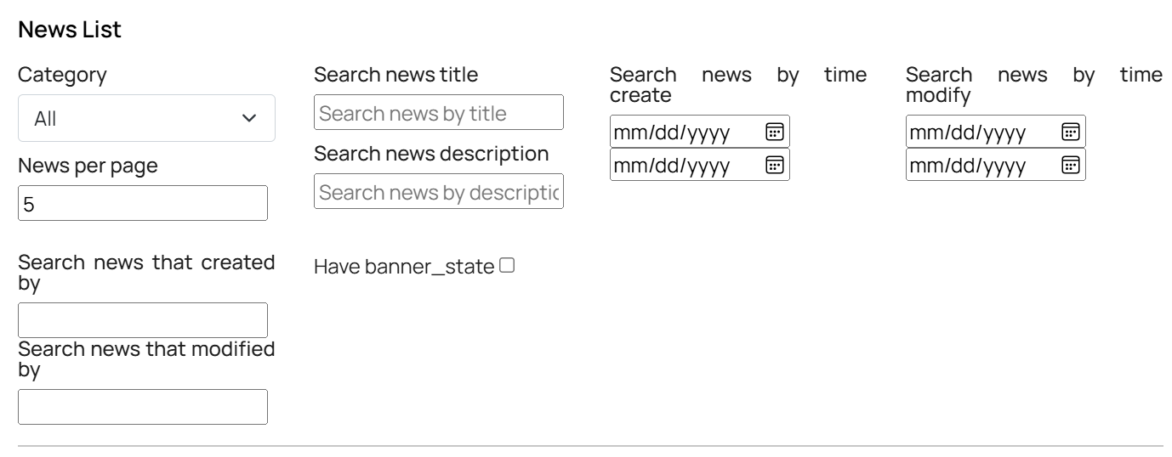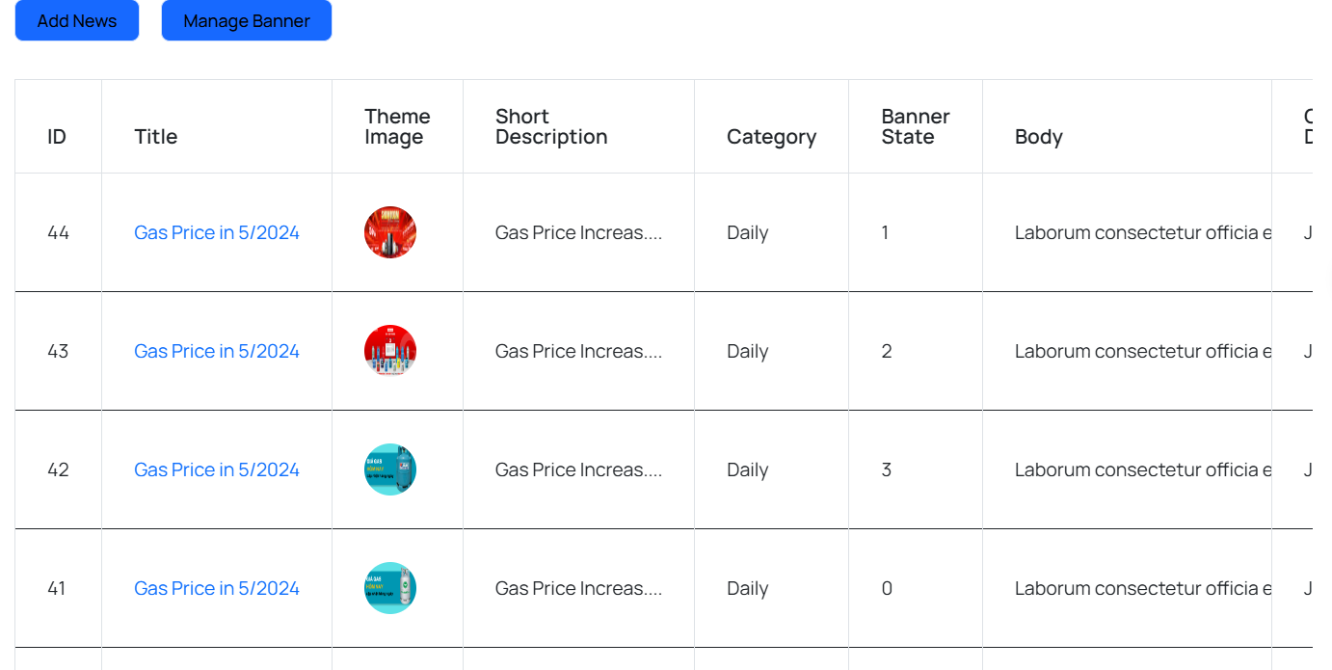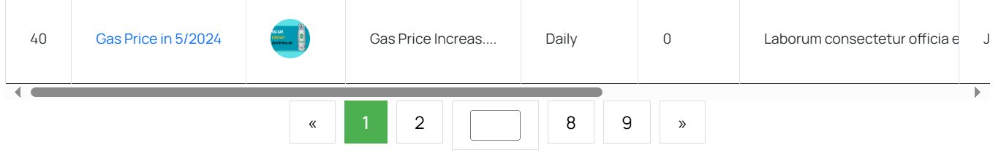

##### **Database Access**

| **Field Name** | **Field Type** | **Description** |
| --- | --- | --- |
| News List | Form | Display all information and filter of news |
| Add news | Link | Redirect to add news page |
| Edit news | Form | Form allow admin update news information |
| Delete news | Button | Button allow admin delete news |

##### 

##### **SQL Commands**

"SELECT post_id, title, author, updated_date, content, bc.bc_name,\n"

+ "thumbnail, brief, acid, status_name\n"

+ "From news bp join BlogCategories bc on bp.bc_id = bc.bc_id\n"

+ "join Status s on s.status_id = bp.status_id\n"

+ "ORDER BY post_id ASC \n"

+ "OFFSET ? ROWS FETCH NEXT 6 ROWS ONLY";

select count (*) from news

SELECT * FROM news

SELECT DISTINCT author FROM news

select * from Status

### 

### 

### 

### 

### 

### 

### 

### 

### 5.2 Manager News Detail

##### **Ui Design**

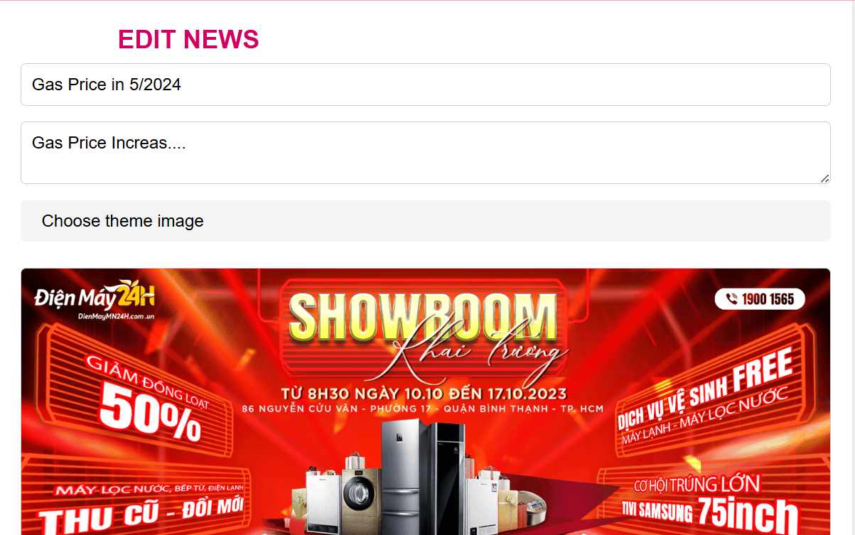

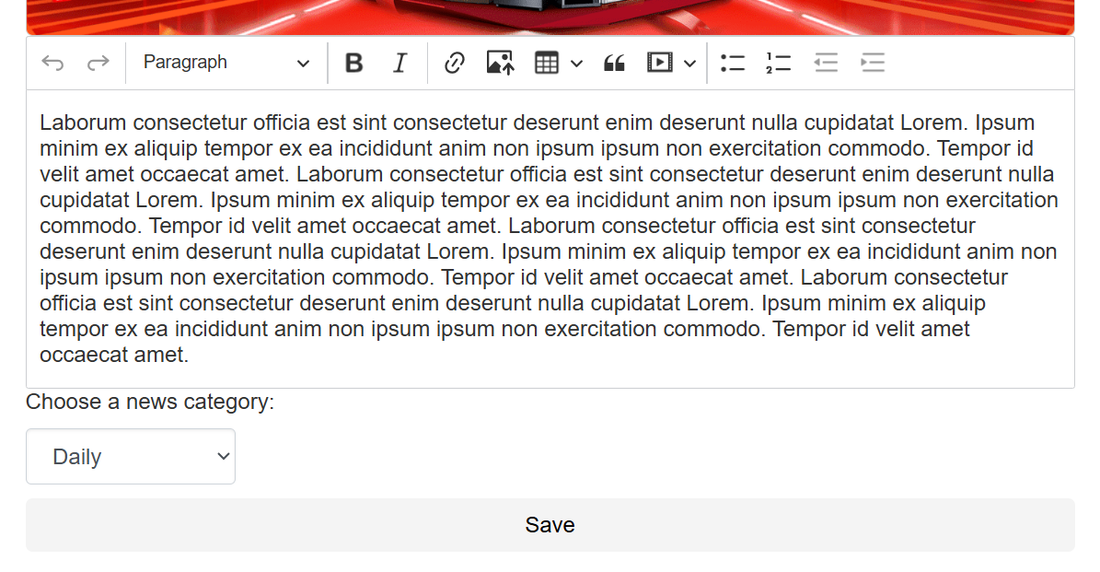

| News Detail | Form | Show all information of news detail |
| --- | --- | --- |
| Save | Button | Save all change |

##### 

##### **Database Access**

##### 

| **Table** | **CRUD** | **Description** |
| --- | --- | --- |
| News | CRUD | Query list the news from the database, Update news |

##### **SQL Commands**

INSERT INTO News (title, author, updated_date, content, bc_id, thumbnail, brief, acid, status_id) "

+ "VALUES (?, ?, ?, ?, ?, ?, ?, ?, ?);

UPDATE News\n"

+ "SET\n"

+ " bc_id = ?,\n"

+ " title = ?,\n"

+ " author = ?,\n"

+ " updated_date = ?,\n"

+ " content = ?,\n"

+ " thumbnail = ?,\n"

+ " brief = ?,\n"

+ " acid = ?,\n"

+ " status_id = ?\n"

+ "WHERE\n"

+ " post_id = ?

select thumbnail from news\n"

+ " where post_id = ?

### 5.3 Manage Banner

##### **UI Design**

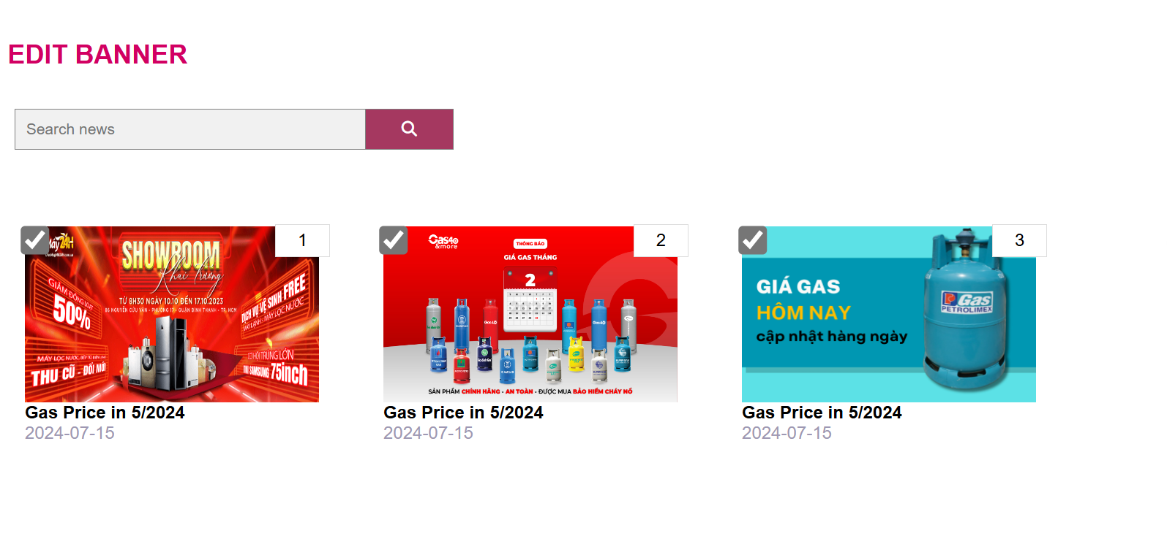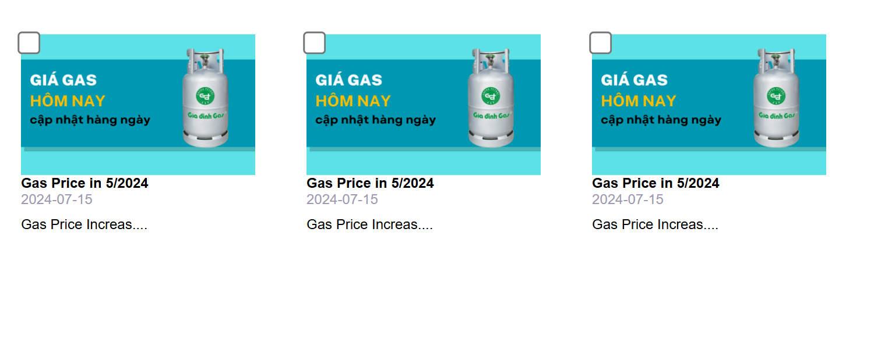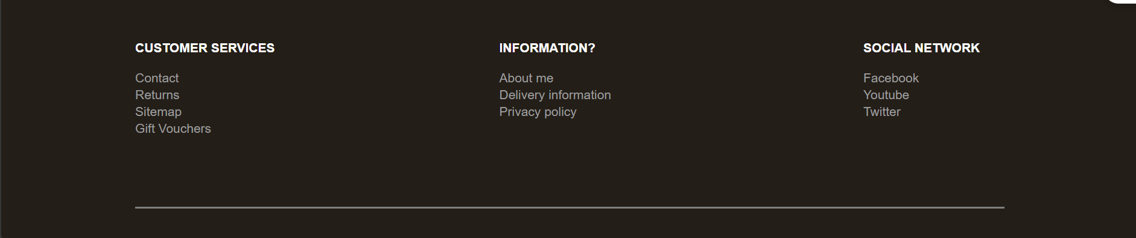

| **Field Name** | **Field Type** | **Description** |
| --- | --- | --- |
| News List | Form | Display all information and filter of news and select news to set it is banner |

##### 

##### **Database Access**

##### 

| **Table** | **CRUD** | **Description** |
| --- | --- | --- |
| news | R | list banner (news have banner_state <>0) |

##### **SQL Commands**

Select * from news where banner_state <>0

### 5.4 Manage Guest

##### **UI Design**

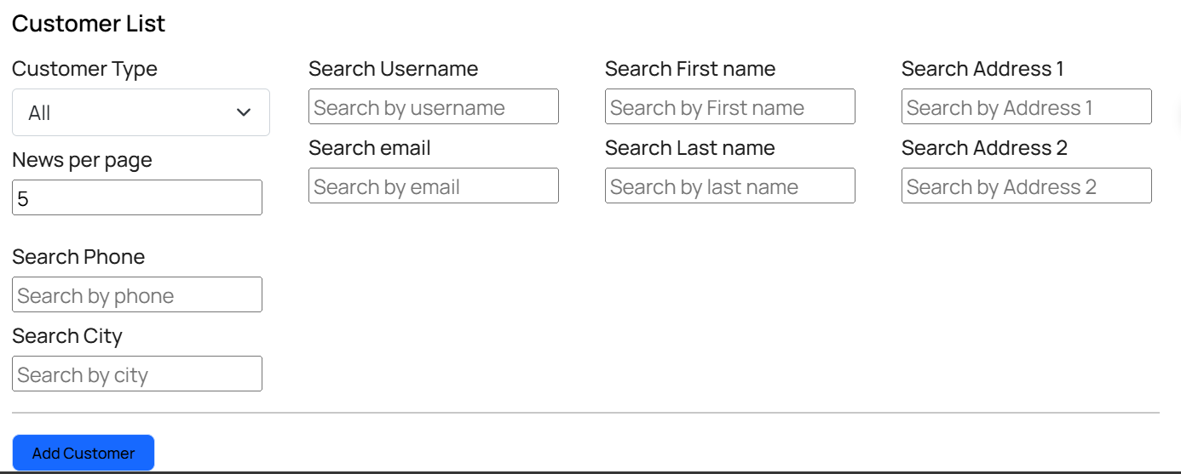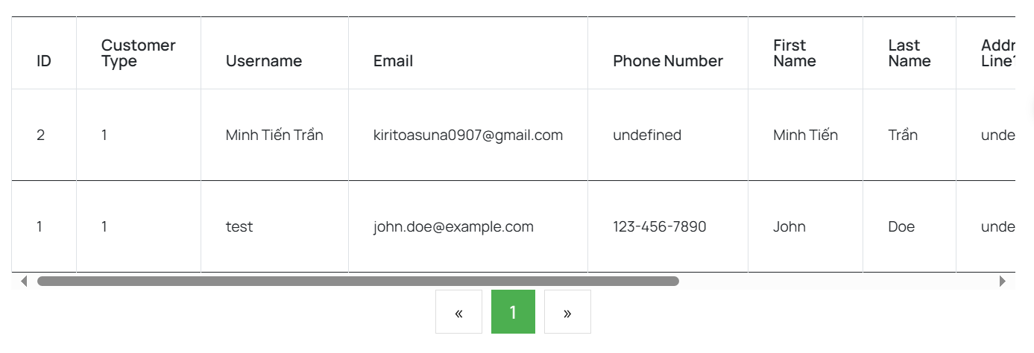

| **Field Name** | **Field Type** | **Description** |
| --- | --- | --- |
| Guest List | Form | Display all information and filter of guest |
| Add guest | Link | Redirect to add guest page |
| Edit guest | Form | Form allow admin update guest information |
| Delete guest | Button | Button allow admin delete guest |

##### 

##### **Database Access**

##### 

| **Table** | **CRUD** | **Description** |
| --- | --- | --- |
| Guest | CRUD | list outputs the list of guest |

##### **SQL Commands**

select * from customer

select * from customer where role_id = ?

select * from customer where role_id = ? and username like ?

### 5.5 Manage Guest Details

##### **UI Design**

Same User Profile

##### **SQL Commands**

String sql = "select * from Customer where email=?";

String sql = " update Customer\n"

+ " set username= ?,\n"

+ " phone_number = ?,\n"

+ " [address] = ?\n"

+ " \n"

+ " where email=?";

### 5.6 Manage Warranty

##### **UI Design**

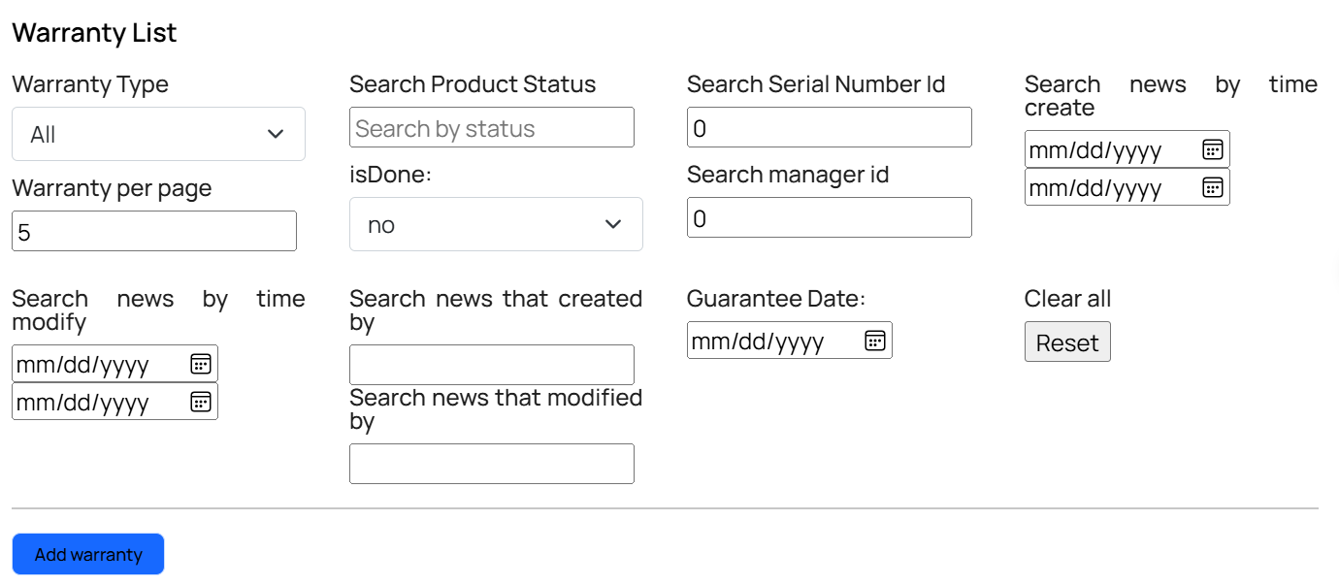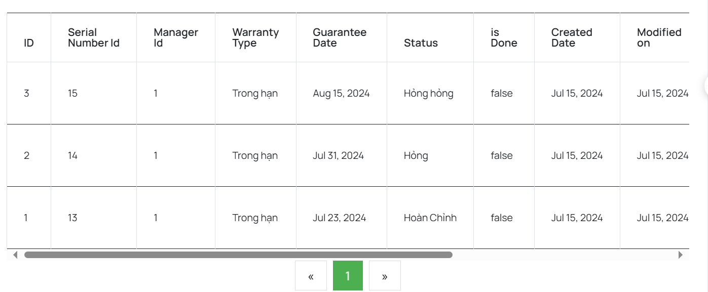

| **Field Name** | **Field Type** | **Description** |
| --- | --- | --- |
| Warranty List | Form | Display all information and filter of warranty |
| Add warranty | Link | Redirect to add warranty page |
| Edit warranty | Form | Form allow admin update warranty information |
| Delete warranty | Button | Button allow admin delete warranty |

##### 

##### **Database Access**

##### 

| **Table** | **CRUD** | **Description** |
| --- | --- | --- |
| Warranty | RU | get information and update from warranty |

##### **SQL Commands**

get warranty: select * from warranty

change status warranty: update warranty set status=? where id=?

update quantity warranty: update warranty set quantity +=? where id=?

### 5.7 Manage Warranty Details

##### **UI Design**

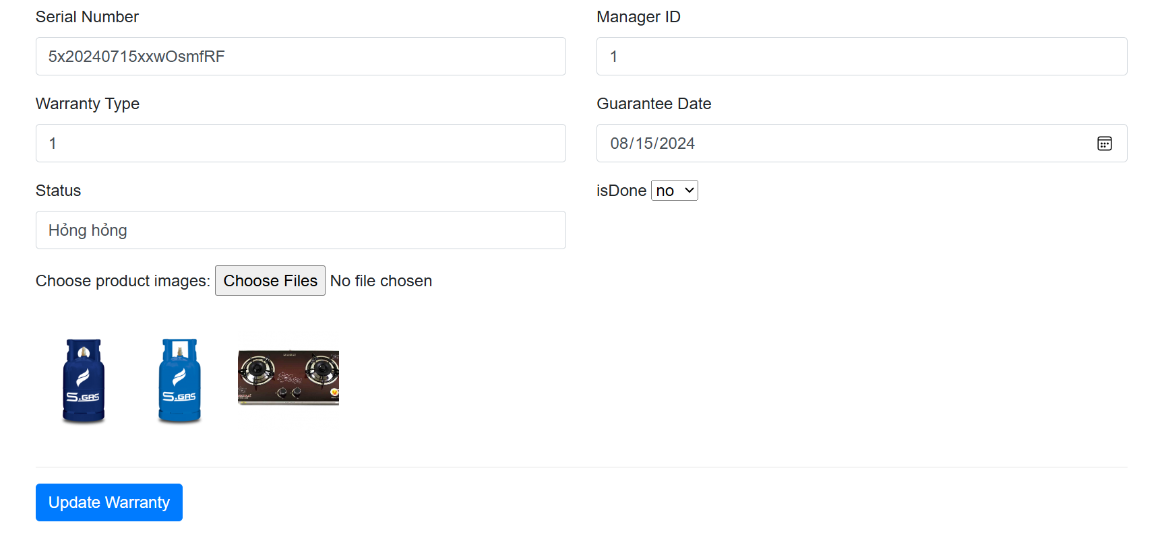

| Warranty Detail | Form | Show all information of warranty detail |
| --- | --- | --- |
| Update Warranty | Button | Save all change |

##### 

##### **Database Access**

##### 

| **Table** | **CRUD** | **Description** |
| --- | --- | --- |
| Warranty | R | get information and update from warranty |

##### **SQL Commands**

get warranty detail:select * from warranty

### 5.8 Manage Feedback

##### **UI Design**

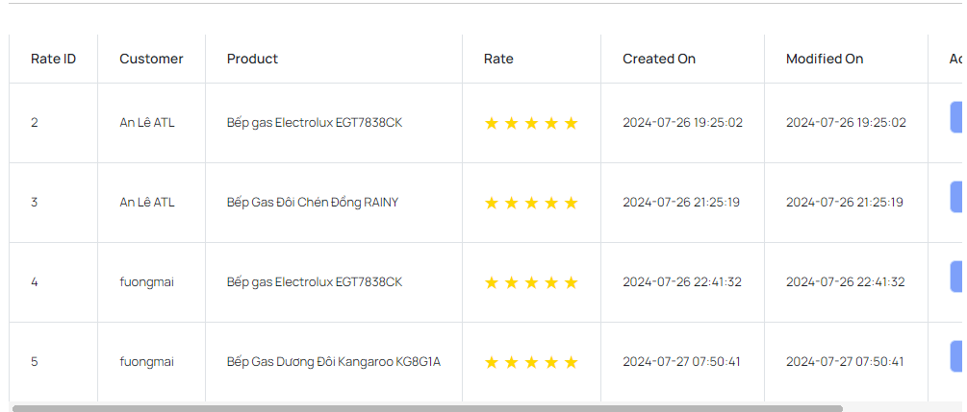

##### **Database Access**

##### 

| **Table** | **CRUD** | **Description** |
| --- | --- | --- |
| Rate | RD | get information and update from rate |

##### 

##### **SQL Commands**

DELETE FROM [dbo].[rate] WHERE rate_id = ?

SELECT [rate_id]\n"

+ " ,[customer_id]\n"

+ " ,[product_id]\n"

+ " ,[rate]\n"

+ " ,[comment]\n"

+ " ,[created_on]\n"

+ " ,[modified_on]\n"

+ " FROM [blazo_db].[dbo].[rate] WHERE rate_id = ?

SELECT [rate_id], [customer_id], [product_id], [rate], [comment], [created_on], [modified_on] FROM [dbo].[rate] WHERE 1=1 AND ([rate] = ? OR ? IS NULL OR ? = '') AND ( ([comment] LIKE ? OR [comment] LIKE ? OR ? IS NULL OR ? = '') ) AND ( [customer_id] IN ( SELECT [customer_id] FROM [dbo].[customer] WHERE ([username] LIKE ? OR [username] LIKE ? OR ? IS NULL OR ? = '') ) ) AND ( [product_id] IN ( SELECT [product_id] FROM [dbo].[product] WHERE ([title] LIKE ? OR [title] LIKE ? OR ? IS NULL OR ? = '') ) ) AND ([created_on] >= ? OR ? IS NULL) AND ([created_on] <= ? OR ? IS NULL) AND ([modified_on] >= ? OR ? IS NULL) AND ([modified_on] <= ? OR ? IS NULL) ORDER BY [modified_on] ?;

### 

## **6. Manager Feature**

### 6.1 Manage Staff

#### *UI Design*

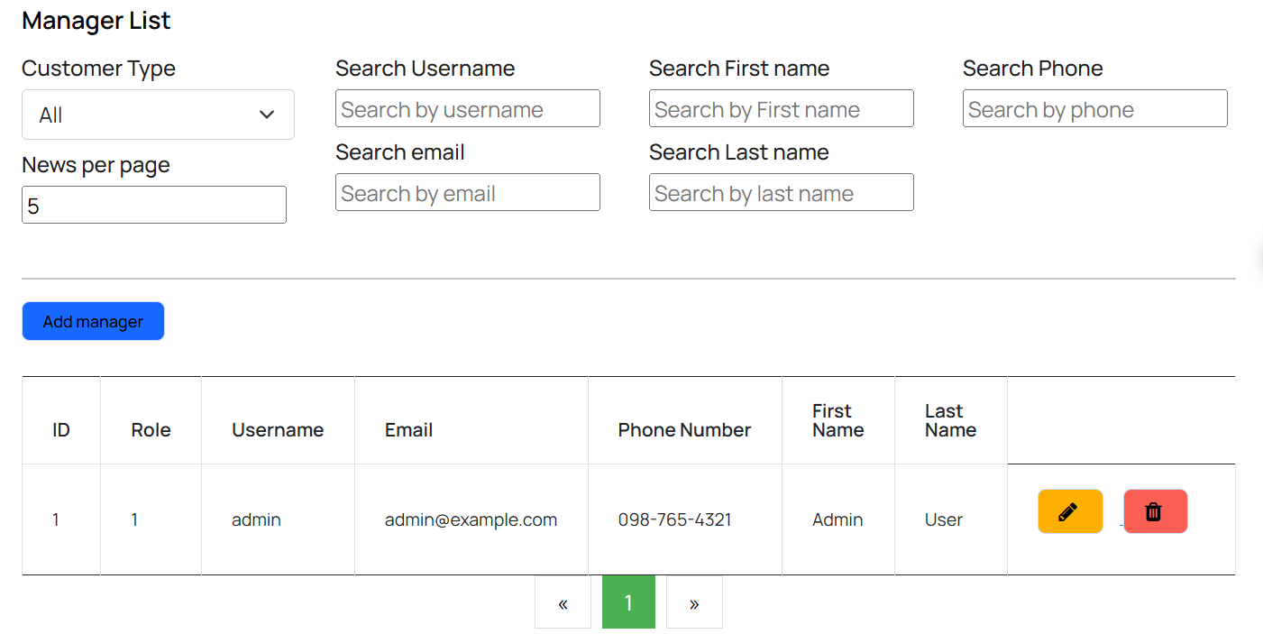

| **Field Name** | **Field Type** | **Description** |
| --- | --- | --- |
| Staff List | Form | Display all information and filter of staff |
| Add staff | Link | Redirect to add staff page |
| Edit staff | Form | Form allow admin update staff information |
| Delete staff | Button | Button allow admin delete staff |

##### 

#### *Database Access*

| **Table** | **CRUD** | **Description** |
| --- | --- | --- |
| Manager | CRUD | Query list the staff, Add new staff ,Update staff from the database |

#### *SQL Commands*

Select * from staff

SELECT a.acid,

a.email,

a.username,

r.role_name,

a.created_at,

acs.status_name,

a.phone_number,

a.gender,

a.address

FROM staff

ORDER BY a.created_at DESC

OFFSET ? ROWS FETCH NEXT 12 ROWS ONLY;

### 6.2 Manage Staff Details

#### *UI Design*

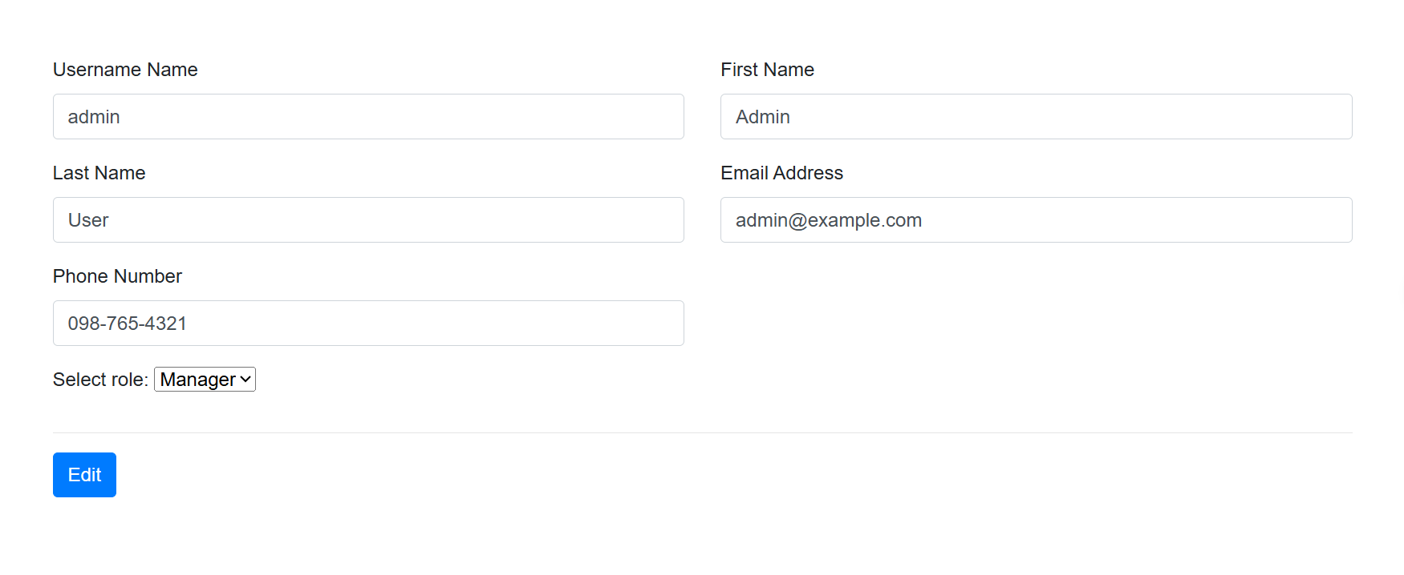

##### 

| Staff Detail | Form | Show all information of staff detail |
| --- | --- | --- |
| Edit | Button | Save all change |

##### 

#### *Database Access*

| **Table** | **CRUD** | **Description** |
| --- | --- | --- |
| Manager | CRUD | Query list the staff, Add new staff ,Update staff from the database |

#### *SQL Commands*

Select * from staff

SELECT a.acid,

a.email,

a.username,

r.role_name,

a.created_at,

acs.status_name,

a.phone_number,

a.gender,

a.address

FROM staff

ORDER BY a.created_at DESC

OFFSET ? ROWS FETCH NEXT 12 ROWS ONLY;

### 6.3 Navbar list

#### **UI Design**

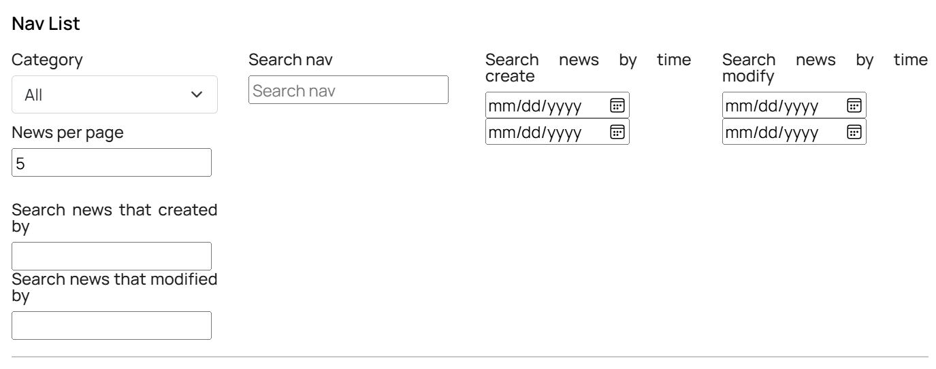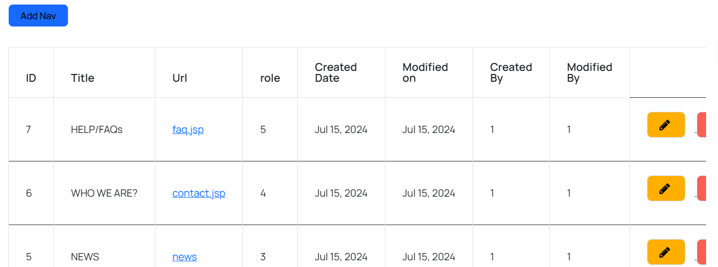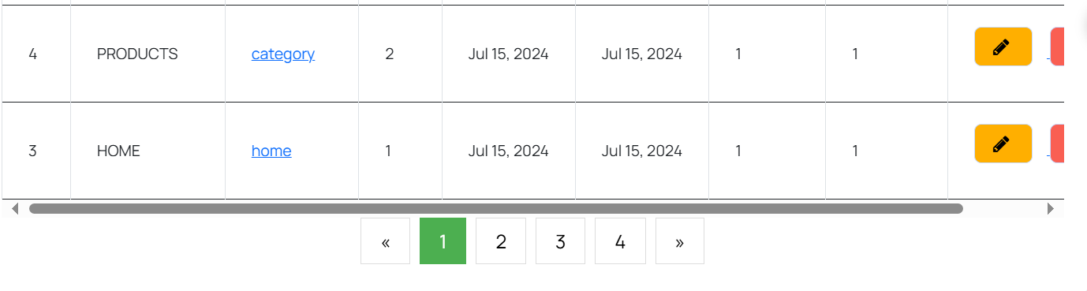

| **Field Name** | **Field Type** | **Description** |
| --- | --- | --- |
| Navbar List | Form | Display all information and filter of navbar |
| Add navbar | Link | Redirect to add navbar page |
| Edit navbar | Form | Form allow admin update navbar information |
| Delete navbar | Button | Button allow admin delete navbar |

##### 

#### **Database Access**

##### 

| **Table** | **CRUD** | **Description** |
| --- | --- | --- |
| Category | CRUD | list outputs the list of navbar |

##### **SQL Commands**

get navbar: select * from navbar

select * from navbar where id=?

update navbar: update category set title=?,body=?....

Delete navbar: delete from category where id=?

# IV. Appendix

## 1. Assumptions & Dependencies

AS-1: It is assumed that the user interface will be designed to be compatible with popular web browsers such as Chrome, Firefox, and Safari.

AS-2: The interface will also be optimized for mobile devices such as smartphones and tablets.

AS-3: It is assumed that the system will use security measures such as data encryption, and login session management to ensure the safety of users' personal information.

AS-4: It is assumed that the system can integrate with external services such as online payment gateways, Google APIs for login, location.

AS-5: It is assumed that data entered into the system will be checked for validity and processed securely to prevent attacks such as SQL Injection or Cross-site Scripting (XSS).

AS-6: Data will be updated and maintained accurately.

DE-1: Developing system functionality will depend on perfecting the user interface and user experience (UI/UX) design.

DE-2: Building data management functions will depend on the database being completely designed and deployed.

DE-3: Functions related to external service integration such as online payments will depend on the availability and successful integration with third parties providing these services.

DE-4: Security measures will depend on the implementation of effective security technologies and methods, as well as the maintenance of information security standards.

## 2. Limitations & Exclusions

- Language Support:

The system does not provide multilingual support for users, only supports a single language (English).

- Online Payment Support:

The system does not provide multilingual online payment support for users, only support for VNPAY.

- Shipping Support:

The system does not have its own delivery system; it only integrates with an external delivery system.

- Insurance Service Integration:

The system does not integrate the ability to buy product insurance or advise on insurance packages related.

## 

## 3. Business Rules

| **ID** | **Rule Definition** |
| --- | --- |
| BR-01 | Allows administrators to create accounts for new staff members in the system. |
| BR-02 | Users can log in to the system using their username and password. |
| BR-03 | Users can log in to the system using their Google account. |
| BR-04 | Allows administrators to delete a user account from the system. |
| BR-05 | Allows users to change their password. |
| BR-06 | Allows guests to register for a new account in the system. |
| BR-07 | Users can view their own profile information. |
| BR-08 | Allows users to update their profile information. |
| BR-09 | Administrators can block a user account to prevent access to the system. |
| BR-10 | Users can request to reset their password if they forget it. |
| BR-11 | Administrators can view a list of accounts in the system. |
| BR-12 | Users can view a list of available cars in the system. |
| BR-13 | Administrators can add a new car to the system. |
| BR-14 | Allows updating details about a specific car. |
| BR-15 | Administrators can delete a car from the system. |
| BR-16 | Users can view detailed information about a specific car. |
| BR-17 | Allows users to filter the list of cars by brand, color, and price. |
| BR-18 | Users can search for a car by its name. |
| BR-19 | Users can view a list of cars they have marked as favorites. |
| BR-20 | Users can view a list of the newest cars added to the system. |
| BR-21 | Users can view a list of available accessories in the system. |
| BR-22 | Administrators can delete an accessory from the system. |
| BR-23 | Allows updating details about a specific accessory. |
| BR-24 | Users can view detailed information about a specific accessory. |
| BR-25 | Administrators can add a new accessory to the system. |
| BR-26 | Users can filter the list of accessories by price. |
| BR-27 | Users can search for an accessory by its name. |
| BR-28 | Users can view a list of featured accessory products. |
| BR-29 | Users can register to order a car with or without accessories. |
| BR-30 | Users provide contact information to place an order. |
| BR-31 | Users can create an order and choose a payment method. |
| BR-32 | Users can view the history of orders they have placed. |
| BR-33 | Users can text with customer care staff. |
| BR-34 | Users can view a list of scheduled test drives. |
| BR-35 | Users can reject booking applications. |
| BR-36 | Users can update booking information. |
| BR-37 | Administrators can create a test drive schedule for customers. |
| BR-38 | Sellers can update the status of a test drive schedule. |
| BR-39 | Users can view maintenance and repair schedules for their cars. |
| BR-40 | Administrators and customer care can create maintenance and repair schedules for vehicles in the system. |
| BR-41 | Customer care can update maintenance and repair schedules for vehicles in the system. |
| BR-42 | Customer care can book maintenance and repair schedules for vehicles in the system. |
| BR-43 | Users can view a list of rescue applications. |
| BR-44 | Users can submit a rescue application along with their location. |
| BR-45 | Customer care can change the status of a rescue application. |
| BR-46 | Create rescue invoice. |
| BR-47 | Users can pay for their rescue application. |
| BR-48 | Users can view the history of maintenance and repairs for their cars. |
| BR-49 | Users can view the current status of their cars. |
| BR-50 | Users can view a list of accessories that have been used on their cars. |
| BR-51 | The system can suggest relevant accessories for the user's car. |
| BR-52 | Users can search for information about a specific license plate. |
| BR-53 | Customer care can update invoices for repair or maintenance services. |
| BR-54 | Customer care can create invoices for repair or maintenance services. |
| BR-55 | Administrators can view sales statistics by brand and each type of car. |
| BR-56 | Administrators can view sales statistics for each month. |
| BR-57 | Administrators can view statistics on the most loyal customers. |
| BR-58 | Administrators can create news articles in the system. |
| BR-59 | Users can view a list of news articles available in the system. |
| BR-60 | Users can view detailed information about a specific news article. |
| BR-61 | Customer care can delete a news article. |
| BR-62 | Users can filter the list of news articles by name and date. |
| BR-63 | Users can rate the web application. |
| BR-64 | Users can delete their rating. |
| BR-65 | Users can update their rating. |
| BR-66 | Admin can view list of rating. |
| BR-67 | BR-67: Only administrators have the authority to create test drive schedules for customers. |
| BR-68 | Test drive schedules must be created based on customer preferences, availability of cars, and operational constraints. |
| BR-69 | The system must provide a user-friendly interface for administrators to manage test drive schedules efficiently. |
| BR-70 | Sellers must have the authority to update the status of test drive schedules, such as confirming, rescheduling, or canceling appointments. |
| BR-71 | Updated test drive schedule status must trigger notifications to the concerned parties, including customers and administrators. |
| BR-72 | Sellers must provide valid reasons for updating the test drive schedule status, which will be logged for audit purposes. |
| BR-73 | Users must have authenticated access to view maintenance and repair schedules for their registered cars. |
| BR-74 | Maintenance and repair schedules must include details such as service type, appointment date, and service provider information. |
| BR-75 | Users may be allowed to filter and sort maintenance and repair schedules based on various criteria for easy management. |
| BR-76 | Only authorized personnel, such as administrators and customer care staff, have the authority to create maintenance and repair schedules. |
| BR-77 | Maintenance and repair schedules must be created based on car model, service requirements, and availability of service providers. |
| BR-78 | The system must provide features for administrators and customer care staff to assign service providers, set appointment dates, and track service status. |
| BR-79 | Customer care staff must be able to book maintenance and repair schedules on behalf of users, considering user preferences and operational constraints. |
| BR-80 | Users must receive confirmation notifications for scheduled maintenance and repair appointments, including appointment details and instructions. |
| BR-81 | Customer care staff must be able to update maintenance and repair schedules based on user requests, service provider availability, and operational constraints. |
| BR-82 | Updates to maintenance and repair schedules must trigger notifications to the concerned parties, including users and administrators. |
| BR-83 | Users must be able to view a list of rescue applications submitted for their registered cars. |
| BR-84 | Rescue applications must include details such as location coordinates, vehicle condition, and urgency level. |
| BR-85 | Customer care staff must have access to a user-friendly interface to manage rescue applications efficiently, including prioritizing, assigning, and tracking rescue operations. |
| BR-86 | Customer care staff must be able to change the status of rescue applications based on progress updates, vehicle availability, and operational constraints. |
| BR-87 | Updates to rescue application status must trigger notifications to the concerned parties, including users and administrators. |
| BR-88 | Users must receive confirmation notifications upon successful submission of rescue applications, including assigned rescue team details and estimated arrival time. |
| BR-89 | Customer care staff must be able to create rescue invoices based on service provided, resources utilized, and billing terms. |
| BR-90 | Rescue invoices must include details such as service charges, additional fees, and payment instructions. |
| BR-91 | Users must be able to view a history of maintenance and repair services performed on their registered cars. |
| BR-92 | Maintenance and repair history must include details such as service type, service provider, service date, and service status. |
| BR-93 | Users must be able to view the current status of their registered cars, including maintenance and repair status. |
| BR-94 | Users must be able to view a list of accessories installed or used on their registered cars. |
| BR-95 | The system must suggest relevant accessories based on user car details, preferences, and compatibility. |
| BR-96 | Users must be able to search for information about specific license plates, including ownership details, vehicle history, and registration status. |
| BR-97 | Customer care staff must have the authority to update invoices for repair or maintenance services based on user requests, service provider updates, or billing adjustments. |
| BR-98 | Updated invoices must accurately reflect the changes made, including service charges, additional fees, and payment terms. |
| BR-99 | Updates to invoices must trigger notifications to the concerned parties, including users and accounting departments, for approval and processing. |
| BR-100 | Customer care staff must provide valid reasons for updating invoices, such as correcting billing errors or applying discounts, which will be logged for audit purposes. |
| BR-101 | Customer care staff must have the authority to create invoices for repair or maintenance services based on completed work orders, service provider estimates, or user requests. |
| BR-102 | Invoices must include details such as service charges, parts/labour costs, taxes, and payment terms. |
| BR-103 | Customer care staff must ensure accuracy and completeness of invoices before sending them to users for payment. |
| BR-104 | Administrators must have access to comprehensive sales reports summarizing sales data by car brand and model. |
| BR-105 | Sales statistics must include metrics such as total units sold, revenue generated, and market share for each brand and car type. |
| BR-106 | Administrators may be allowed to filter and compare sales data based on various criteria such as time period, region, or customer demographics. |
| BR-107 | Administrators must have access to monthly sales reports summarizing sales performance for each month. |
| BR-108 | Monthly sales statistics must include metrics such as total revenue, units sold, average selling price, and sales trends over time. |
| BR-109 | Administrators may be allowed to analyze sales data for insights into seasonal variations, product popularity, and market demand. |
| BR-110 | Administrators must have access to customer loyalty reports identifying the most loyal customers based on their purchase history and engagement. |
| BR-111 | Loyalty statistics must include metrics such as repeat purchase frequency, total spending, and customer lifetime value. |
| BR-112 | Administrators may be allowed to segment loyal customers into different tiers based on their loyalty level and provide targeted incentives or rewards. |
| BR-113 | Only administrators have the authority to create and publish news articles in the system. |
| BR-114 | News articles must be created using a user-friendly content management interface, allowing administrators to add text, images, and multimedia content. |
| BR-115 | Administrators must ensure that news articles adhere to relevant editorial guidelines, including accuracy, relevance, and non-bias. |
| BR-116 | Users must have authenticated access to view the list of news articles available in the system. |
| BR-117 | The list of news articles must include titles, publication dates, and brief summaries for easy browsing and selection. |
| BR-118 | Users may be allowed to filter and sort news articles based on various criteria such as category, topic, or publication date. |
| BR-119 | Users must have authenticated access to view detailed information about a specific news article. |
| BR-120 | Detailed information about a news article must include the full article content, author information, and related media assets. |
| BR-121 | Users may be allowed to share, bookmark, or comment on news articles based on their preferences and interests. |
| BR-122 | Customer care staff must have the authority to delete news articles from the system if they are outdated, inaccurate, or irrelevant. |
| BR-123 | Deleting a news article must trigger notifications to the concerned parties, including administrators and users who have engaged with the article. |
| BR-124 | Customer care staff must provide valid reasons for deleting news articles, which will be logged for audit purposes. |
| BR-125 | Users must be able to apply filters based on news article name and publication date to narrow down their search. |
| BR-126 | Filtered results must be displayed in real-time, reflecting the applied filter criteria accurately. |
| BR-127 | Users can combine multiple filters to refine their search results further for better relevance and accuracy. |
| BR-128 | Users must be able to provide ratings and reviews for the web application based on their user experience and satisfaction. |
| BR-129 | Rating functionality must be accessible from various pages of the web application for user convenience. |
| BR-130 | Users may be encouraged to provide feedback through prompts, surveys, or incentives to improve overall user engagement and satisfaction. |
| BR-131 | Users must have authenticated access to delete their previously submitted ratings and reviews. |
| BR-132 | Deleting a rating must remove the associated feedback from the system and reflect the change in the overall rating calculation. |
| BR-133 | Users may be prompted to provide a reason for deleting their rating to gather insights for continuous improvement. |
| BR-134 | Users must have authenticated access to update their previously submitted ratings and reviews. |
| BR-135 | Updating a rating must overwrite the existing feedback with the new rating and review provided by the user. |
| BR-136 | Users may be encouraged to update their rating periodically to reflect changes in their experience or satisfaction level with the web application. |
| BR-137 | Admin must have access to a list of all ratings and reviews submitted by users for analysis and monitoring purposes. |
| BR-138 | The list of ratings must include details such as user name, rating value, review content, and submission date. |
| BR-139 | Admin may be allowed to filter and sort ratings based on various criteria such as rating value, submission date, or user demographics. |
| BR-140 | Admin must be able to view detailed information about a specific rating, including the associated user profile and feedback content. |
| BR-141 | Admin may be allowed to respond to user reviews, addressing concerns, acknowledging positive feedback, or providing additional information. |
| BR-142 | Admin responses to user reviews must be displayed publicly to encourage transparency and accountability. |
| BR-143 | Users must have access to admin responses to reviews to see how their feedback has been addressed or acknowledged by the management. |
| BR-144 | Admin must ensure that responses to user reviews adhere to relevant guidelines, including professionalism, courtesy, and accuracy. |
| BR-145 | Admin may be allowed to edit or delete their responses to user reviews if necessary, ensuring consistency and relevance over time. |
| BR-146 | Admin must have access to review analytics and insights, summarizing trends, sentiment analysis, and user feedback patterns for strategic decision-making. |
| BR-147 | Analytics must include metrics such as average rating, review sentiment distribution, most mentioned keywords, and user engagement trends. |
| BR-148 | Admin may be allowed to generate custom reports and visualizations based on specific criteria or time periods to support data-driven decision-making. |
| BR-149 | Admin must have access to real-time updates and alerts regarding significant changes or trends in user ratings and reviews for timely intervention or response. |
| BR-150 | Admin may be allowed to export rating and review data in various formats for further analysis, reporting, or integration with other systems. |
| BR-151 | Users must have authenticated access to view the list of scheduled maintenance activities for their registered cars. |
| BR-152 | The list of maintenance activities must include details such as service type, scheduled date, service provider, and service status. |
| BR-153 | Users may be allowed to filter and sort maintenance activities based on various criteria such as service type, scheduled date, or service status. |
| BR-154 | Maintenance activities must be color-coded or visually represented to indicate their status, such as pending, ongoing, or completed. |
| BR-155 | Users must be able to view detailed information about a specific maintenance activity, including service details and service provider contact information. |
| BR-156 | Users may be allowed to request rescheduling or cancellation of scheduled maintenance activities based on their availability or changing needs. |
| BR-157 | Maintenance activities must be updated in real-time to reflect changes in status, such as appointment confirmation, rescheduling, or completion. |
| BR-158 | Users must receive notifications for scheduled maintenance activities, including appointment reminders, updates, and confirmation messages. |
| BR-159 | Users must have authenticated access to view the list of scheduled repair tasks for their registered cars. |
| BR-160 | The list of repair tasks must include details such as repair type, scheduled date, service provider, and repair status. |
| BR-161 | Users may be allowed to filter and sort repair tasks based on various criteria such as repair type, scheduled date, or repair status. |
| BR-162 | Repair tasks must be color-coded or visually represented to indicate their status, such as pending, in progress, or completed. |
| BR-163 | Users must be able to view detailed information about a specific repair task, including repair details and service provider contact information. |
| BR-164 | Users may be allowed to request updates or modifications to scheduled repair tasks based on their preferences or changing requirements. |
| BR-165 | Repair task status must be updated in real-time to reflect changes, such as repair commencement, completion, or delays. |
| BR-166 | Users must receive notifications for scheduled repair tasks, including updates, progress reports, and completion notifications. |
| BR-167 | Users must have authenticated access to view the list of scheduled maintenance and repair tasks for their registered cars. |
| BR-168 | The combined list of maintenance and repair tasks must include details such as task type, scheduled date, service provider, and task status. |
| BR-169 | Users may be allowed to filter and sort maintenance and repair tasks based on various criteria such as task type, scheduled date, or task status. |
| BR-170 | Maintenance and repair tasks must be color-coded or visually represented to distinguish between different types of tasks and their statuses. |
| BR-171 | Users must be able to view detailed information about a specific maintenance or repair task, including task details and service provider contact information. |
| BR-172 | Users may be allowed to request updates or modifications to scheduled maintenance and repair tasks based on their preferences or changing requirements. |
| BR-173 | Task statuses must be updated in real-time to reflect changes, such as task commencement, completion, or delays. |
| BR-174 | Users must receive notifications for scheduled maintenance and repair tasks, including updates, progress reports, and completion notifications. |
| BR-175 | Users must have authenticated access to view the list of scheduled test drive appointments for their registered cars. |
| BR-176 | The list of test drive appointments must include details such as appointment date, time, location, and status. |
| BR-177 | Users may be allowed to filter and sort test drive appointments based on various criteria such as appointment date, location, or status. |
| BR-178 | Test drive appointments must be color-coded or visually represented to indicate their status, such as pending, confirmed, or canceled. |
| BR-179 | Users must be able to view detailed information about a specific test drive appointment, including appointment details and contact information. |
| BR-180 | Users may be allowed to request updates or modifications to scheduled test drive appointments based on their preferences or changing availability. |
| BR-181 | Test drive appointment statuses must be updated in real-time to reflect changes, such as appointment confirmation, rescheduling, or cancellation. |
| BR-182 | Users must receive notifications for scheduled test drive appointments, including appointment reminders, updates, and confirmation messages. |
| BR-183 | The search functionality should return accurate results based on the entered title. |
| BR-184 | The search should be case-insensitive. |
| BR-185 | The search should support partial matches. |
| BR-186 | Rescue operations must be color-coded or visually represented to indicate their status, such as pending, in progress, or completed. |
| BR-187 | Users must be able to view detailed information about a specific rescue operation, including operation details and contact information. |
| BR-188 | Users may be allowed to request updates or modifications to scheduled rescue operations based on their preferences or changing circumstances. |
| BR-189 | Rescue operation statuses must be updated in real-time to reflect changes, such as operation commencement, completion, or delays. |
| BR-190 | Users must receive notifications for scheduled rescue operations, including updates, progress reports, and completion notifications. |
| BR-191 | Users must have authenticated access to view the list of previous maintenance and repair services performed on their registered cars. |
| BR-192 | The list of previous services must include details such as service type, service provider, service date, and service status. |
| BR-193 | Users may be allowed to filter and sort previous services based on various criteria such as service type, service date, or service status. |
| BR-194 | Previous services must be color-coded or visually represented to indicate their type and status, such as maintenance, repair, or completed. |
| BR-195 | Users must be able to view detailed information about a specific previous service, including service details and service provider contact information. |
| BR-196 | Users may be allowed to provide feedback or ratings for previous services based on their experience and satisfaction level. |
| BR-197 | Users may be encouraged to provide feedback or ratings for previous services to improve service quality and customer satisfaction. |